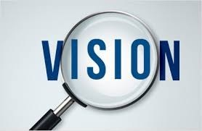k
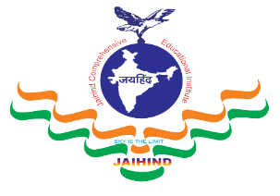
JCEI’s Jaihind Polytechnic, Kuran

Mechanical Engineering

Content
⇒Vision and Mission
⇒HOD’s Message
⇒Program Educational Objectives(PEOs)
⇒ Program Specific Outcomes(PSOs)
⇒Program Outcomes(POs)
⇒Departmental Events
⇒Faculty Training
⇒Faculty Achievements
⇒Students Achievements
⇒Co-curricular Activities
⇒Extra-curricular Activities
⇒Examination Toppers

Newsletter

Department of Mechanical Engineering Pursues Excellence In
Academic Through Continuous Process Abiding Its Quality
Education And To Achieve The Industrial And Social Goal Through
Value Based Education.

Provide The Students With Academic Environment Of Excellence, Leadership, Ethical Guidelines And
Life Long Learning Needed For A Long Productive Career. Imparting Highest Quality Education To The
Students To Build Their Capacity And Enhancing Their Skills To Make Them Globally Competitive
Mechanical Engineers

HOD Massage …….

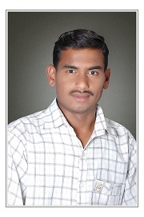
Welcome to the Department of Mechanical Engineering at Jaihind Polytechnic Kuran.
We started our journey in the year of 1997. Now our Mechanical Students intake is 120. Our department is
one of the most reputed and well established department, we have grown our expertise and competence
in the core Mechanical Engineering curriculum and consistently excellence in academic results. Our
well experienced and dedicated faculty grows knowledge of our students in dynamics, energy, thermo-fluids,
design & manufacturing, and control etc. apart from that we have a number of Guest faculties, who with
their rich experience in industry are able to enlighten the students about the latest trends and practical
aspects of engineering.
We strive to ensure that all our young students have a strong education with leadership, management
and teaming skills, internship experience, Entrepreneurship and involvement in student activities.
We entrust that accentuating these areas will make our young students well-qualified to
take leadership roles in the future.Our Laboratories have been very well established not only to cover
syllabus but to motivate students to learn beyond the syllabus which definitely develops complete knowledge
of the subject (both the practical and theoretical depth of knowledge) and develop skill sets of students
to become promising engineers in future. I wish a very best of luck to the students.

Prof. Patait S.B. HOD
Mechanical Engineering Department
JCEI'S JAIHIND POLYTECHNIC, KURAN (0508)
Mechanical Engineering Department

Program Outcomes (POs)
- Basic and Discipline specific knowledge: Apply knowledge of basic mathematics, science and engineering fundamentals and engineering specialization to solve the engineering problems.
- Problem analysis: Identify and analyse well-defined engineering problems using codified standard methods.
- Design/ development of solutions: Design solutions for well-defined technical problems and assist with the design of systems components or processes to meet specified needs.
- Engineering Tools, Experimentation and Testing: Apply modern engineering tools and appropriate technique to conduct standard tests and measurements.
- Engineering practices for society, sustainability and environment: Apply appropriate technology in context of society, sustainability, environment and ethical practices.
- Project Management: Use engineering management principles individually, as a team member or a leader to manage projects and effectively communicate about well-defined engineering activities.
- Life-long learning: Ability to analyse individual needs and engage in updating in the context of technological changes.
Programme Educational Objectives (PEOs)
PEO 1. Provide socially responsible, environment friendly solutions to Mechanical engineering related broad-based problems adapting professional ethics.
PEO 2. Adapt state-of-the-art Mechanical engineering broad-based technologies to work in multidisciplinary work environments.
PEO 3. Solve broad-based problems individually and as a team member communicating effectively in the world of work

Program Specific Outcomes (PSOs) :

PSO 1. Modern Software Usage: Use latest Mechanical engineering related software’s for simple design, drafting, manufacturing, maintenance and documentation of mechanicalengineering components and processes.

PSO 2. Equipment and Instruments: Maintain equipment and instruments related to Mechanical Engineering. And Manage Mechanical engineering processes by selecting and scheduling relevant equipment, substrates, quality control techniques, and operational parameters

Departmental Events
Guest Lecture
Expert Lecture No.:-1
Topic Name: “Career Opportunities of Mechanical Engineer”
Guest Name : Mr.Waykar Ishwar Pandurang.
I Can Engineering, Hivare (Kh)
Tal:-Junnar Dist:- Pune.
Date: 19/08/2023.
No. of Student: 39 (First Year Students.)

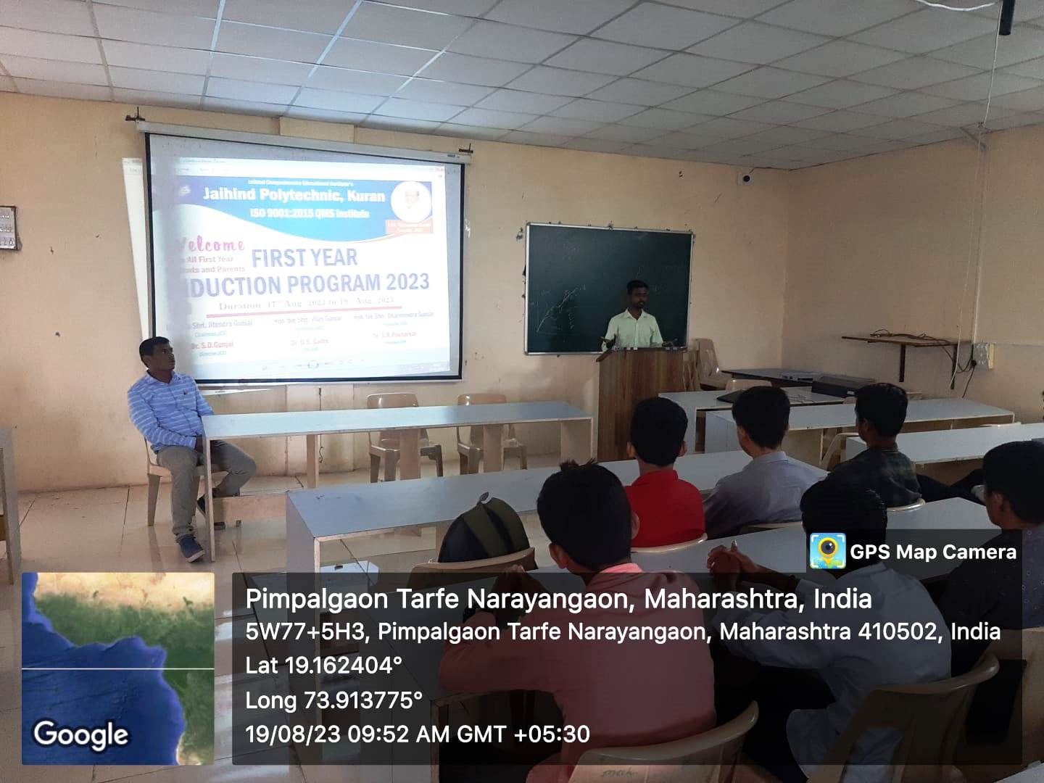
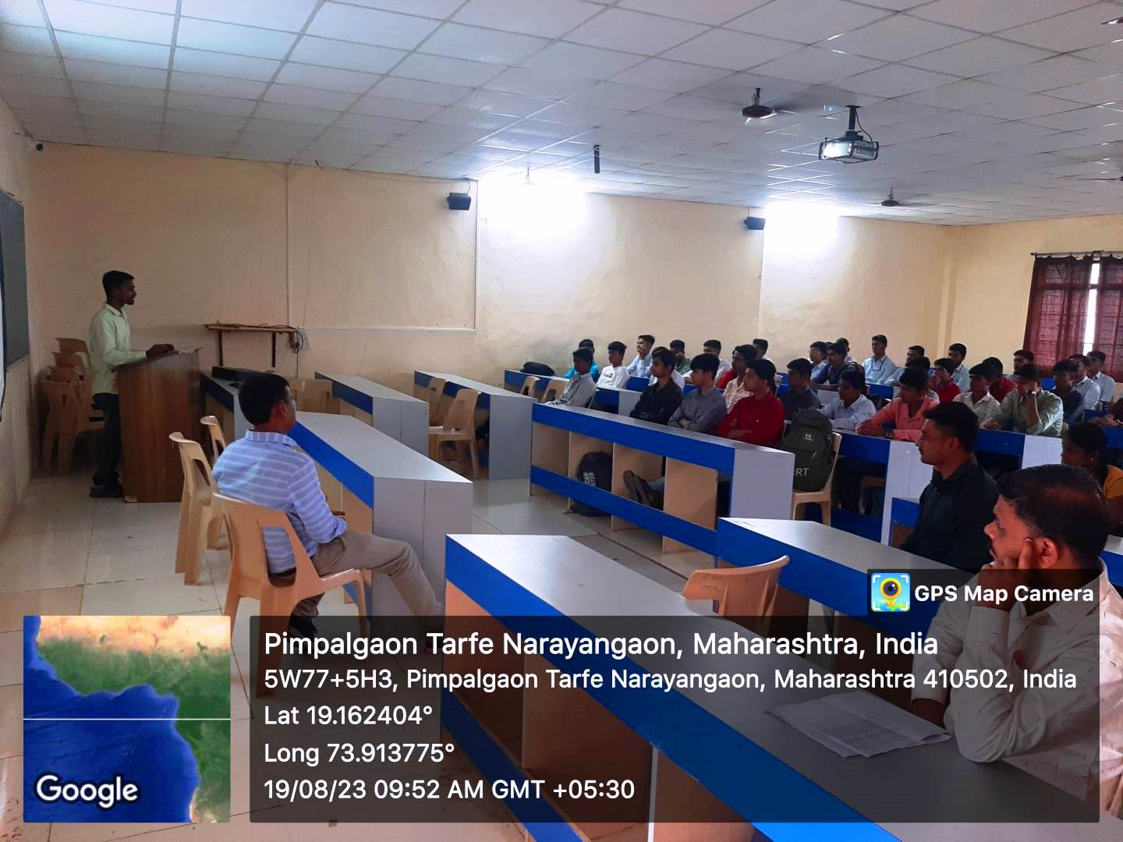
Expert Lecture No.:-2
Induction Program -2023-24
Topic Name: “Additive Manufacturing And Industrial Automation Fundamentals”
Guest Name : Mr. Milind Joshi
Assistant Manager
Tata Indian Institute of Skills
Mumbai 400001.
Date: 09/02/2024.
No. of Student: 50 ME6I ( Third Year Mechanical Engineering ).

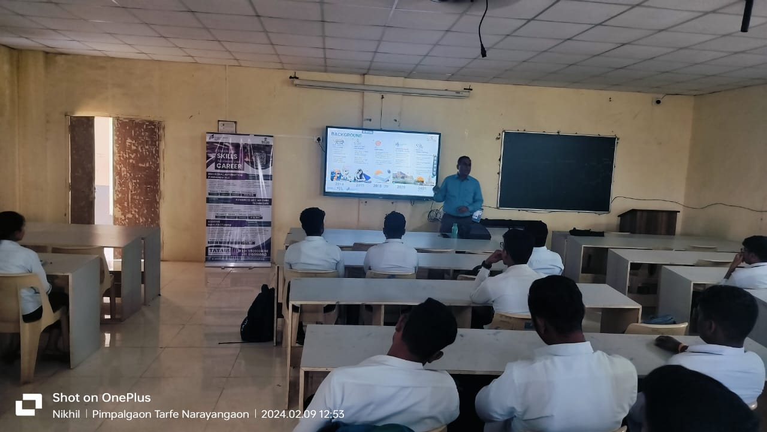

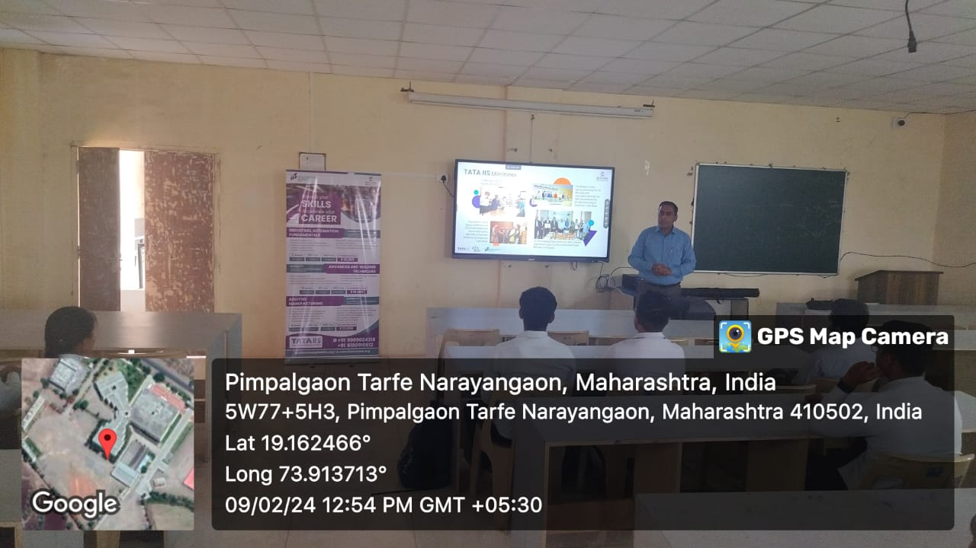

Industrial Visit
Topic Name:- “Industrial Visit to ElringKlinger Automotive Components
(India) PVT. LTD.Ranjangaon Tal:- Shirur. ”.
Date: 20/10/2023.
Class :- (Second & Third Year Students.) No. of Student:- 50

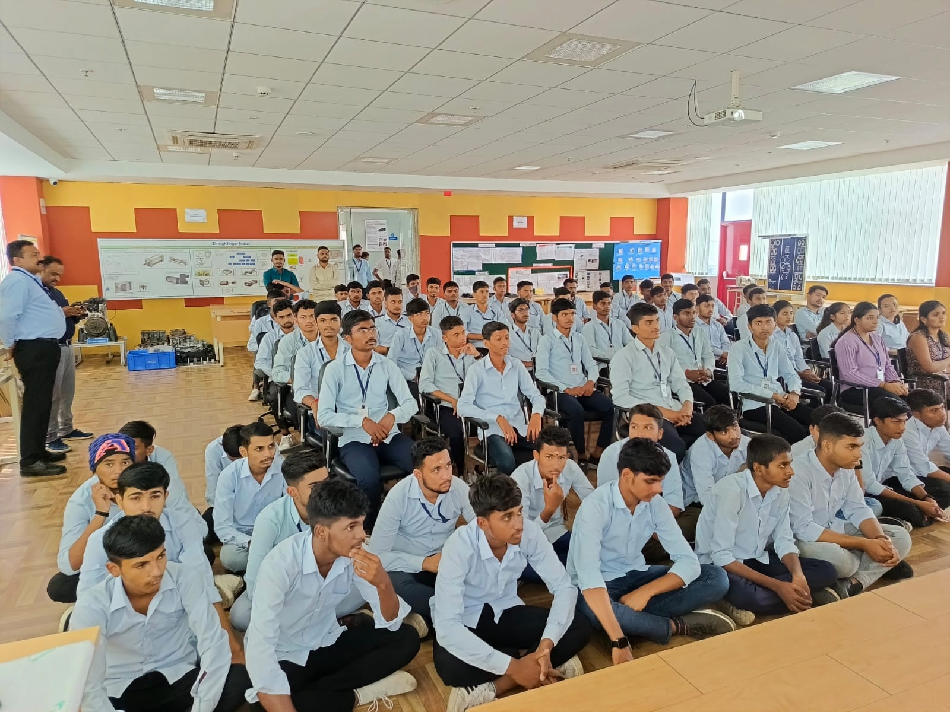

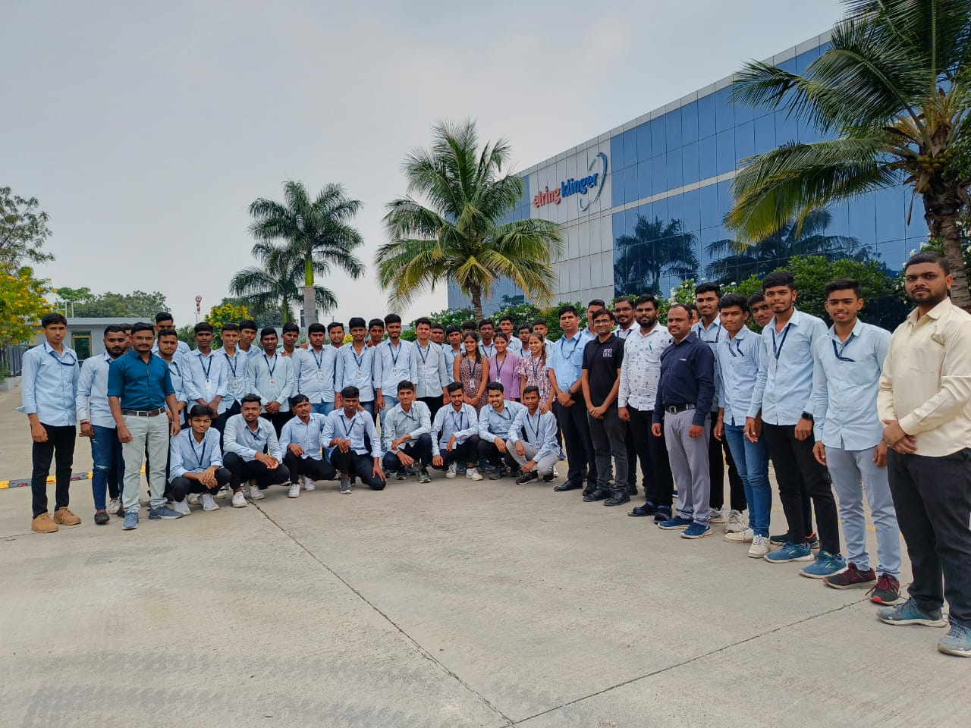

Topic Name:- Industrial Visit to Vighnahar Sahakari Sugar Factory, A/P:- Shiroli.
Tal:- Junnar Dist:-Pune.
Date: 17/02/2024
Class :- (First Year & Second Mechanical Year Students.)
No. of Student:- 60

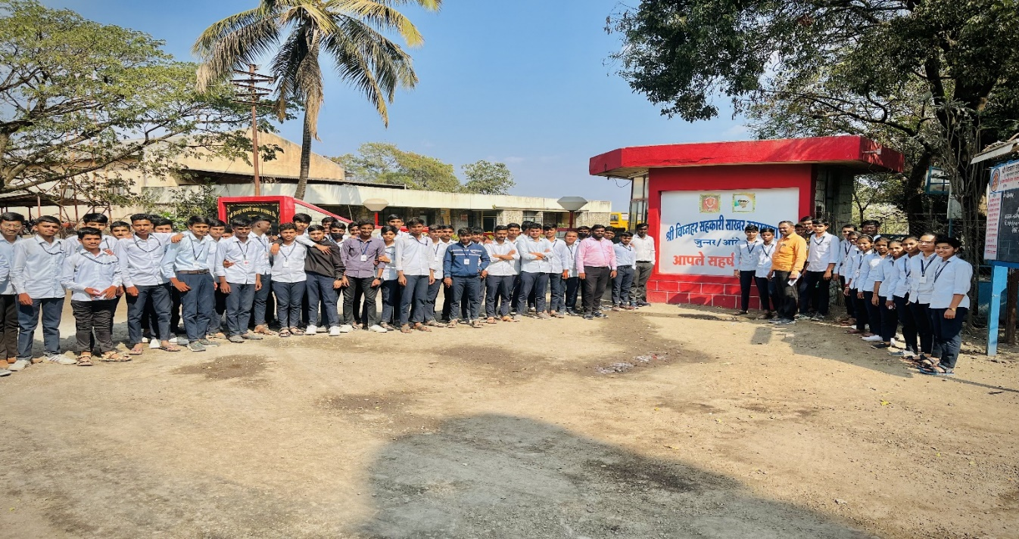

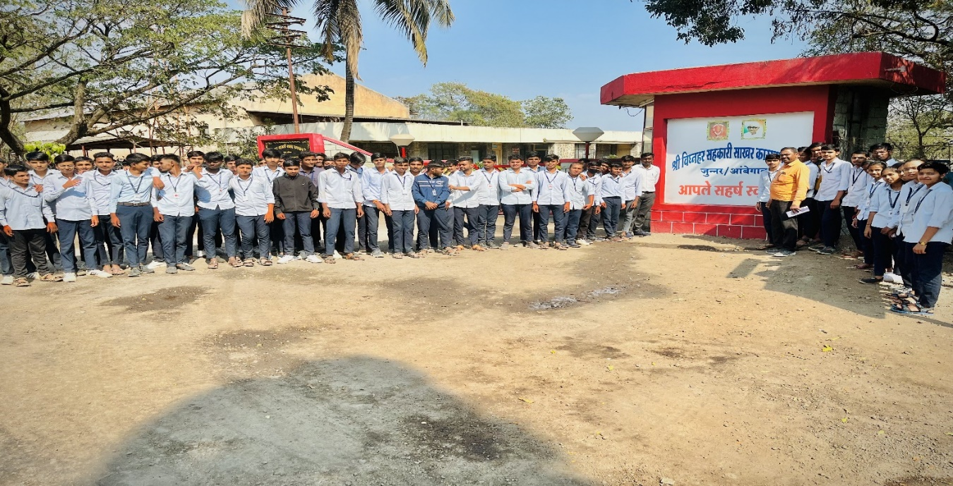

Topic Name:- Industrial Visit to Science Park Pimpri-Chinchwad,Pune
Class :- (First Year Mechanical Students.)
Date: 09/03/2024.
No. of Student:- 30

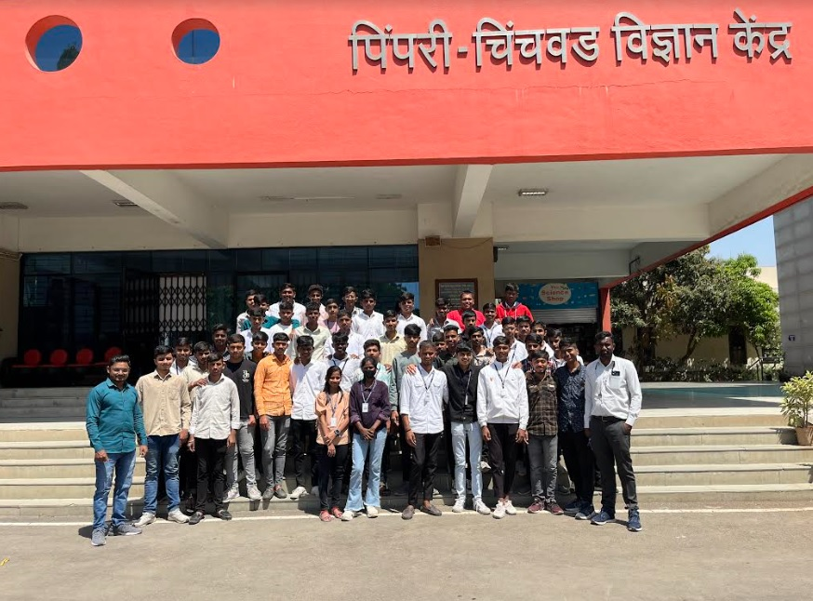

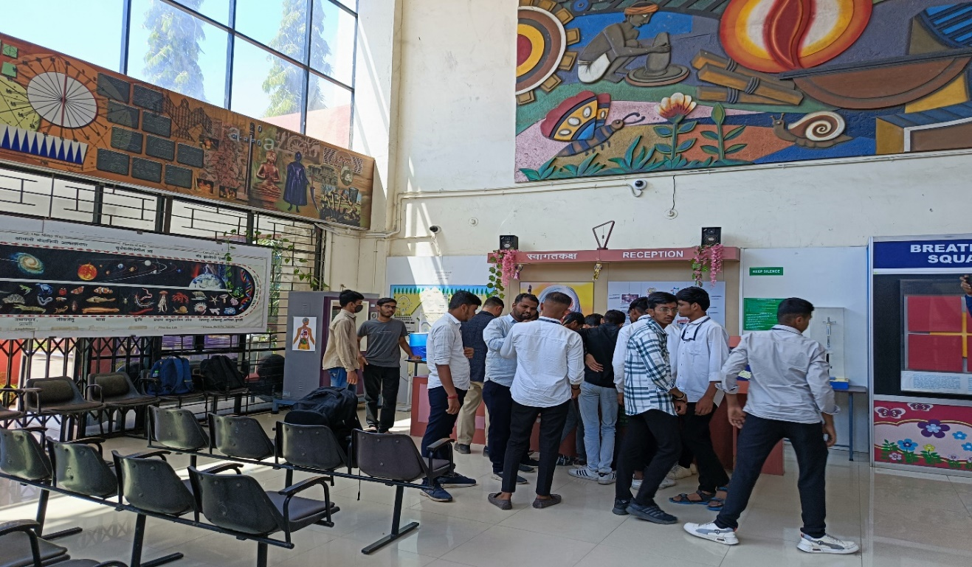

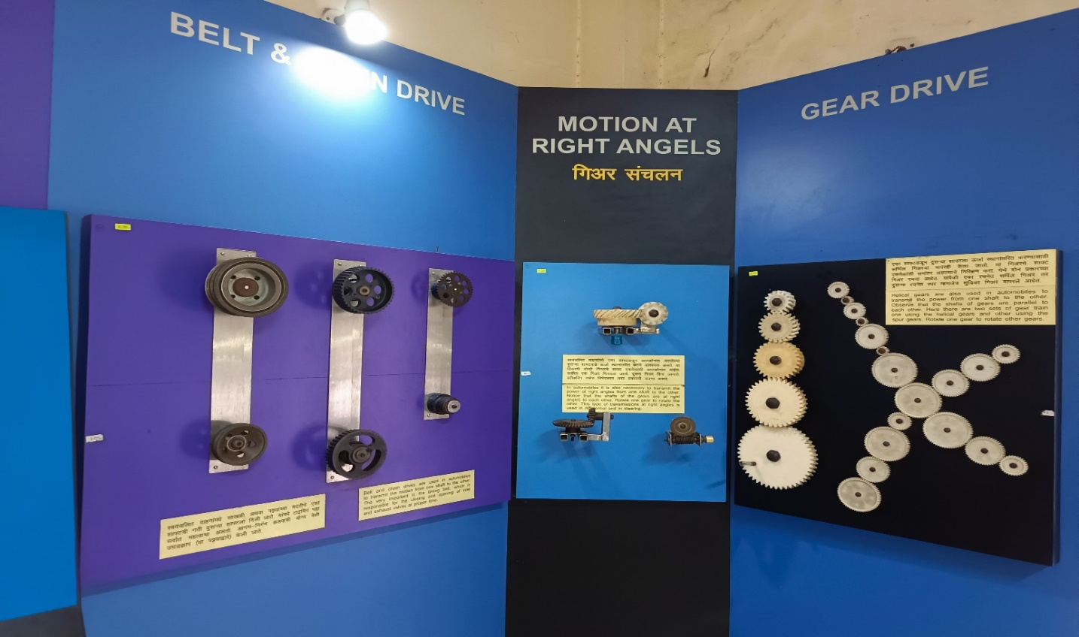

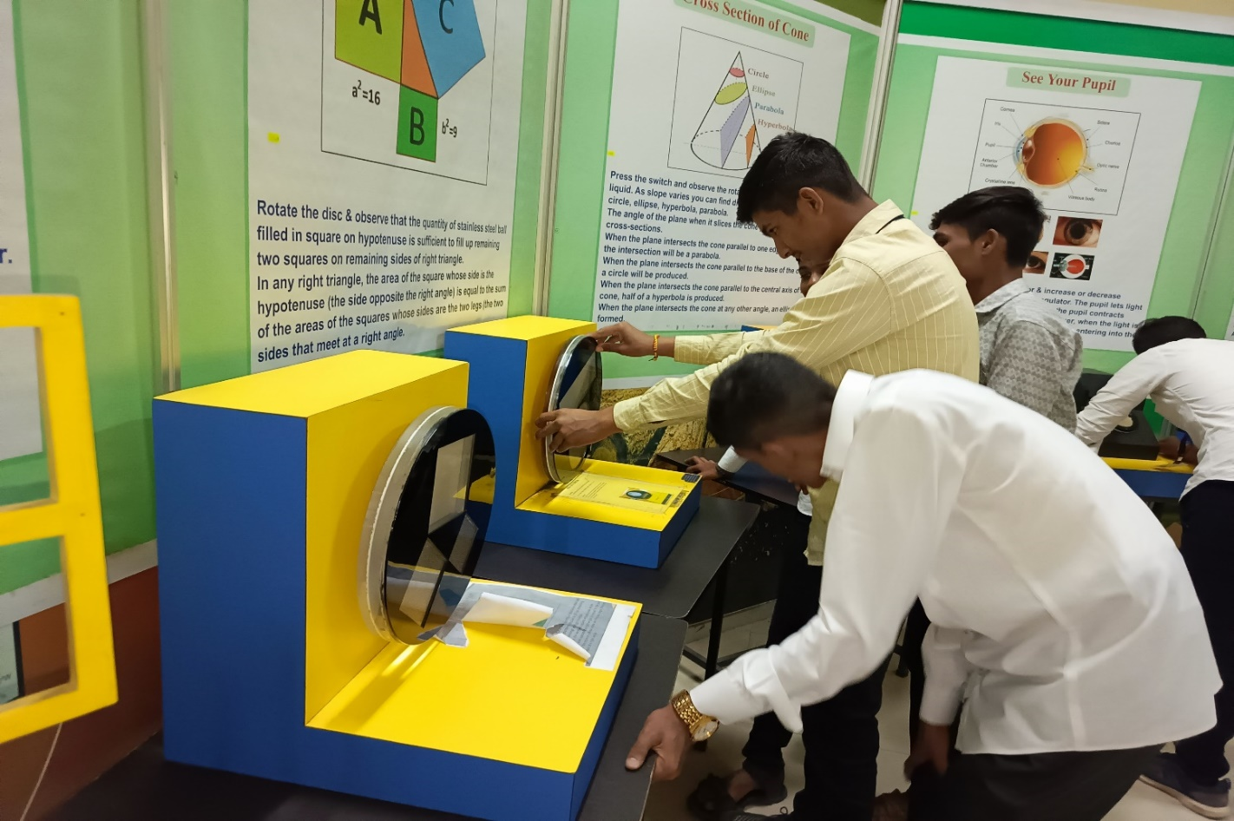
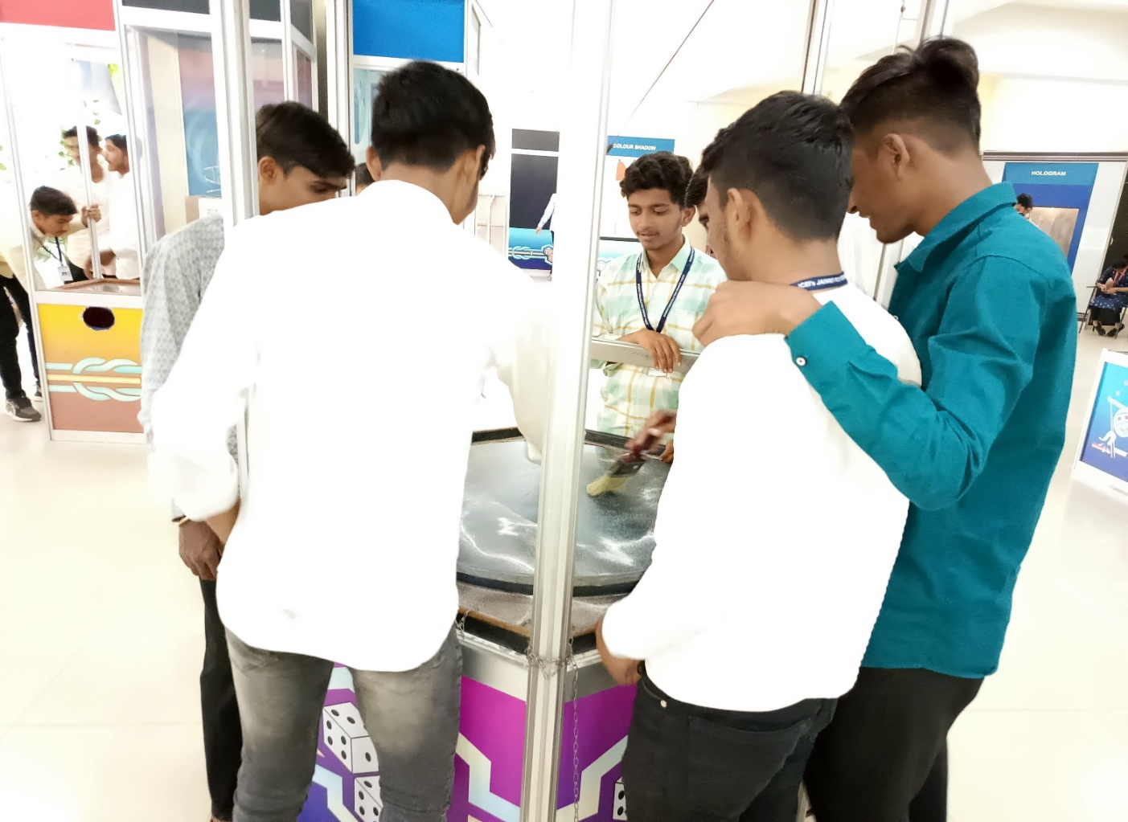

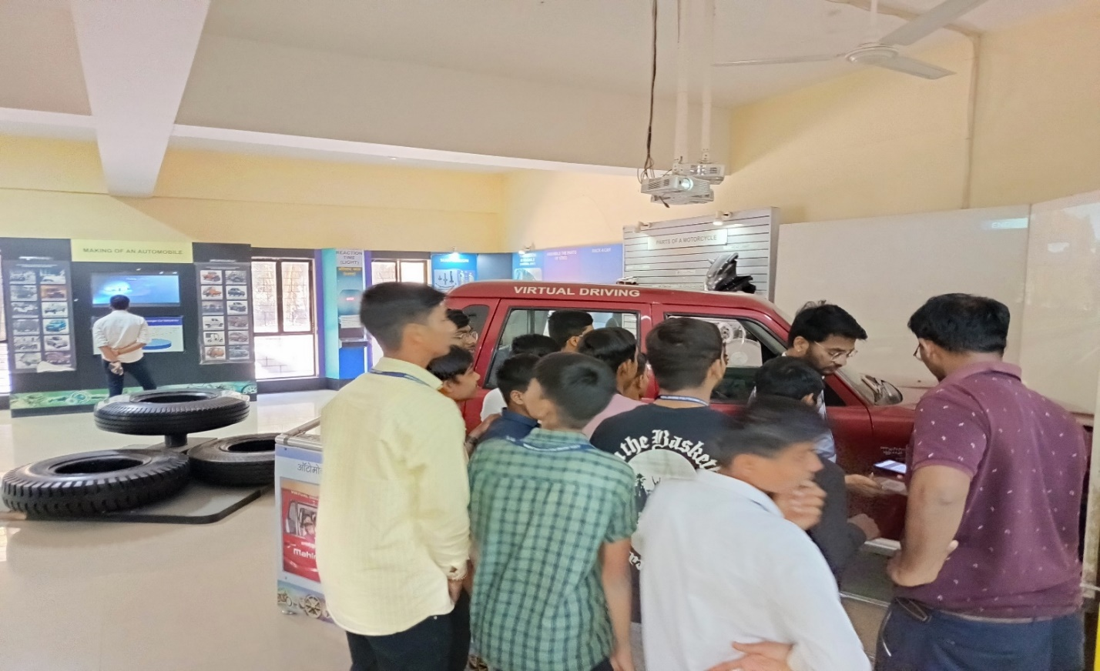

Faculty Training

Participation in Faculty Training

Sr. No. | Name of  faculty / staff | Details of Training (Industial / Content Updating / Soft Skill Any Other) | Duration of Training (schedule) | Organizing Body | Organizing Institute
1 | Patait Surendra Balasaheb | Outcome Base Education in NBA Accreditation. | 29/12/2023.To 30/12/2023. | MSBTE | Department of Computer Engg.of Jaihind Polytechnic Kuran
2 | Abuj Deviraj Kisanrao
3 | Pokale Mahesh Namdev
4 | Varhade Vishal Gorakshnath
5 | Shinde Sachin Sharad
6 | Amale Dnyaneshwar Kisan
7 | Bhosale Akshay Janardhan
8 | Nawale Saurab Chandrakant
9 | Patait Surendra Balasaheb | Dassault Systemes Solidwork 2024 Hand on Workshop on FEA/CFD/MBD(Kinematics) Solid Modeling Assignments | 12/01/2024.To 13/01/2024. | SPPU Course Curriculum | JCEI's Jaihind College of Engineering.
10 | Amale Dnyaneshwar Kisan
11 | Shinde Sachin Sharad
12 | Pokale Mahesh Namdev
13 | Varhade Vishal Gorakshnath
14 | Bhosale Akshay Janardhan
15 | Bhor Akshay Shivaji
16 | Pokale Mahesh Namdev | Designing Robust Mechatronics System Tools And Techniques | 12/02/2024.to 16/02/2024. | MSBTE | Guru Govind Singh Polytechnic, Nashik.
17 | Shinde Sachin Sharad | Designing Robust Mechatronics System Tools And Techniques | 12/02/2024.to 16/02/2024. | MSBTE | Guru Govind Singh Polytechnic, Nashik.
18 | Varhade Vishal Gorakshnath | Youth Leadership for Climate Action | 12/03/2024 To 13/03/2024. | CEE,Life,MH,Central Govt. | CEE,Life,MH,Central Govt. online Course.
19 | Abuj Deviraj Kisanrao | Youth Leadership for Climate Action | 12/03/2024 To 13/03/2024. | CEE,Life,MH,Central Govt. | CEE,Life,MH,Central Govt. online Course.

Co-curricular Activities

TECHNOPHILIA-2K24.QUIZ COMPETITION AND LATHE CHAMPION

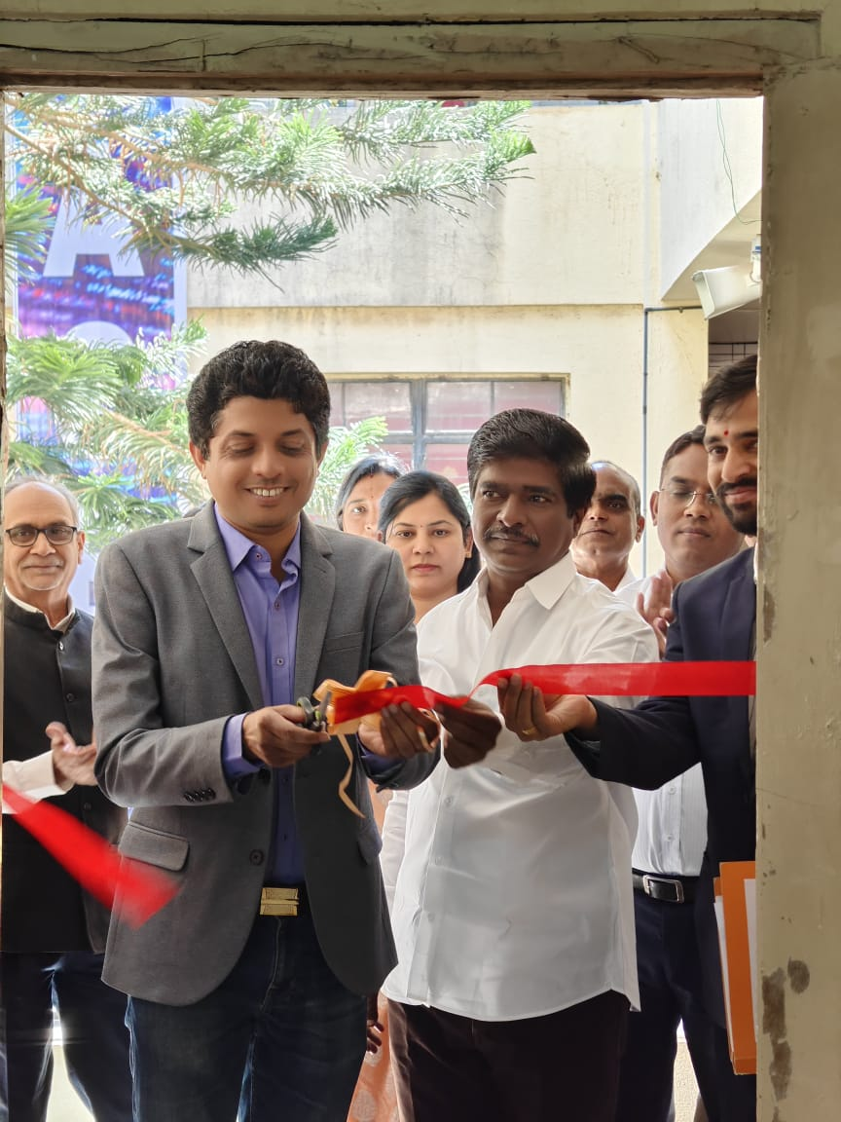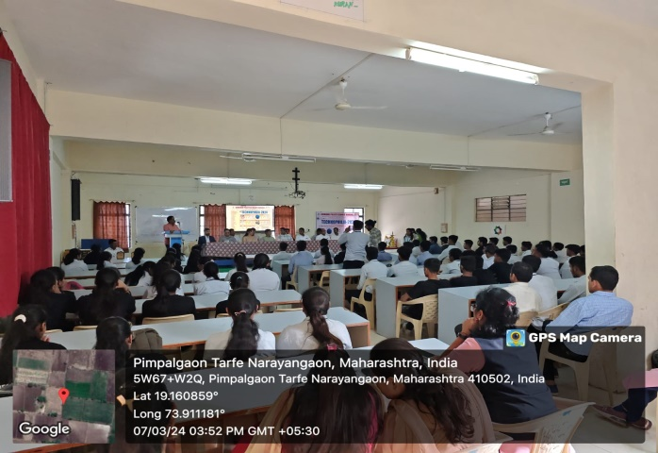

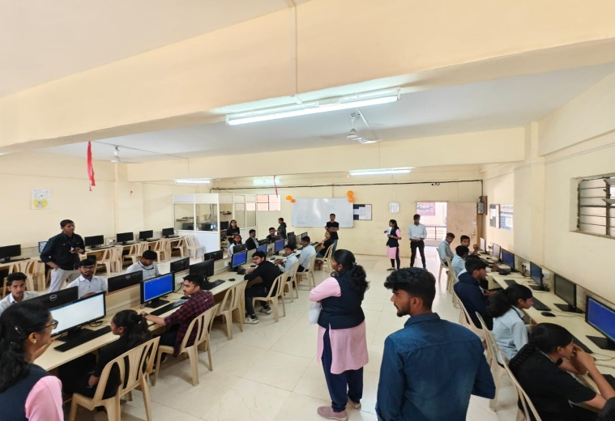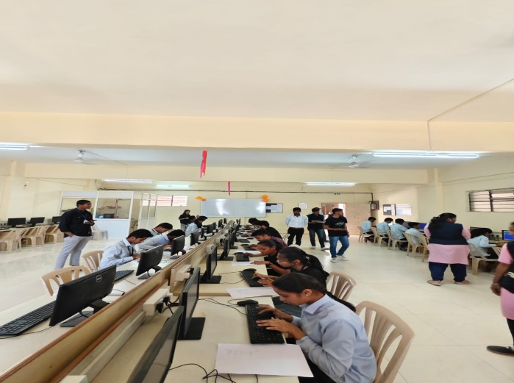

Student Participation in Technophilia-2k24.Quiz Competition And Lathe Champion

Sr. No. | Types of Activity & Details  (Paper Presentaion / Project / Quiz / Etc.) | Date | Name of Participating Student | Organizing Body And Organizing Institute | Awards (Winner / Participation)
1 | TECHNOPHILIA-2K24. QUIZ COMPETITION | 07/03/2024. | Deokar Aryan Mawesh | JCEI'S Jaihind Polytechnic Kuran. | Participation
 |  |  | Dhomase Abhishek Balu
 |  |  | Bothe Om Manohar
 |  |  | Biswas Pritam Prodip
2 | TECHNOPHILIA-2K24. LATHE CHAMPION | 07/03/2024. | Dhomase Abhishek Balu | JCEI'S Jaihind Polytechnic Kuran. | Participation
 |  |  | Kurhade Prem Sanjay
 |  |  | Bhise Vedant Dipak
 |  |  | Nalawade Rugved Ganesh
 |  |  | Salunke Atharava Sandeep
 |  |  | Erande Lokesh Sanjay
 |  |  | Rajguru Sai Kailash
 |  |  | Hande Om Yogesh
 |  |  | Dhole Santosh Maruti
 |  |  | Gholap Pranay Pravin
 |  |  | Tambe Atharva Vikas
 |  |  | Deokar Aryan Mawesh
 |  |  | Mohare Nilesh Nivrutti
 |  |  | Nalawade Omkar Puranik
 |  |  | Chavan Yash Umesh
 |  |  | Gawade Varad Yashwant
 |  |  | Sarjine Yash Nilesh
 |  |  | Wadekar Tejas sandeep
 |  |  | Doke Vaibhav Ashok
 |  |  | Tambe sandesh Naryan
 |  |  | Balsaraf Nilkanth Ramkrushna
 |  |  | Gawade Vinayak Sanjay
 |  |  | Waghamare Shantanu Shivaji
 |  |  | Pawar Anuj

Extra-Curricular Activities
Zonal Sports-D1 Zone IEDSSA Achievements
- Runner-up Team in Kho-Kho

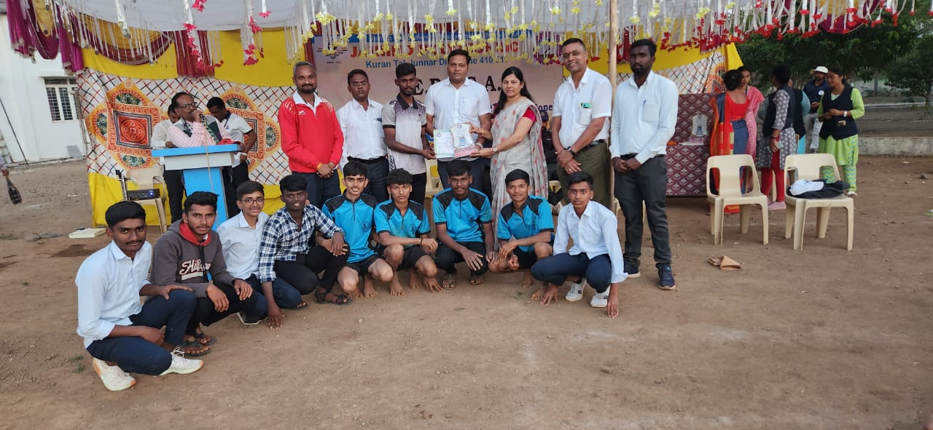

- Runner-up Team in Basket-Ball

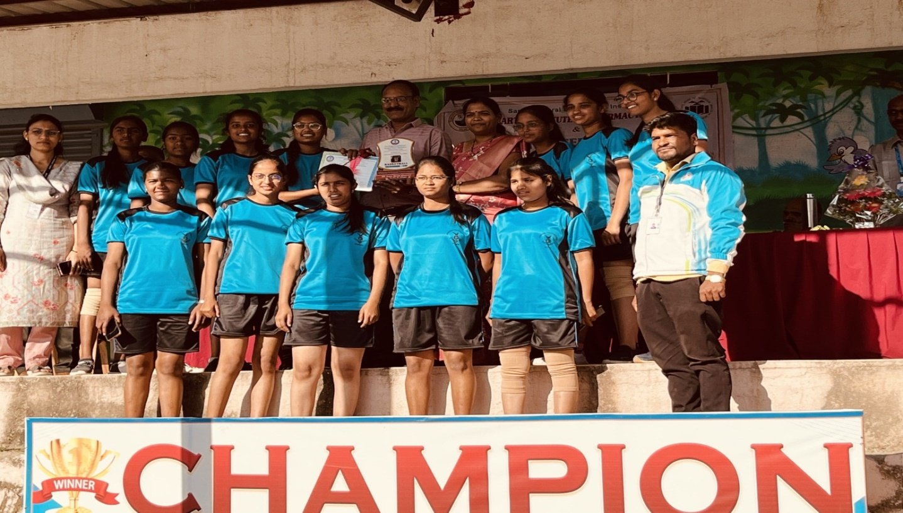

- Winner Team in Volleyball

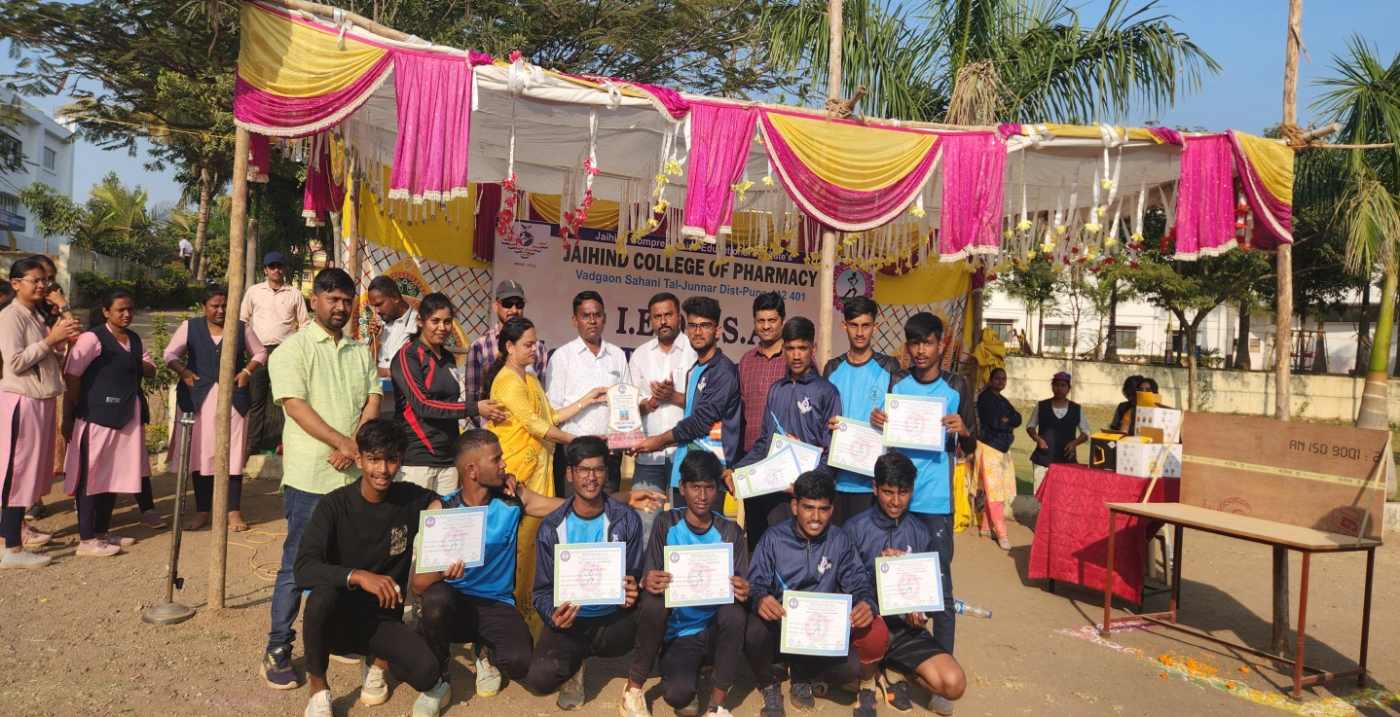

Student Participation in Sports

Sr. No. | Types of Activity & Details  (Sports / Drama / Social / NSS Etc.) | Date | Name of Participating Student | Organizing Body And Organizing Institute | Awards (Winner / Participation) | Level  (State / National / etc.)
1 | Kabbadi | 24/02/2024. | Dhomase Abhishek Balu | JCEI'S Jaihind Polytechnic Kuran. | Runner Up | College
 |  |  | Mengal Siddhesh Suresh
 |  |  | Nalawade Rugved Ganesh
 |  |  | Balsaraf Nilkanth Ramkrushna
 |  |  | Hinge Vedant Jawahar
 |  |  | Kanade Sai Santosh
 |  |  | Wayal Tejas Deepak
 |  |  | Sarjine Yash Nilesh
 |  |  | Bhise Vedant Dipak
 |  |  | Erande Lokesh Sanjay
 |  |  | Kawate Vinayak Eknath
 |  |  | Kanade Sahil Ranjit
 |  |  | Nalawade Omkar Puranik
2 |  | 24/02/2024. | Dhomase Abhishek Balu | JCEI'S Jaihind Polytechnic Kuran. | Runner Up | College
 |  |  | Chavan Rahul Laxman
 |  |  | Nalawade Omkar Puranik
 |  |  | Kanade Sai Santosh
 |  |  | Sharma Ganesh Shivkumar
 |  |  | Dhepe Vivek Ramesh
 |  |  | Kute Prasad Bhaskar
 |  |  | Habade Ritesh Somnath
 |  |  | Mohare Nilesh Nivrutti
 |  |  | Kawate Vinayak Eknath
 |  |  | More Paras Kisan
 |  |  | Rajguru Sai Kailash
3 | Shot Put |  | Dhomase Abhishek balu | JCEI'S Jaihind Polytechnic Kuran. | Winner | College
4 | Javelin Throw |  | Kawate Vinayak Eknath | JCEI'S Jaihind Polytechnic Kuran. | Runner Up | College
5 | Javelin Throw |  | Dhomase Abhishek balu | JCEI'S Jaihind Polytechnic Kuran. | Winner | College
6 | Kho-Kho (Boys) Zonal Sport Conducted by I.E.D.S.S.A.  JCEI'S Jaihind Polytechnic Kuran Pune. | 23/01/2024. | Kurhade Prem Sanjay | JCEI'S Jaihind Polytechnic Kuran. | Runner | Zonal Sport

Examination Topper (Winter 2023)
Department of Mechanical Engineering

Topper List of Winter 2023 Examination
Year | Ranking
 | Rank | Photo | Name of the Candidate | Marks Obtained | Out of | %
ME1K | 1 | 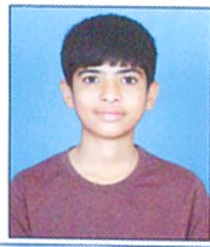 | SALUNKE ATHARVA SANDEEP | 715 | 850 | 84.10
 | 2 |  | CHAVAN OMKAR JAYSING | 617 | 850 | 72.60
 | 3 | 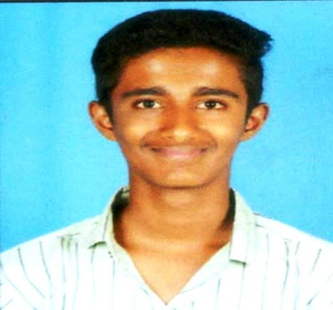 | HINGE VEDANT JAWAHAR | 615 | 850 | 72.40
ME3I | 1 | 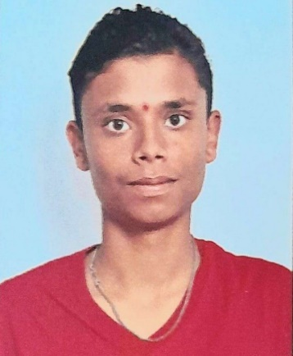 | DESHMUKH SHREYASH SANTOSH | 773 | 950 | 81.37
 | 2 |  | GHOGARE SAGAR LAXMAN | 762 | 950 | 80.21
 | 3 | 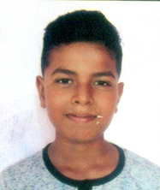 | YASH VINOD KAKADE | 752 | 950 | 79.16
ME5I | 1 | 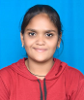 | BORADE TANUJA PRASHANT | 928 | 1050 | 88.38
 | 2 | 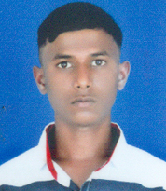 | MOHARE NILESH NIVRUTTI | 921 | 1050 | 87.71
 | 3 | 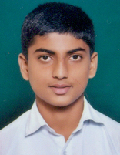 | WAGHMARE SHANTANU SHIVAJI | 906 | 1050 | 86.29

------------------------------------------ THANKS -------------------------------------

