







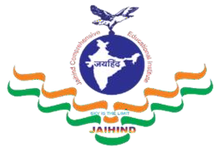
JCEI’s Jaihind Polytechnic, Kuran

Information Technology

Content

Vision and Mission HOD’s Message
Program Educational Objectives (PEOs)
Program Specific Outcomes (PSOs)
Program Outcomes (POs) Departmental Events Faculty Training
Faculty Achievements
Students Achievements
Co-curricular Activities
Extra-curricular Activities
Examination Toppers

Newsletter

To provide quality based technical education and development in Information Technology by adopting the rapid technological advancements in software programming.

M1: Producing quality based technical education and ethically responsible graduates through balanced and dynamic curriculum.
M2: Enhancing technical exploration in collaboration with government agencies and higher learning.
M3: Producing technical education for serving and enriching Information Technology.
M4: Exploring the recent trends in the field of Information Technology.

HOD’s Message………..

The Information Technology program was started in the year 2023-24 with intake of 60 seats. The main focus of the department is to deliver the professionals with strong and Placement. The department has well equipped and well-furnished 7 labs.
Department of Information Technology is prepared to meet the challenges and is playing a leadership role in shaping the education of the 21st Century by providing the lifelong learning and leadership skills to the students that enable them to grow in their professions and advance to positions of responsibility. The main motto of our department is to provide quality education. The process of learning is extremely important in everyone’s life. For that, we provide excellent infrastructure, many values added courses, teaching faculty of the best kind ensuring quality education such as interaction among students, parents and staff ensures a bright future to our students.
The Department also has a departmental library, computer center and seminar hall. The department focuses on the overall fundamentals in Computer Science and Engineering Domain. The department has well qualified and experienced teaching faculty members with various specializations. The department has excellent infrastructure with state-of-the-art equipment and software tools. The activities of the Department are conducted, besides teaching, in the areas of research, consulting, training, alumni and Training development of the students imparting Industry standard skills through Projects and by encouraging Student Association activities and Industrial visits.
I congratulate the team of faculty members and the students for their brilliant and original efforts. I wish all the Students and Faculty a great academic career.

Prof. Tannu R. R. HOD
Information Technology

Program Educational Objectives (PEOs)
PEO1: Adopt IT based technologies for software development, team and schedule management.
PEO2: Analyze, design, restructure and coordinate hardware, networking and information management system.
PEO3: Communicate effectively, work collaboratively and exhibit high level of professionalism and ethical responsibility.

Program Specific Outcomes (PSOs)
PSO 1: Software and Database: Develop, Test and maintain Software and Database by using IT Technologies and Tools.
PSO 2: Hardware and Networking: Maintain, Troubleshoot and provide Hardware and Networking support by applying IT related Standards and Principles.

Program Outcomes (POs)
PO1: Basic and Discipline specific knowledge: Apply knowledge of basic mathematics, science and engineering fundamentals and engineering specialization to solve the engineering problems.
PO2: Problem analysis: Identify and analyze well-defined engineering problems using codified standard methods.
PO3: Design/ development of solutions: Design solutions for well-defined technical problems and assist with the design of systems components or processes to meet specified needs.
PO4: Engineering Tools, Experimentation and Testing: Apply modern engineering tools and appropriate technique to conduct standard tests
PO5: Engineering practices for society, sustainability and environment: Apply appropriate technology in context of society, sustainability, environment and ethical practices.
PO6: Project Management: Use engineering management principles individually, as a team member or a leader to manage projects and effectively communicate about well-defined engineering activities.
PO7: Life-long learning: Ability to analyze individual needs and engage in updating in the context of technological changes.

Departmental Events


Expert Lecture No.:-1

- Name of Topic: “Emerging Trends and Future of AI.”
- Name of Guest Lecturer: Mr. Dattatray Shriram
- Date: 07 Aug 2025 10:00 AM

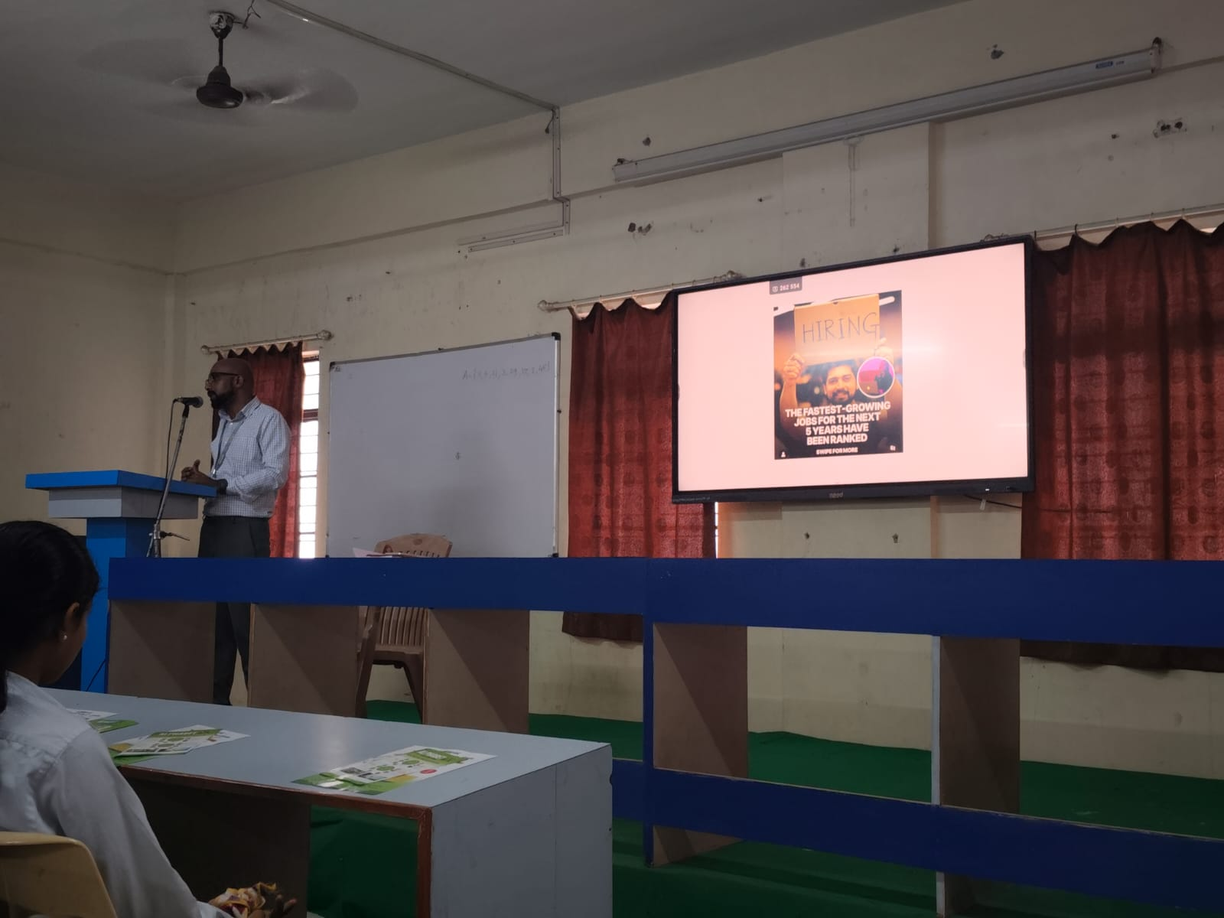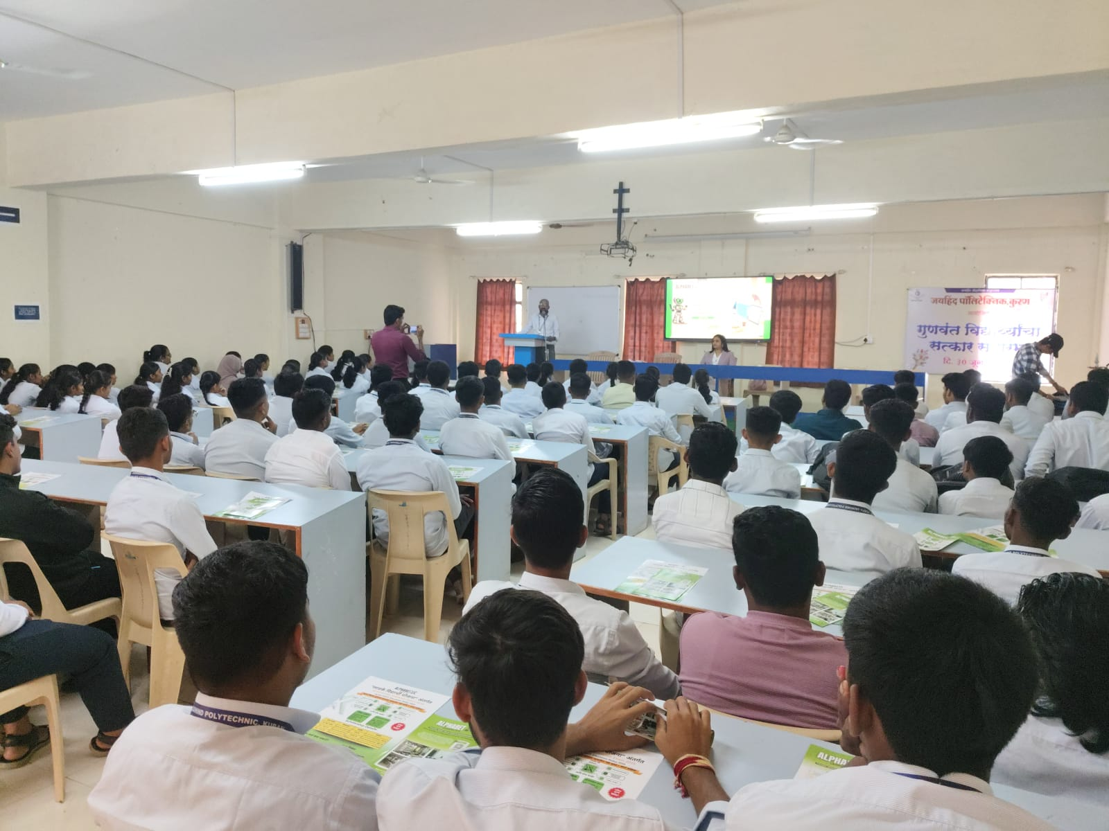

Expert Lecture No.:-2

1)Name of Topic: “Choosing the Right Software Project from Idea to Implementation.”
2)Name of Guest Lecturer: Mr. Dilip Singh
3)Date: 10 Sept 2025 10:00 AM

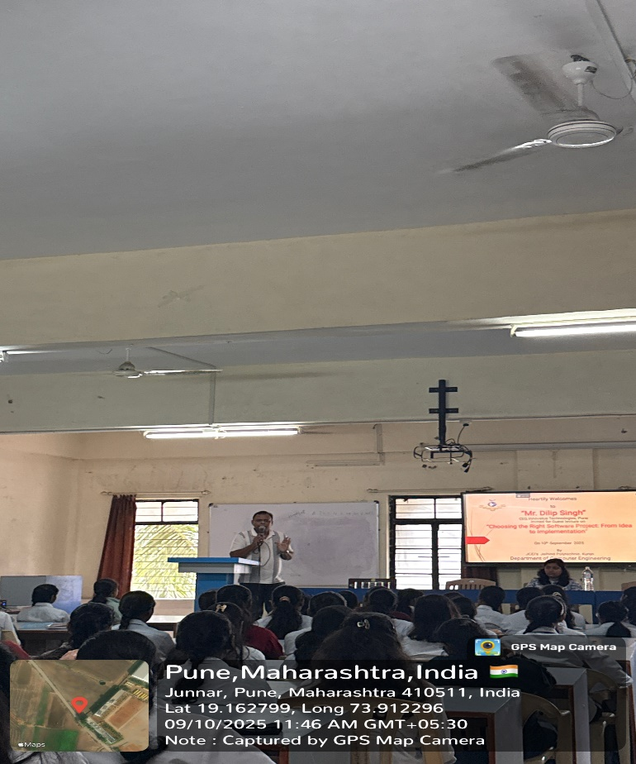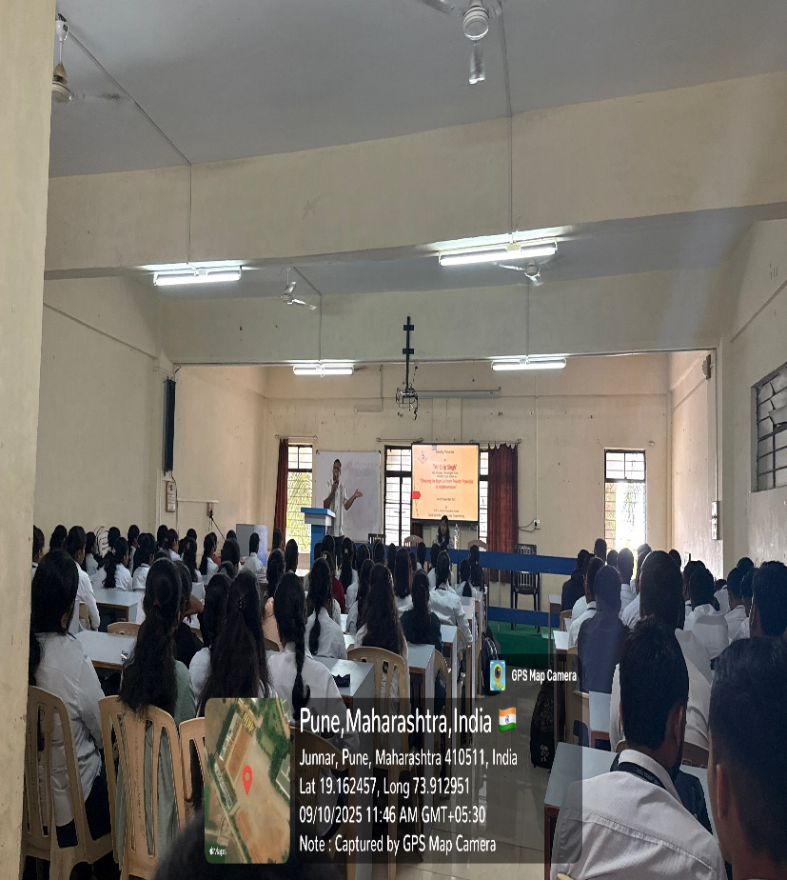

Expert Lecture No.:-3
- Name of Topic: “Implementation of Advanced Database Queries”
- Name of Guest Lecturer: Mr. Yuvraj Hande
- Date: 18 Sept 2025 12:30 PM

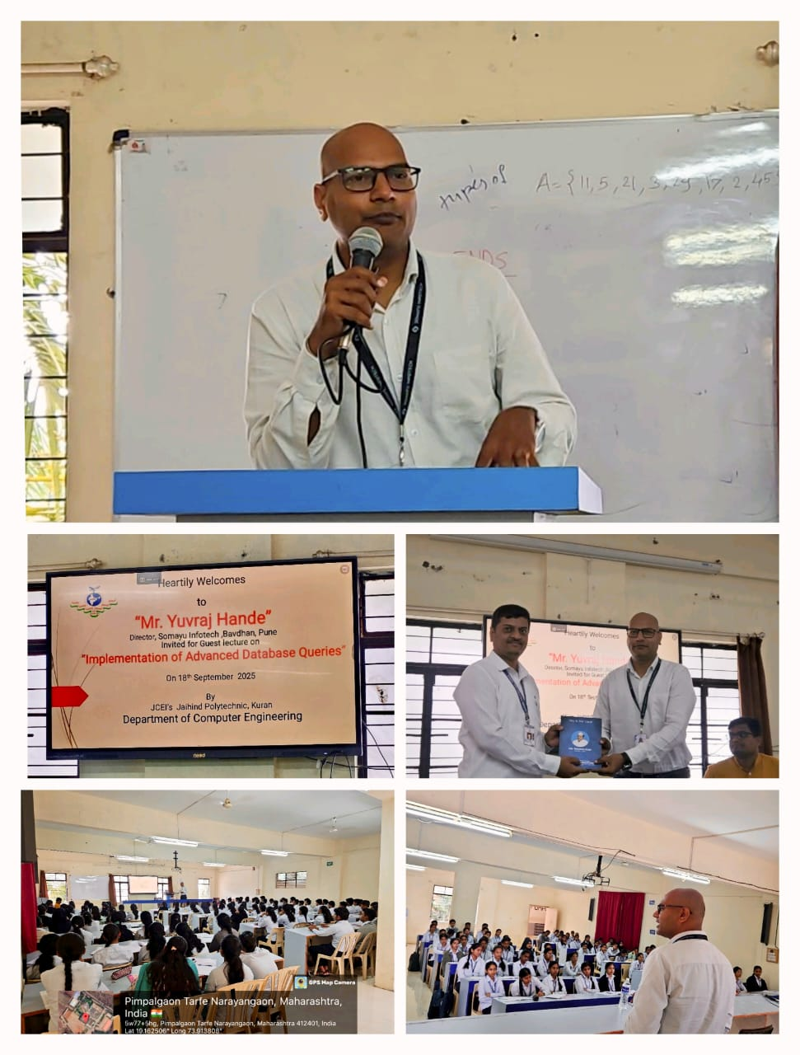

Expert Lecture No.:-4
1)Name of Topic: “Career Management Essentials”
2)Name of Guest Lecturer: Mr. Ketan Sathe
3)Date: 27 Sept 2025 12:30 PM

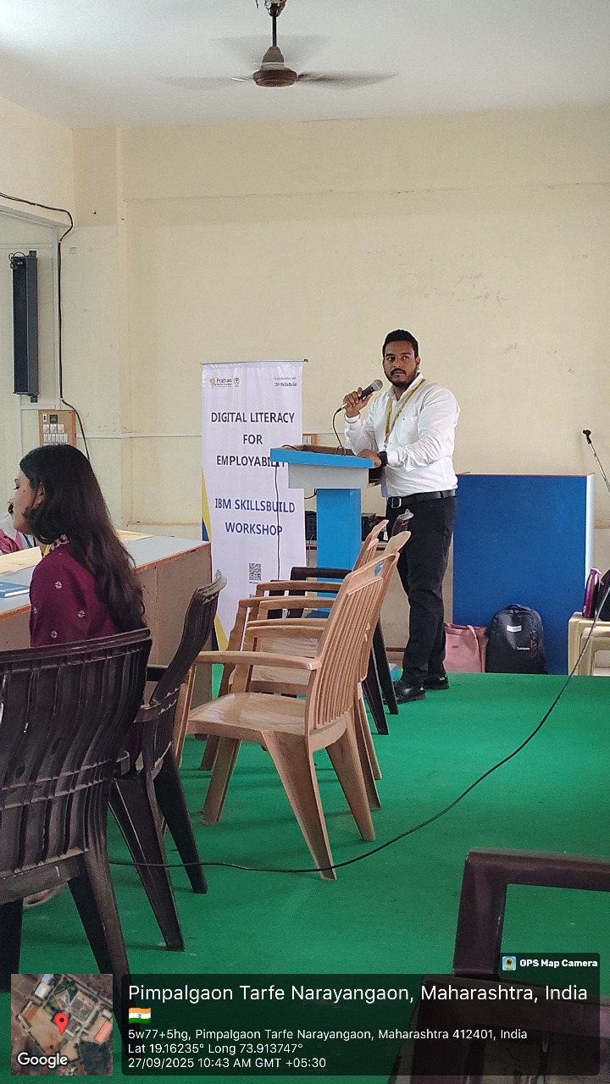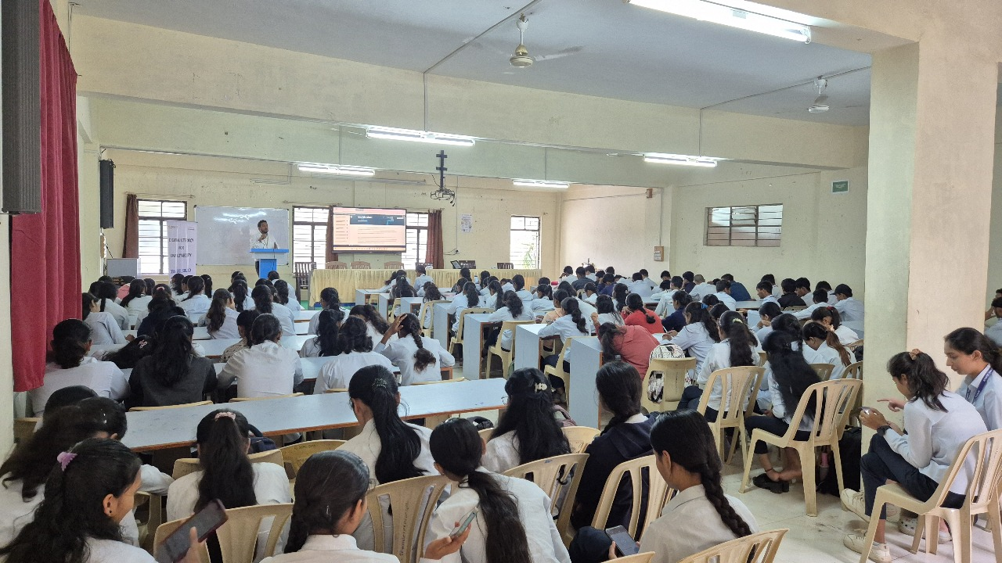

Teachers Day Celebration
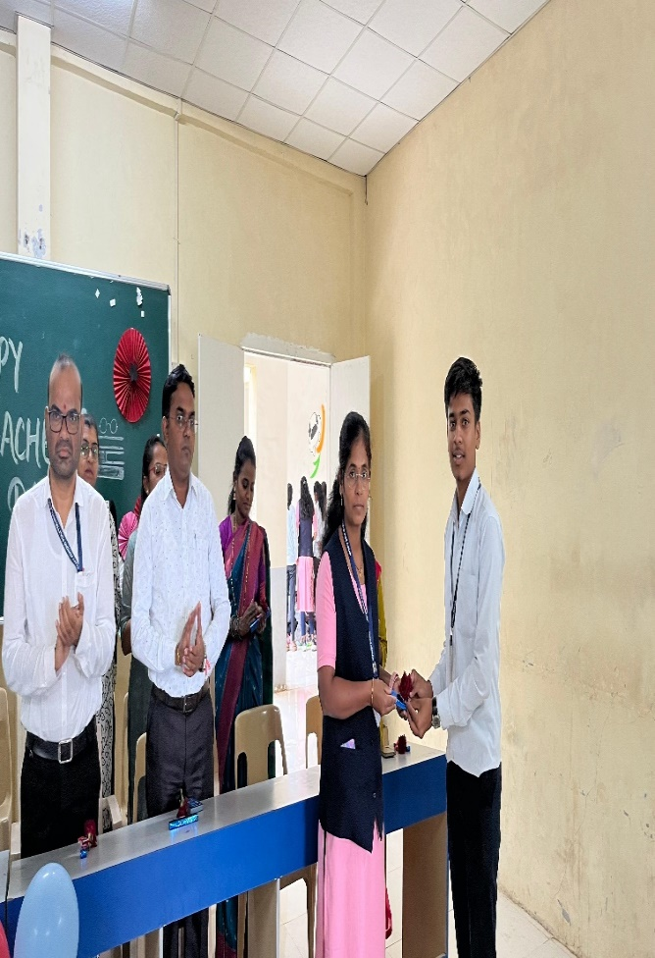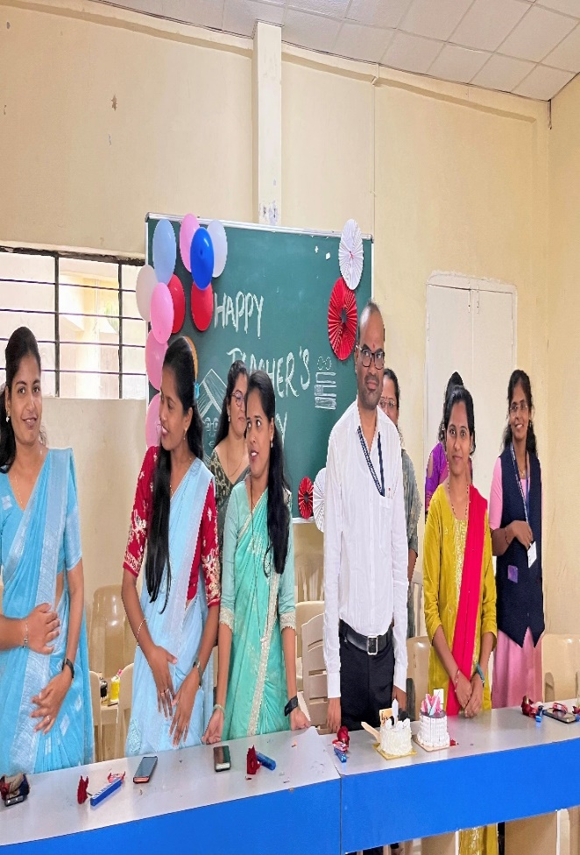
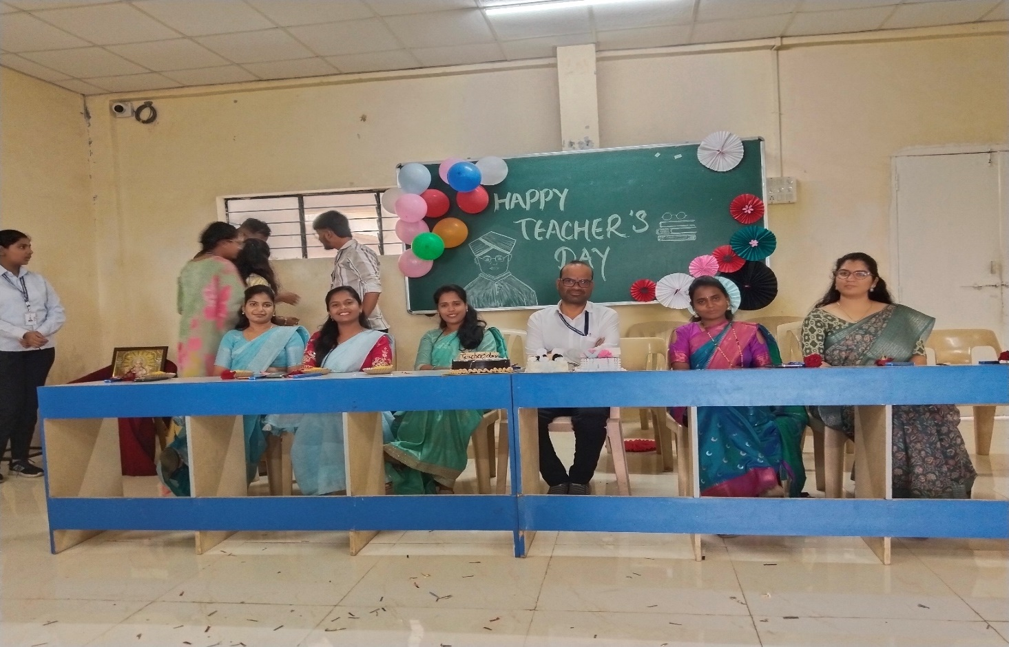

Industrial Visit First
Company Name: “Maya Academy Advanced Creativity Pvt Ltd JM Road, Pune”
Date: 27/09/2025
Name of Staff: Mr. Tannu R. R., Mrs. Lande R. S., Ms Kedari V. K., Ms. Dimbale M. S.
No. of Students: 55 (SY)

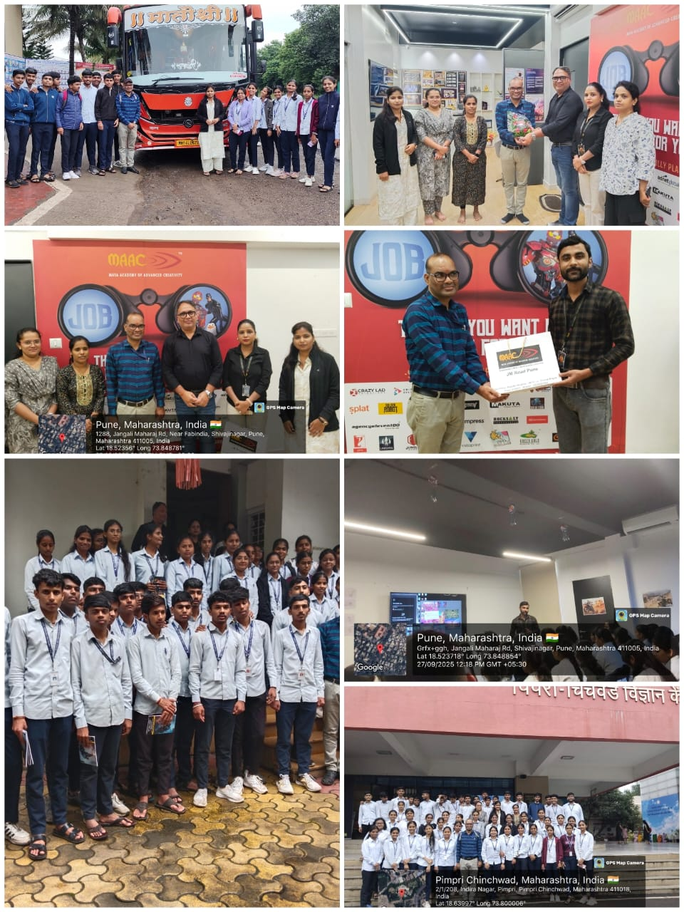

Industrial Visit Second
“Pimpri Chinchwad Science Park, Pune”
Date: 27/09/2025
Name of Staff: Mr. Tannu R. R., Mrs. Lande R. S., Ms Kedari V. K., Ms. Dimbale M. S.
No. of Students: 55 (SY)

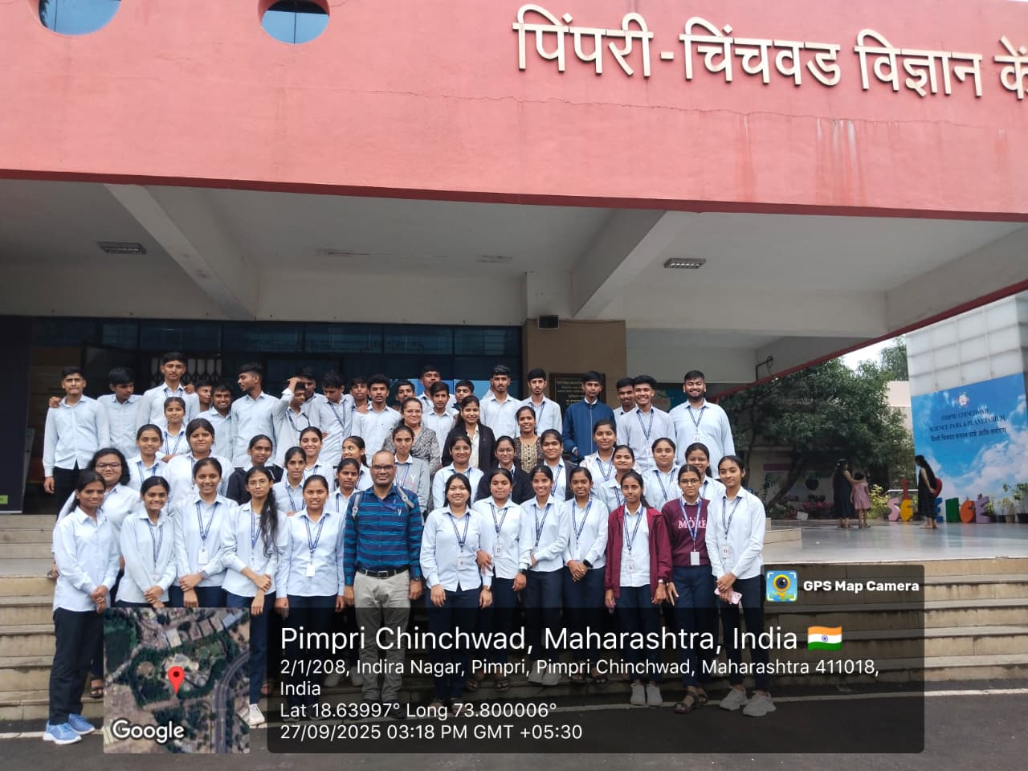

Expert Lecture First on Personality Development
- Name of Topic: “Focusing on crucial aspects of personal growth”
- Name of Guest Lecturer: Mr. Aniruddha Vinay Pathak
- Date: 08 Oct 2025 10:00 AM

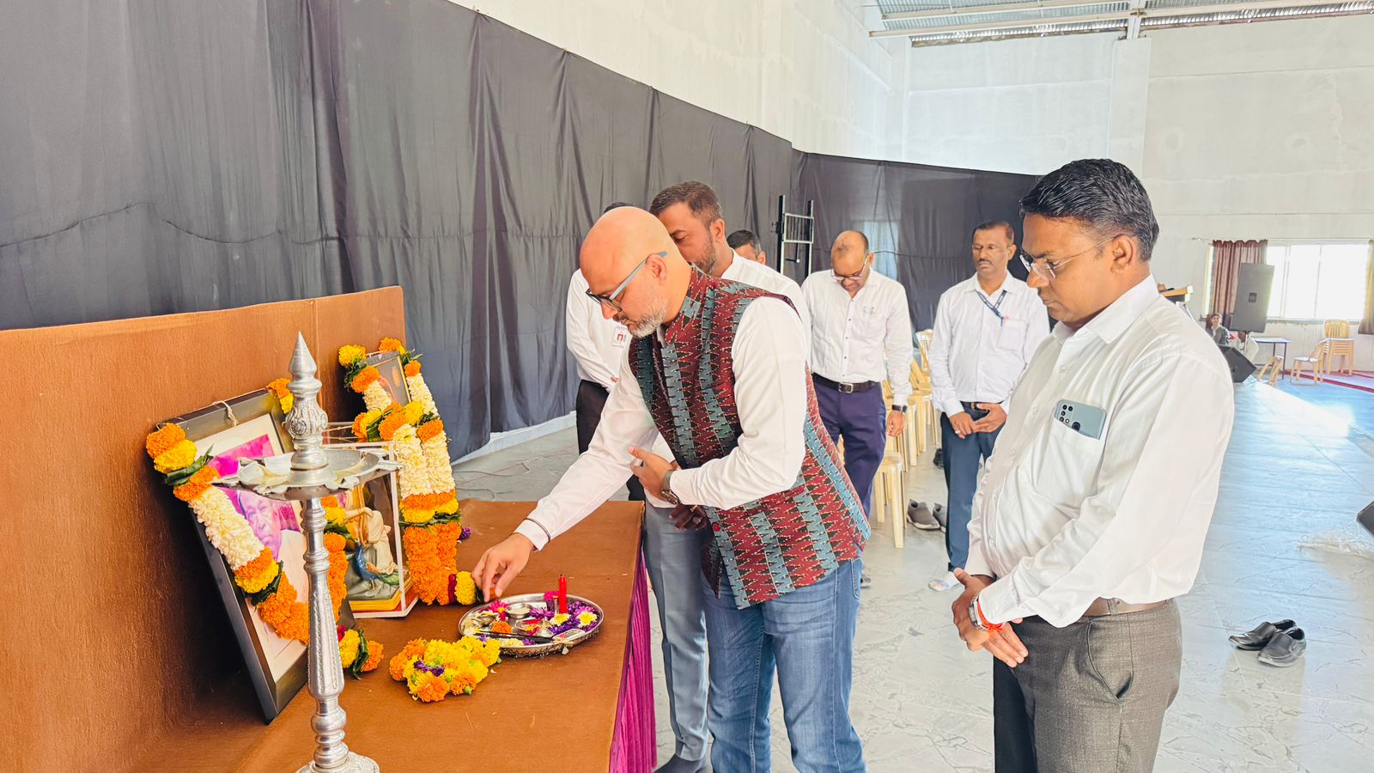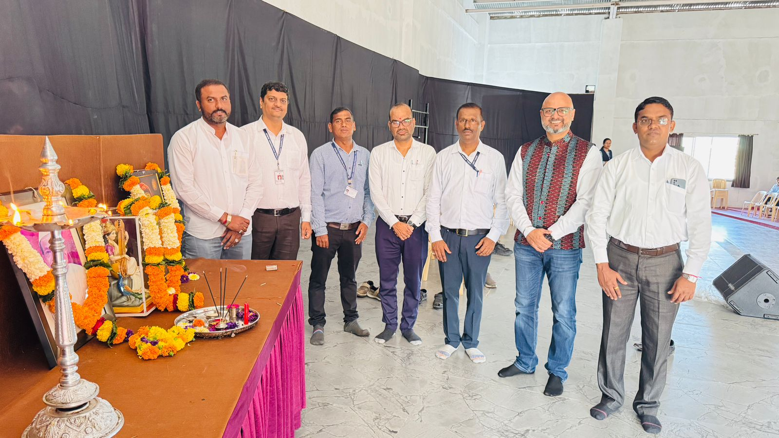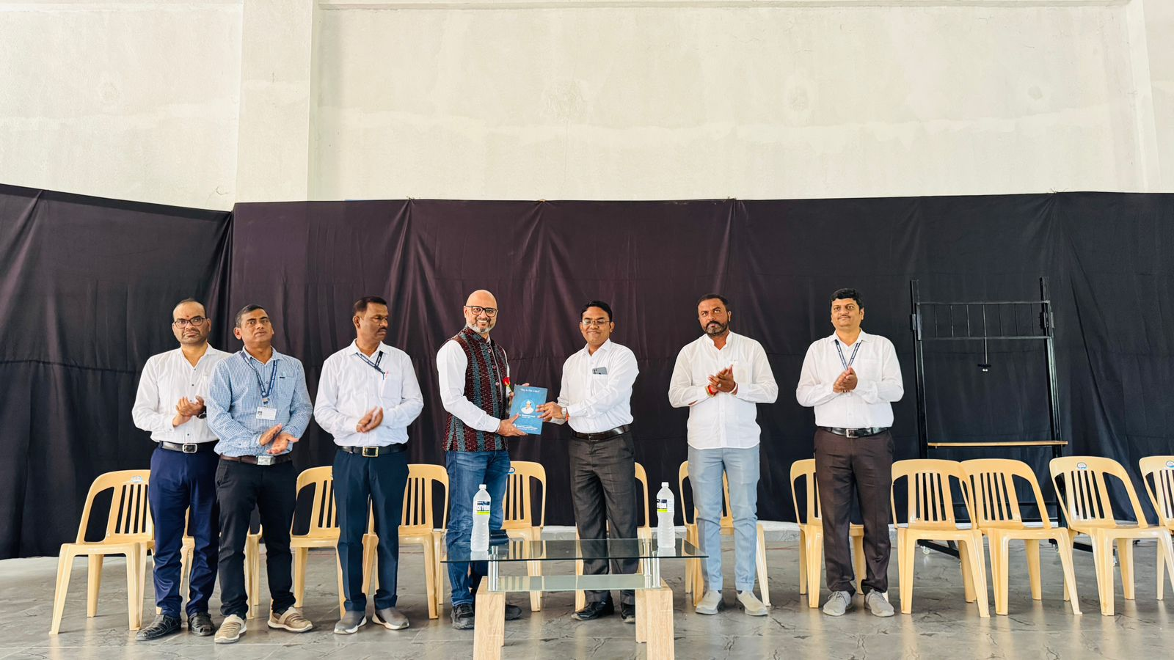
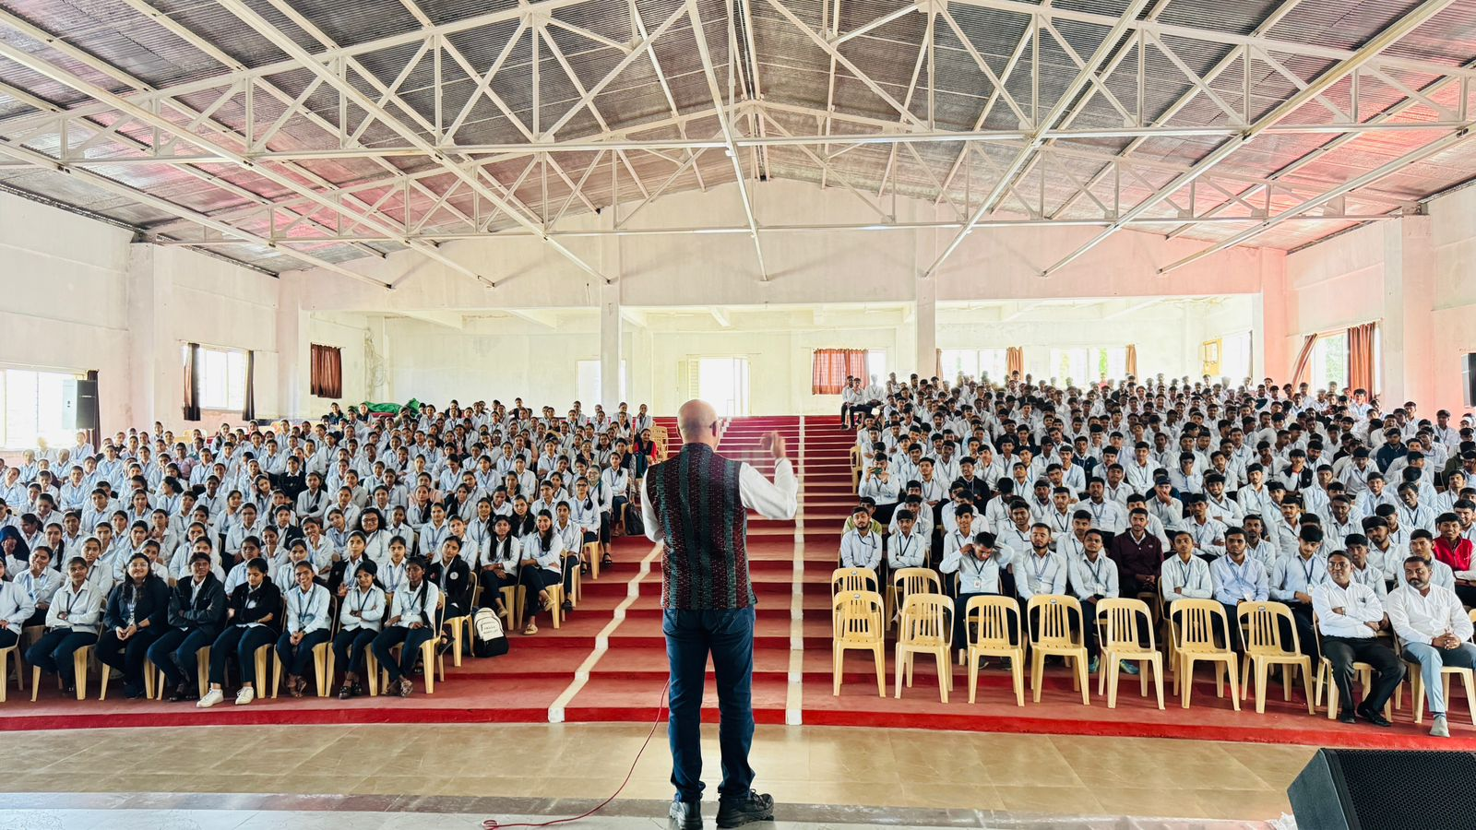

Parents Meeting Conducted on Dated 04th Oct 2025
Class: - FY

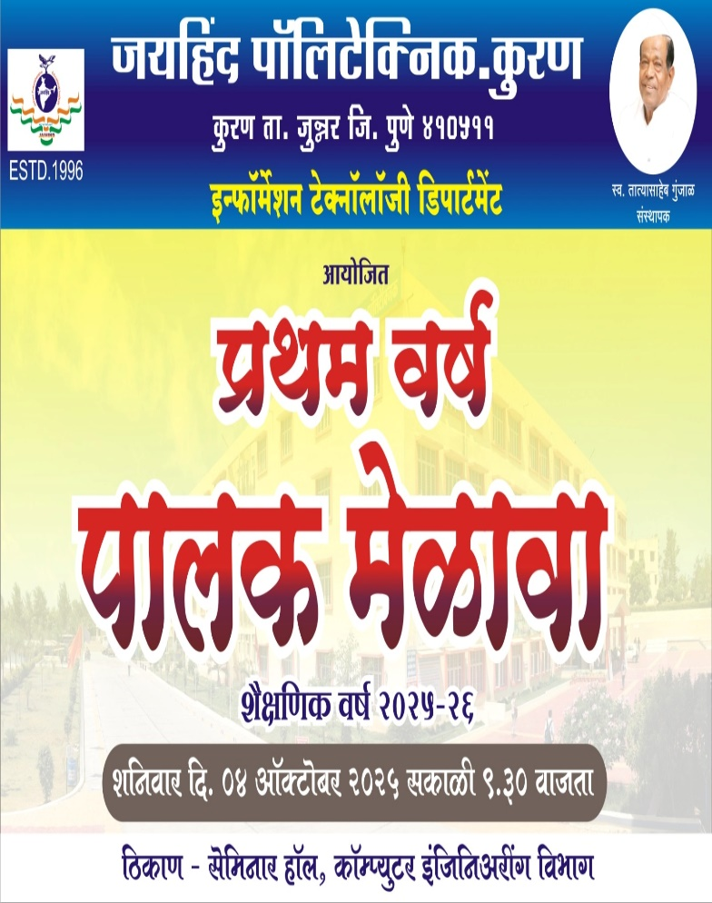

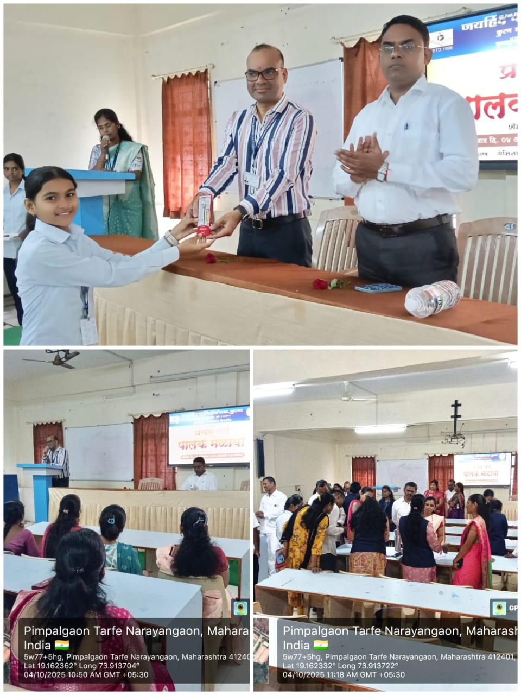

NSS Activity 1
Blood Donation Camp
Blood Donation Camp on dated 10/10/2025

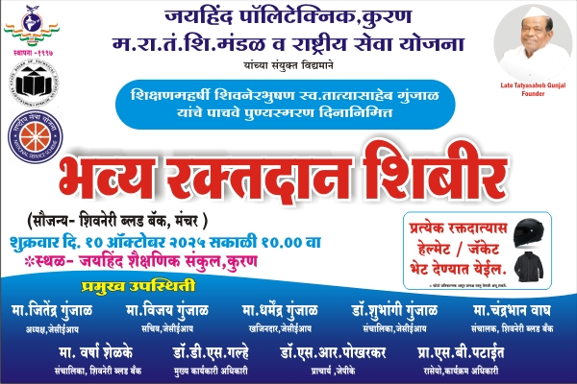
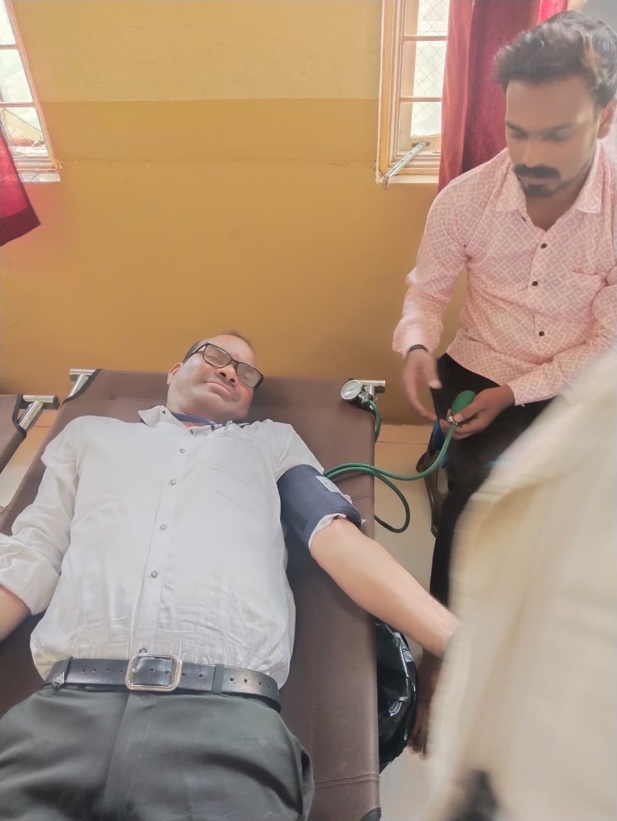

Faculty Achievement

- Published Paper on, “Enhancing Cloud Security: A Multi-Factor Authentication And Adaptive Cryptography Approach Using Machine Learning Techniques” in the International Research Journal of Modernization In Engineering Technology And Science, ISSN NO: 2582-2508 Certified Journal, Vol- 7, Issue – 6, June 2025.

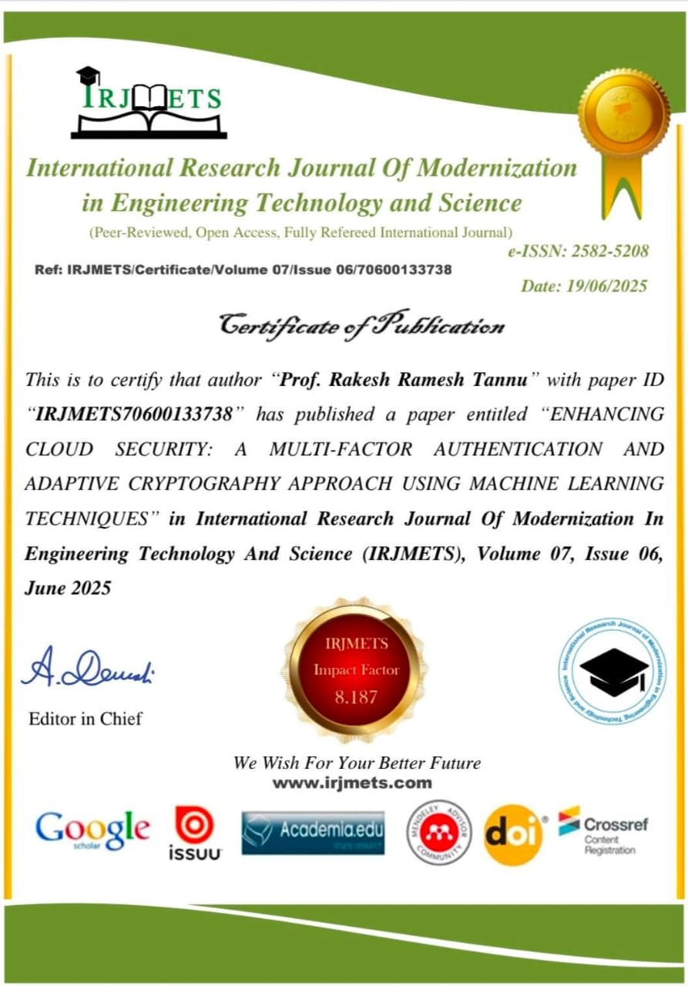

- Published Paper on, “Lung and Pancreatic Tumor Characterization in the Deep Learning Era: Novel Supervised and Unsupervised Learning Approaches” in the International Research Journal of Advanced Research in Science, Communication and Technology, ISSN NO: 2581-9429 Certified Journal, Vol- 5, Issue – 9, June 2025.

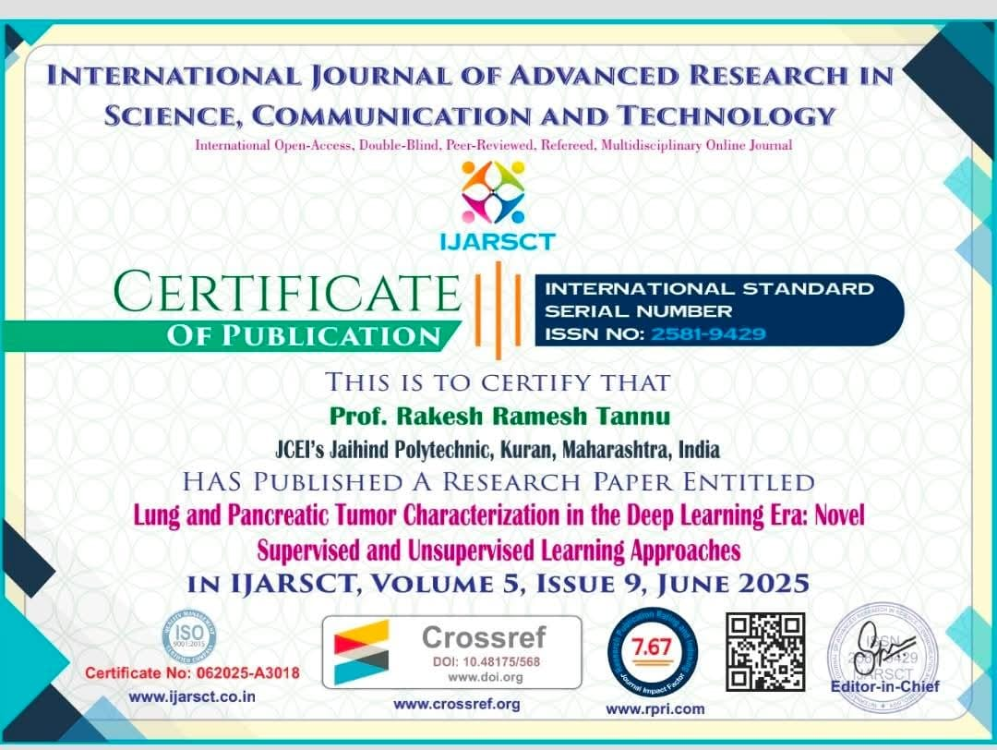

- Published Paper on “Predicting Heart Diseases Using Machine Learning and Different Data Classification Techniques” in UGC Approved Journal - The Board of International of Innovative Research in Technology, ISSN 2349-6002 Certified Journal, Vol-12, Issue- 5, October 2025.

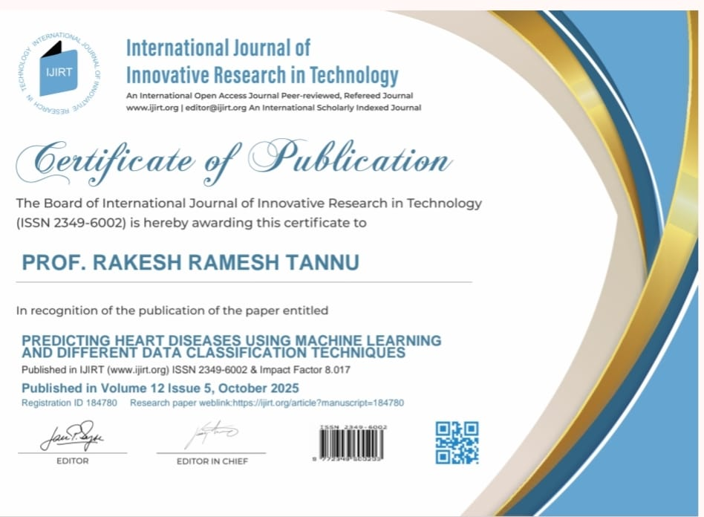

MSBTE NEWS LETTER FACULTY SPEAK OCT-2025


Introduction: Improving teaching strategies for diploma faculty through the use of AI tools can greatly enhance educational efficiency, tailor learning experiences, and better equip students for their future careers. By automating repetitive tasks and offering innovative instructional features, AI enables educators to concentrate on impactful, student-focused endeavors such as mentoring and practical skill acquisition.

Educational techniques improved through Artificial Intelligence
- Targeted instruction: AI platforms possess the capability to evaluate student performance data, thereby identifying gaps in knowledge and various learning styles, which allows for the creation of a tailored learning path for each student. For those pursuing diplomas, this may translate into personalized practice sets and modules focused on particular vocational skills.
- Adaptive assessments: Faculties have the ability to utilize AI-driven platforms such as Gradescope or Moodle plugins to design quizzes and assessments that dynamically modify their difficulty according to a student's performance. This approach aids in guaranteeing that each student attains mastery before progressing to a subsequent topic.

Immersive and practical training
- Virtual and augmented reality (VR/AR) simulations: In vocational disciplines such as healthcare and engineering, AI-driven virtual and augmented reality simulations enable students to engage in intricate, real-world tasks within a secure and regulated digital setting. These immersive experiences significantly improve practical skills and enhance problem-solving capabilities.
- AI-driven simulations and tutorials: Intelligent tutoring systems are capable of simulating vocational scenarios, offering sequential guidance and immediate feedback. For instance, an AI could assist an automotive student in navigating a complicated diagnostic procedure, thereby improving practical application.

Streamlined curriculum and content creation
- Automated resource generation: Resources such as Eduaide.ai and Magic School assist educators in swiftly creating lesson plans, quizzes, syllabi, and rubrics that are customized for particular subjects and skill levels. This greatly alleviates administrative burdens and allows for more time dedicated to direct teaching.
- Smarter training materials: Artificial Intelligence has the capability to extract essential information from curriculum documents or industry standards, thereby facilitating the automatic generation of structured and easily comprehensible learning materials. This process aids in maintaining the curriculum's relevance in light of evolving industry requirements.
- Course creation tools: Platforms such as Lingio and Learn Worlds enable educators to swiftly transform their current materials into engaging, gamified, and mobile-compatible courses.

Enhanced feedback and assessment
- Automated grading: Educators have the opportunity to utilize AI-powered assessment platforms such as Grade scope or Turnitin to streamline the grading process for assignments and examinations. This approach guarantees uniform and impartial evaluation, while also delivering students prompt and comprehensive feedback.
- Real-time feedback: Artificial Intelligence provides prompt feedback on assignments, writing techniques, or even programming code, assisting students in rectifying errors and enhancing their work at a faster pace compared to conventional approaches.
- Performance-based assessment: Artificial Intelligence has the capability to assess student performance within simulations and offer data-informed insights to educators.
In scenarios where students engage with AI tools, educators can examine chat logs and interactions with these tools to evaluate critical thinking and problem-solving abilities.

AI tools for diploma faculty
- Generative AI: ChatGPT, Google Gemini, and Perplexity AI are capable of assisting in the preparation of course materials and the development of assessments.
- Assessment and grading: Grade scope, Turnitin, and Moodle plugins facilitate the automation of the grading process.
- Content creation and lesson planning: Grade scope, Turnitin, and Moodle plugins facilitate the automation of the grading process.
- Course development platforms: Lingio, Learn Worlds, and Absorb LMS utilize artificial intelligence to develop engaging courses.
- Administrative tools: Otter.ai and Fireflies.ai are utilized for transcribing lectures, whereas Notion AI assists in the organization of class materials.

Best practices for diploma faculty
- Start small: Start with straightforward assignments to assist faculty and students in becoming familiar with the technology.
- Maintain ethical standards: Maintain transparency regarding the utilization of AI and confront matters related to academic integrity.
- Emphasize human interaction: Utilize artificial intelligence to minimize administrative responsibilities and concentrate on mentoring.
- Promote digital literacy: Instruct diploma students on the responsible use of artificial intelligence.
- Stay updated: Continue to investigate novel tools and techniques.

Prof. Tannu Rakesh Ramesh
Head of Information Technology Dept.
JCEI’s Jaihind Polytechnic Kuran.
Taluka – Junnar, Dist-Pune, Pin-410511

