JCEI’s JAIHIND POLYTECHNIC KURAN

DEPARTMENT OF INFORMATION TECHNOLOGY

Academic Year:- 2023-24

DEPARTMENT OF INFORMATION TECHNOLOGY

INDEX
Sr.No | Title
1 | Vision, Mission, Program Education Objectives Program Specific Outcomes of department.
2 | Toppers of the department
3 | Details of Expert Lectures
4 | Details of Industrial Visit
5 | Co-Curricular Activity
6 | Extra-Curricular Activity

DEPARTMENT OF INFORMATION TECHNOLOGY
Vision
To provide quality based technical education and development in Information Technology by adopting the rapid technological advancements in software programming.

Mission
M1: To produce quality based technical education and ethically responsible graduates through balanced and dynamic curriculum.
M2: To enhance technical exploration in collaboration with government agencies and higher learning.
M3: To produce technical education for serving and enriching Information Technology.
M4: To explore the recent trends in the field of Information Technology.

Program Education Objectives(PEOs)
- PEO1: Adopt IT based technologies for software development, team and schedule management.
- PEO2: Analyze, design, restructure and coordinate hardware, networking and information management system.
- PEO3: Communicate effectively, work collaboratively and exhibit high level of professionalism and ethical responsibility.

Program Specific Outcomes (PSOs)
PSO1: Software and Database: Develop, Test and maintain Software and Database by using IT Technologies and Tools.

PSO2: Hardware and Networking: Maintain, Troubleshoot and provide Hardware and Networking support by applying IT related Standards and Principles.

Program Outcomes(POs)

PO1: Basic and Discipline specific knowledge: Apply knowledge of basic mathematics, science and engineering fundamentals and engineering specialization to solve the engineering problems.
PO2: Problem analysis: Identify and analyze well-defined engineering problems using codified standard methods.
PO3: Design / development of solutions: Design solutions for well-defined technical problems and assist with the design of systems components or processes to meet specified needs.
PO4: Engineering Tools, Experimentation and Testing: Apply modern engineering tools and appropriate technique to conduct standard tests and measurements.
PO5: Engineering practices for society, sustainability and environment: Apply appropriate technology in context of society, sustainability, environment and ethical practices.
PO6: Project Management: Use engineering management principles individually, as a team member or a leader to manage projects and effectively communicate about well-defined engineering activities.
PO7: Life-long learning: Ability to analyze individual needs and engage in updating in the context of technological changes.

DEPARTMENT OF INFORMATION TECHNOLOGY TOPPERS OF 2023-24 SEM-I
Rank | Name of Student | Per. | Photo
1 | GUNJAL ESHWARI DNYANESHWAR | 86.24 | 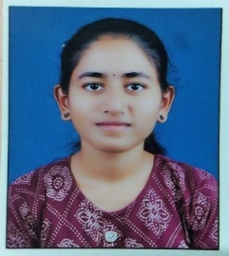
2 | CHASKAR RISHIKA SACHIN | 85.77 | 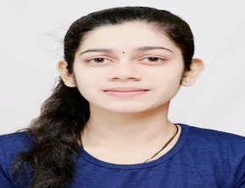
3 | KHAN MOHD AASIM SAJID | 83.93 | 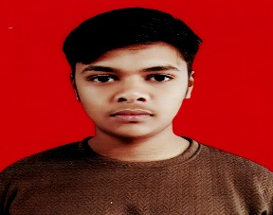

Departmental Events
Guest Lectures

Expert Lecture No.:-1
Name of Topic: “Cyber Crime and Secured use of Social Media Platforms”
Date: 05 Oct. 2023 2:00 PM
Conducted By: Mr. Shankar Mane, Software Developer, Proazure Software Solutions Pvt. Ltd.
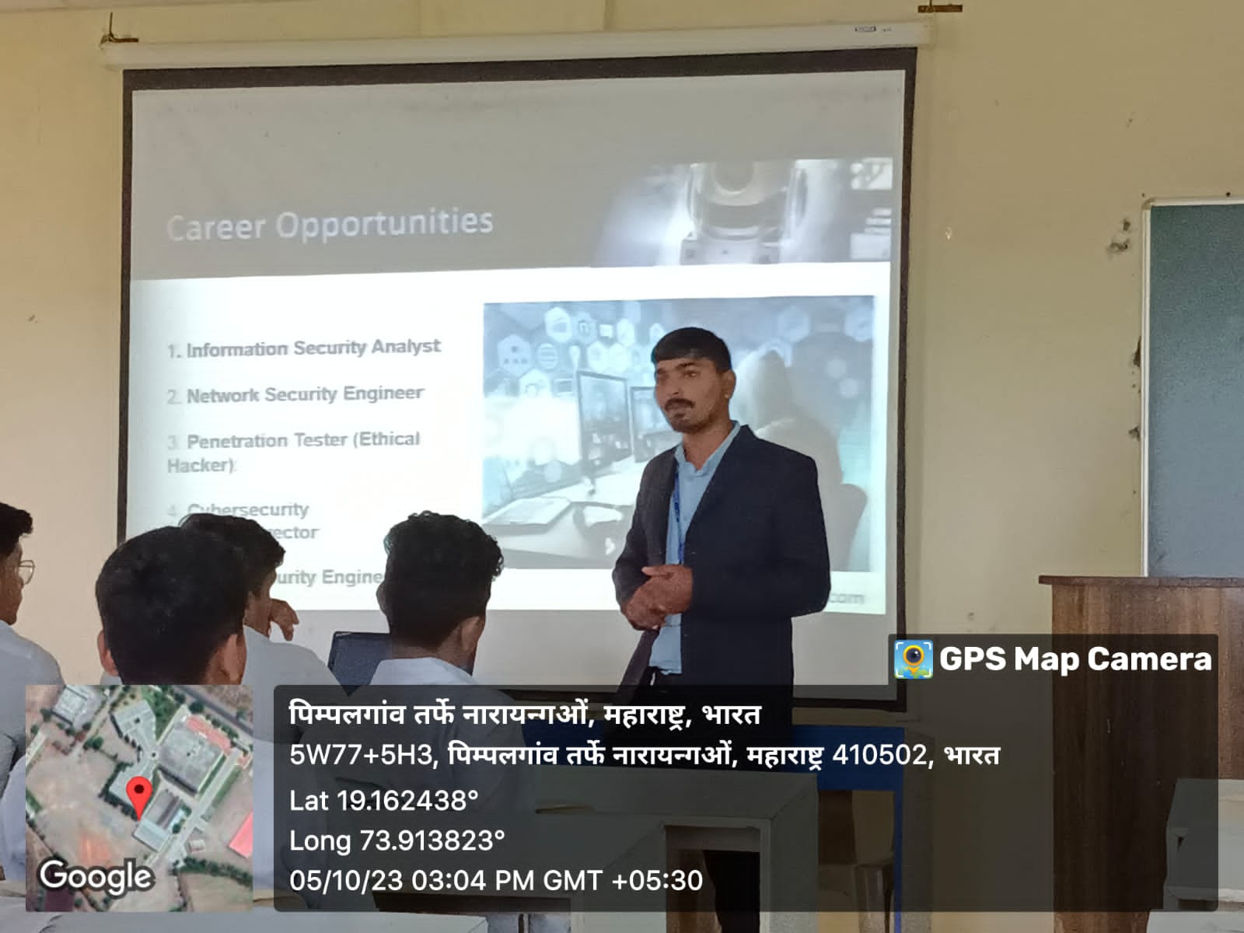
Detail of Guest Lecturer:

The Guest Lecture was arranged for the students of first Year IF engineering on
the topic of “Cyber Crime and Secured use of Social Media Platforms” on 05
Oct 2023. The speaker for the session was Mr. Shankar Mane, Software
Developer, Proazure Software Solutions Pvt. Ltd.

This Guest Lecture is structured into Sections and topic wise, starting from the
basic Cyber Crime Means what is cyber Crime, Causes of cybercrime, what is
the percussion of that and secured use of Social Media platforms. Next covered
the cyber thread and its causes for us.
At the conclusion of this expert Lecture, students have good knowledge about
Cyber Crime and Secured use of Social Media and focused on teaching student how
to stop cybercrime.to

Expert Lecture No:-2
Name of Topic:- “Decoding the Matrix: Unveiling the Thrill of a Career in Information Technology”
Date:- 05 March 2024 12:30 PM
Conducted by Mr. Prasad Pawar, Program Manager, Sumago Infotech Pvt. Ltd.

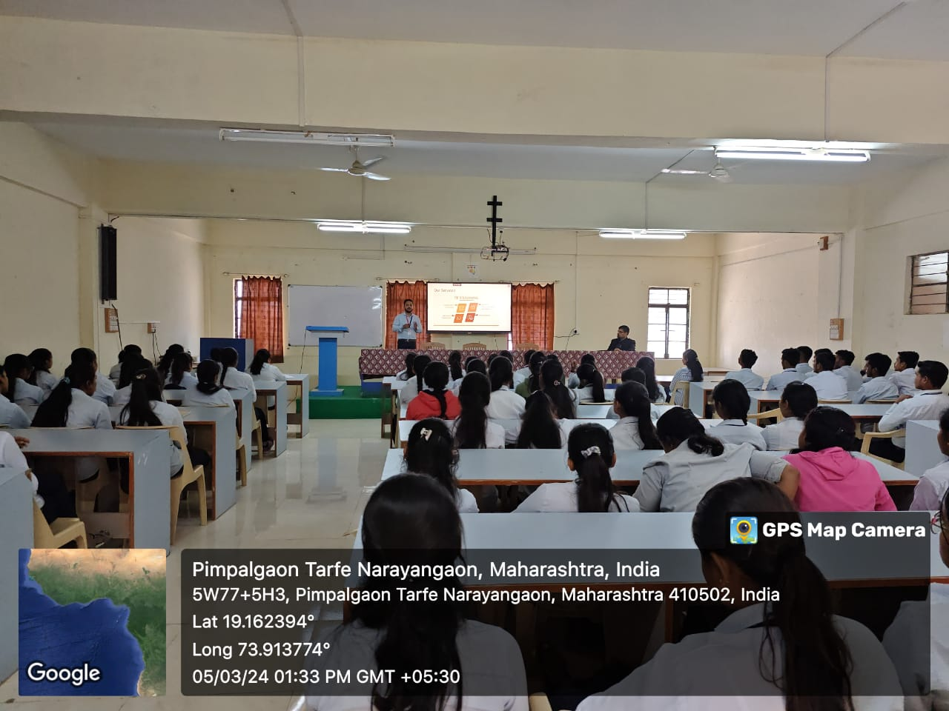

Detail of Guest Lecturer:

The Guest Lecture was arranged for the students of First Year IT on the Topic
of “Decoding the Matrix: Unveiling the Thrill of a Career in Information
Technology” on 5th March 2024.The speaker for the session was Mr. Prasad
Pawar, Program Manager, Sumago Infotech Pvt. Ltd.
This Guest Lecture is structured into Sections and topic-wise, starting from the
basic Decoding the Matrix. Next covered the Unveiling the thrill and its causes for
us. Students are unaware about Unveiling the thrill So, This all information are
very informative to our students and very useful in future life.
At the conclusion of this expert lecture, students have good knowledge
about Decoding Matrix - Unveiling the thrill.

Industrial Visit:
Venue: Reva Tech Software Solution Pvt.Ltd. at Manchar
Date: 15/02/2024
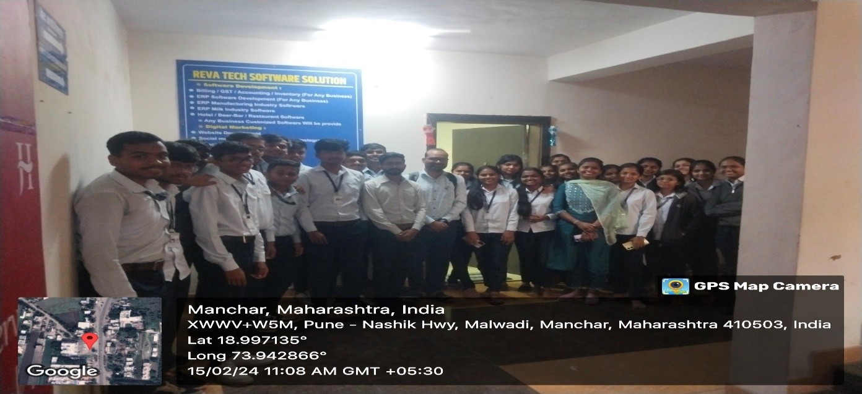
Venue: Smart Tech Software Solution Pvt.Ltd. at Manchar
Date: 15/02/2024
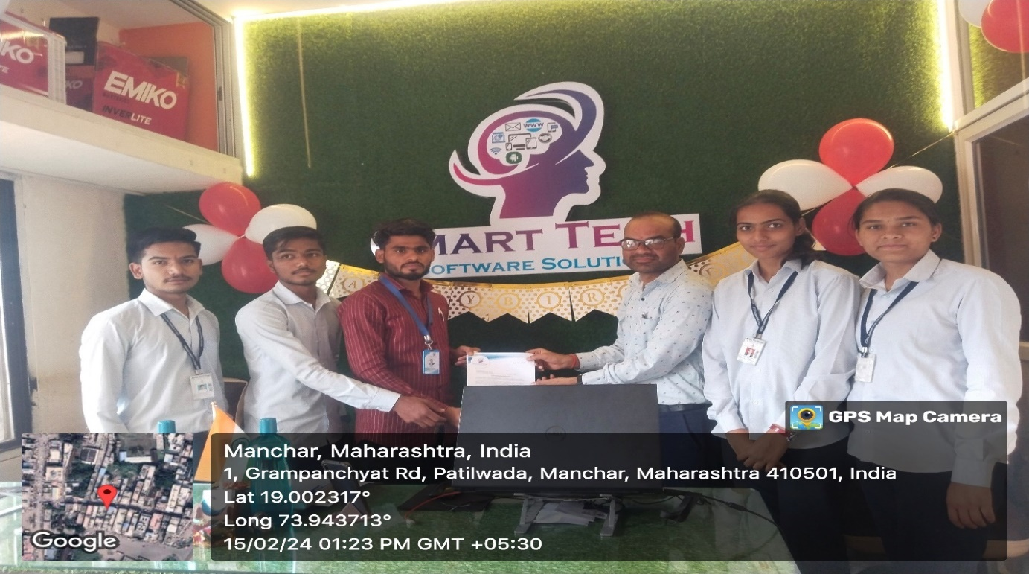

Social Activity
Swachhta Abhiyan
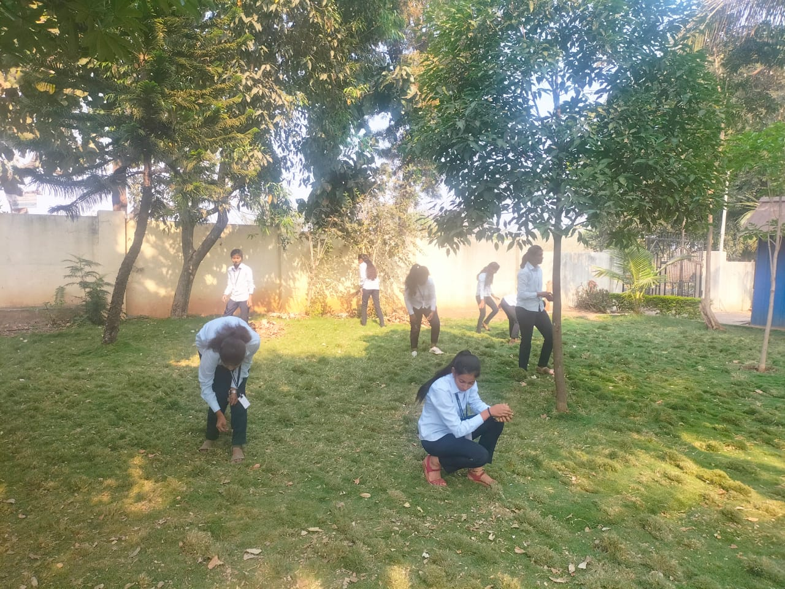
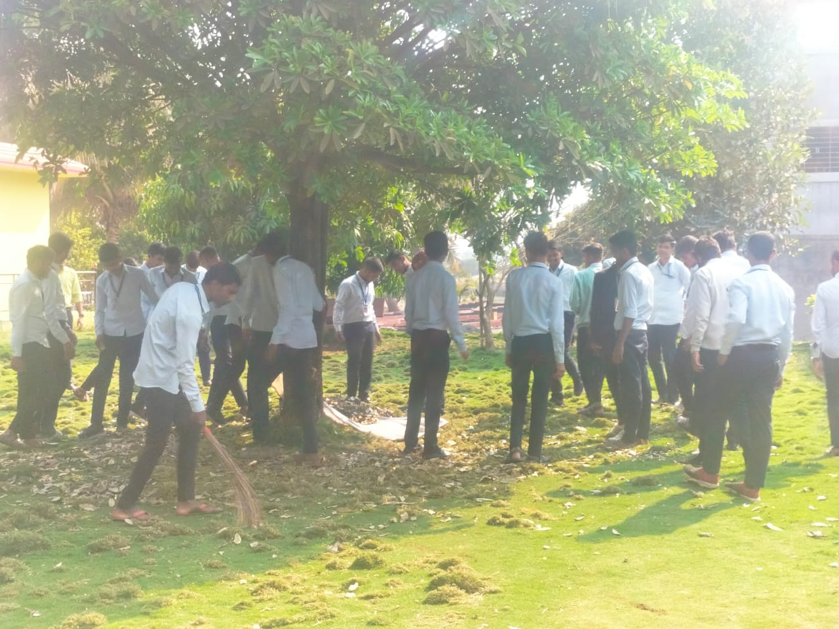

Blood Donation Camp
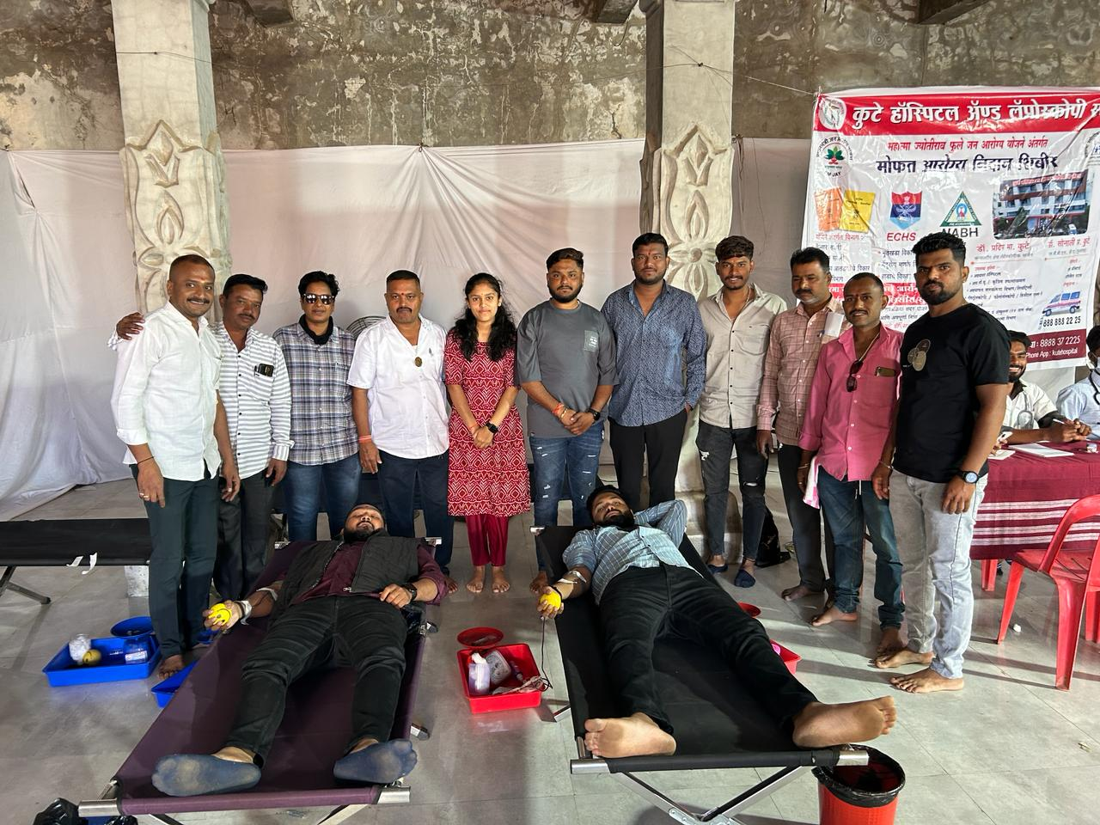
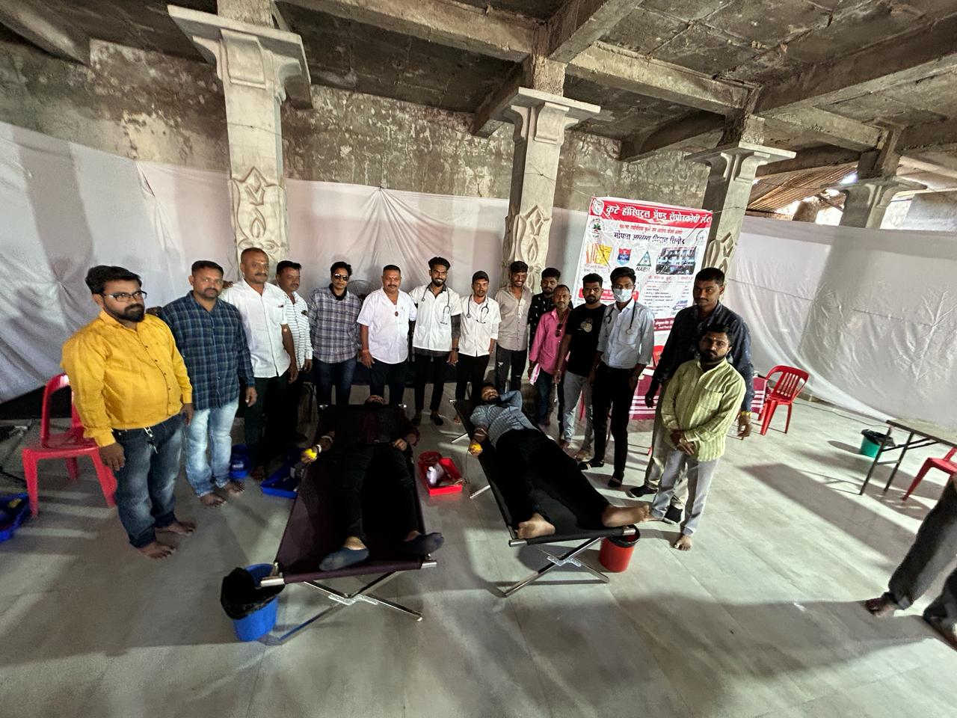

Co-Curricular Activity

Sr. No. | Types of Activity & Details  (Paper Presentation / Project / Quiz / Etc.) | Date | Name of Participating Student | Organizing Body And Organizing Institute | Awards (Winner / Participation)
1 | QUIZ COMPETITION | 07-03-2024 | GAWADE SAI RAJARAM | JAIHIND POLYTECHNIC KURAN | Participation
2 | QUIZ COMPETITION | 07-03-2024 | GAWADE OM | JAIHIND POLYTECHNIC KURAN | Participation
3 | QUIZ COMPETITION | 07-03-2024 | GUNJAL ESHWARI DNYANESHWAR | JAIHIND POLYTECHNIC KURAN | Participation
4 | QUIZ COMPETITION | 07-03-2024 | SARAVADE VAISHNAVI BABURAO | JAIHIND POLYTECHNIC KURAN | Participation
5 | QUIZ COMPETITION | 07-03-2024 | DURGUDE KIRTI SANTOSH | JAIHIND POLYTECHNIC KURAN | Participation
6 | QUIZ COMPETITION | 07-03-2024 | MEHER PRIYA RAHUL | JAIHIND POLYTECHNIC KURAN | Participation
7 | QUIZ COMPETITION | 07-03-2024 | DURAFE KOMAL DEEPAK | JAIHIND POLYTECHNIC KURAN | Participation
8 | QUIZ COMPETITION | 07-03-2024 | GUNJAL SAKSHI SANTOSH | JAIHIND POLYTECHNIC KURAN | Participation
9 | QUIZ COMPETITION | 07-03-2024 | JORI SHRAWANI GANESH | JAIHIND POLYTECHNIC KURAN | Participation
10 | CODE BUILDER | 07-03-2024 | SARVADE UTKARSHA RAJENDRA | JAIHIND POLYTECHNIC KURAN | Participation
11 | CODE BUILDER | 07-03-2024 | RATHOD SHRIKANT SURESH | JAIHIND POLYTECHNIC KURAN | Participation

Extra-Curricular Activity
Sr. No. | Types of Activity & Details  (Sports / Drama / Social / NSS Etc.) | Date | Name of Participating Student | Organizing Body And Organizing Institute | Awards (Winner / Participation)
1 | SPORT - KHOKHO | 23-01-2024 | GANJAVE SIDDHESH SHANTARAM | IEDSSA D1,JAIHIND POLYETCHNIC KURANORGANISING COMMITTEE | Runner Up
2 | SPORT - BADMINTON | 02-02-2024 | BIDKAR ANUSHKA DEEPAK | IEDSSA D1,AJEENKYA DY PATIL SCHOOL OF ENGG CHAROLI | Runner Up
3 | SPORT- WEIGHTLIFTING | 05-02-2024 | CHASKAR KUNAL DATTATRAY | IEDSSA D1,RAJGAD DNYAPEETH TECHNICAL CAMPUS POLYETCHNIC BHOR | Runner Up
4 | SPORT- CARROM | 07-02-2024 | WALSE ABHINANDAN DINESH | IEDSSA D1, SAU. VENU TAI CHAVA POLYTECHNIC | Runner Up
5 | SPORT- CHESS | 07-02-2024 | GUNJAL ESHWARI DNYANESHWAR | IEDSSA D1,JSPM POLYTECHNIC TATHAWADE | Paticipation
6 | SPORT- KABADDI | 23-01-2024 | WAMAN SANIKA RAMDAS | IEDSSA D1,JAIHIND POLYETCHNIC KURANORGANISING COMMITTEE | Paticipation
Volume 3, Issue 1

Editorial Team
Faculty Coordinator: K. G. Borhade Student Coordinator: S. R. Gawade

