







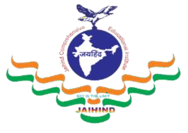
JCEI’s Jaihind Polytechnic, Kuran

Information Technology

Content

Vision and Mission HOD’s Message
Program Educational Objectives (PEOs)
Program Specific Outcomes (PSOs)
Program Outcomes (POs) Departmental Events Faculty Training
Faculty Achievements
Students Achievements
Co-curricular Activities
Extra-curricular Activities
Examination Toppers

Newsletter

To provide quality based technical education and development in Information Technology by adopting the rapid technological advancements in software programming.

M1:To produce quality based technical education and ethically responsible graduates through balanced and dynamic curriculum.
M2: To enhance technical exploration in collaboration with government agencies and higher learning.
M3: To produce technical education for serving and enriching Information Technology.
M4: To explore the recent trends in the field of Information Technology.

HOD’s Message………..
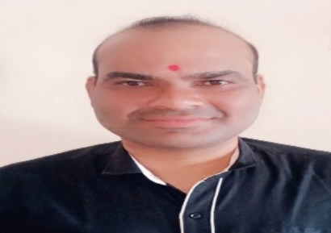
The Information Technology program was started in the year 2023-24 with intake of 60 seats. The main focus of the department is to deliver the professionals with strong and Placement. The department has well equipped and well-furnished 7 labs.
Department of Information Technology is prepared to meet the challenges and is playing a leadership role in shaping the education of the 21st Century by providing the lifelong learning and leadership skills to the students that enable them to grow in their professions and advance to positions of responsibility. The main motto of our department is to provide quality education. The process of learning is extremely important in everyone’s life. For that, we provide excellent infrastructure, many values added courses, teaching faculty of the best kind ensuring quality education such as interaction among students, parents and staff ensures a bright future to our students.
The Department also has a departmental library, computer center and seminar hall. The department focuses on the overall fundamentals in Computer Science and Engineering Domain. The department has well qualified and experienced teaching faculty members with various specializations. The department has excellent infrastructure with state-of-the-art equipment and software tools. The activities of the Department are conducted, besides teaching, in the areas of research, consulting, training, alumni and Training development of the students imparting Industry standard skills through Projects and by encouraging Student Association activities and Industrial visits.
I congratulate the team of faculty members and the students for their brilliant and original efforts. I wish all the Students and Faculty a great academic career.

Prof. Tannu R. R. HOD
Information Technology

Program Educational Objectives (PEOs)
PEO1: Adopt IT based technologies for software development, team and schedule management.
PEO2: Analyze, design, restructure and coordinate hardware, networking and information management system.
PEO3: Communicate effectively, work collaboratively and exhibit high level of professionalism and ethical responsibility.

Program Specific Outcomes (PSOs)
PSO 1: Software and Database: Develop, Test and maintain Software and Database by using IT Technologies and Tools.
PSO 2: Hardware and Networking: Maintain, Troubleshoot and provide Hardware and Networking support by applying IT related Standards and Principles.

Program Outcomes (POs)
PO1: Basic and Discipline specific knowledge: Apply knowledge of basic mathematics, science and engineering fundamentals and engineering specialization to solve the engineering problems.
PO2: Problem analysis: Identify and analyze well-defined engineering problems using codified standard methods.
PO3: Design/ development of solutions: Design solutions for well-defined technical problems and assist with the design of systems components or processes to meet specified needs.
PO4: Engineering Tools, Experimentation and Testing: Apply modern engineering tools and appropriate technique to conduct standard tests
PO5: Engineering practices for society, sustainability and environment: Apply appropriate technology in context of society, sustainability, environment and ethical practices.
PO6: Project Management: Use engineering management principles individually, as a team member or a leader to manage projects and effectively communicate about well-defined engineering activities.
PO7: Life-long learning: Ability to analyze individual needs and engage in updating in the context of technological changes.

Departmental Events


Expert Lecture No.:-1
- Name of Topic: “Financial Literacy (Sarthi App)”
- Name of Guest Lecturer: Mr. Amup Mundada
- Date: 6 Sept 2024 12:30 PM

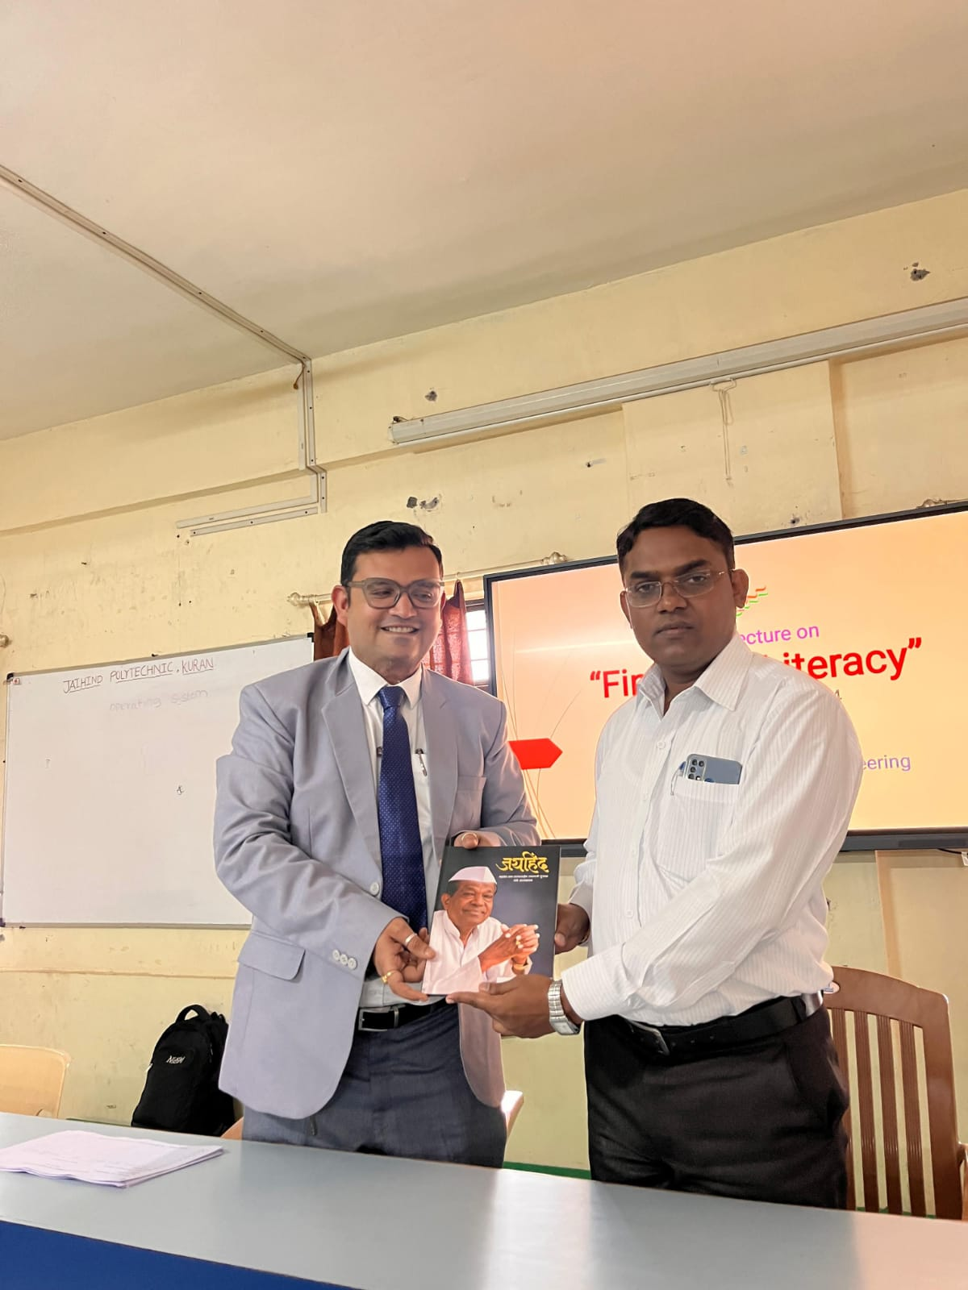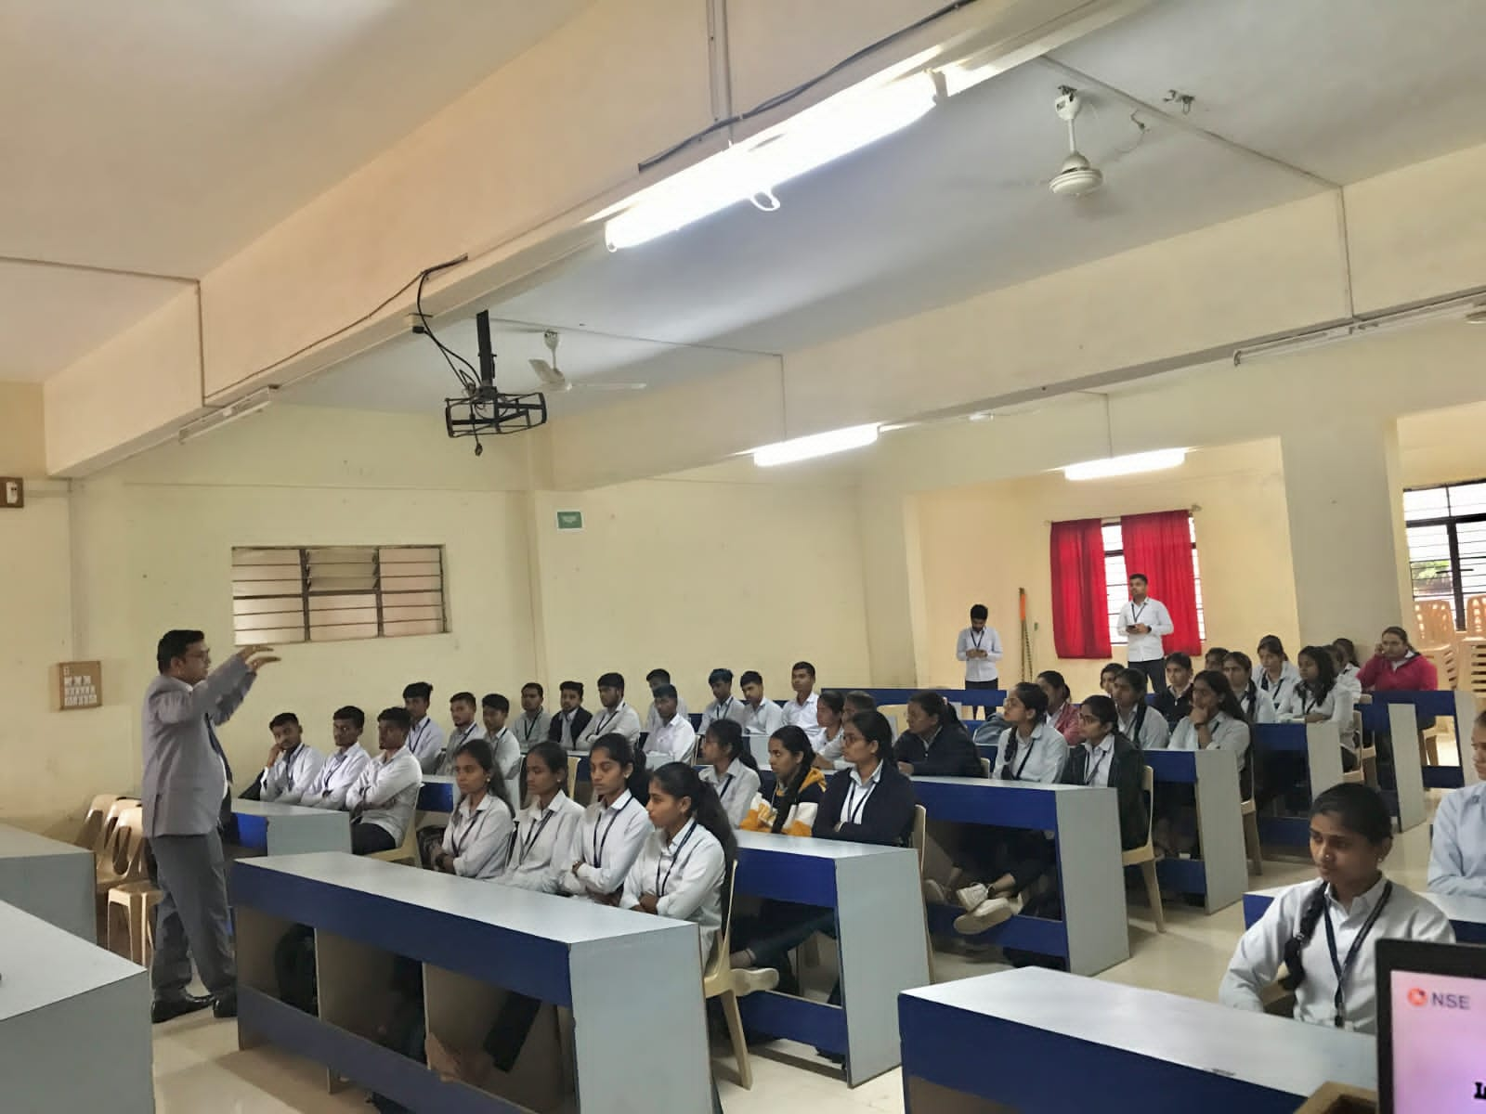

Expert Lecture No.:-2
1)Name of Topic: “Application AI in Industry”
2)Name of Guest Lecturer: Mr. Ketan Sathe
3)Date: 10 Jan. 2025 12:30 PM
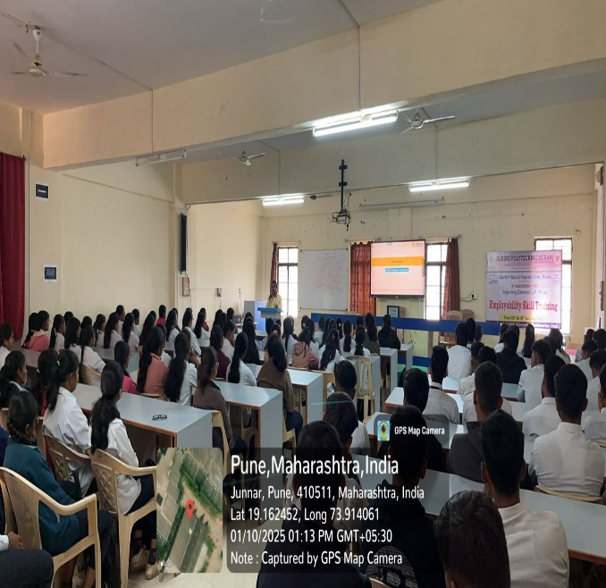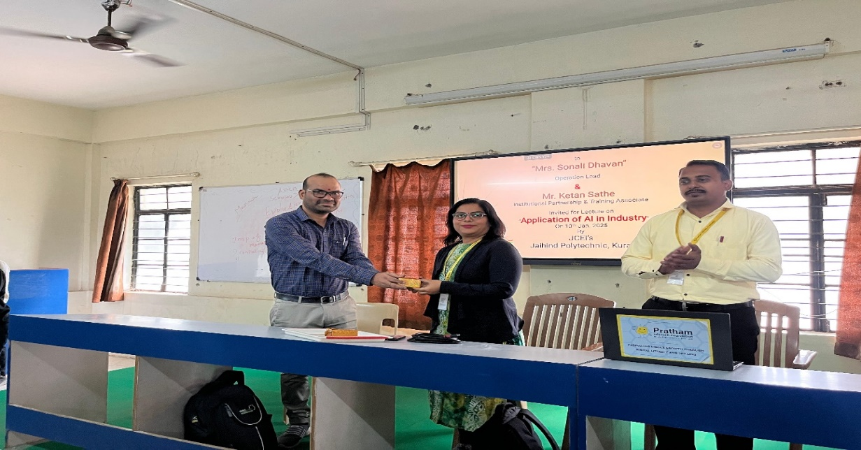

Expert Lecture No.:-3
- Name of Topic: “Use of AI in Web Development”
- Date: 11 Jan. 2025 12:30 PM
- Conducted By: Mr. Yuvraj Hande (CEO, Somayu Infotech)
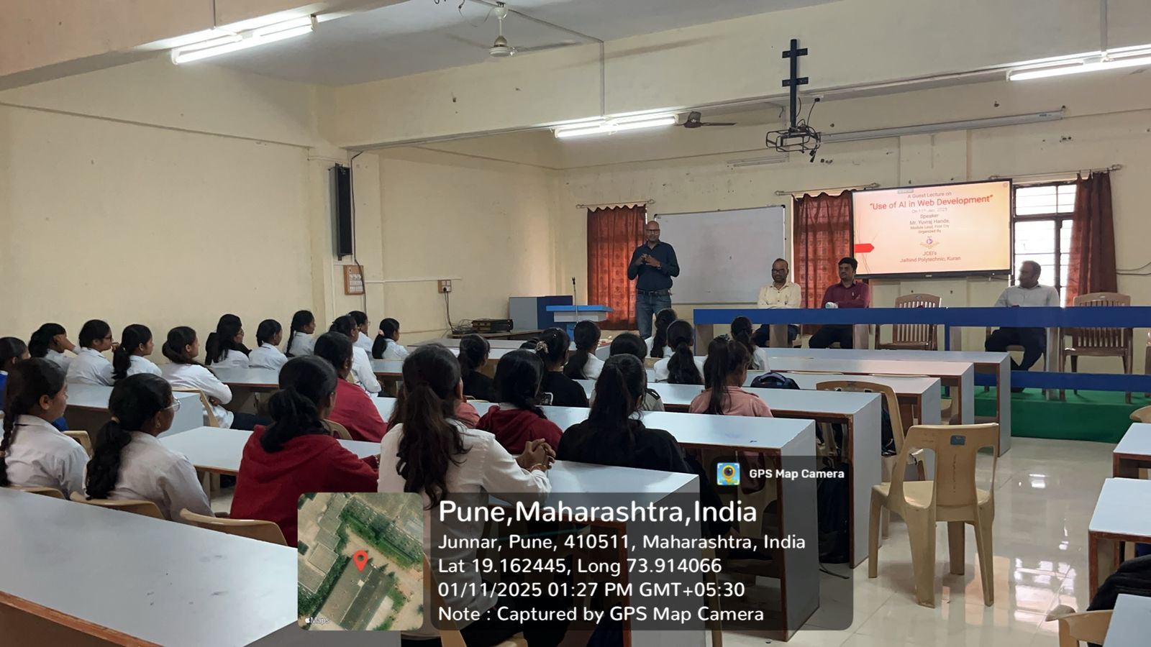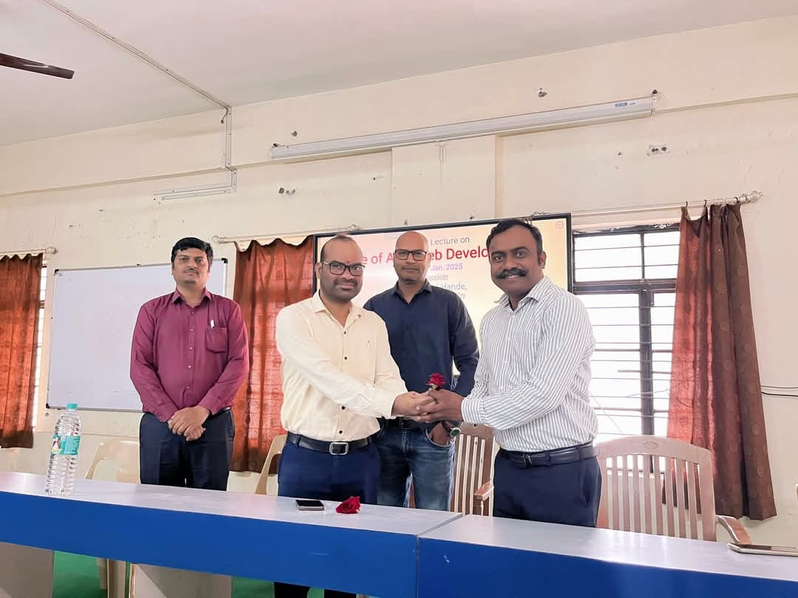

Expert Lecture No.:-4
- Name of Topic: “Career opportunity in Data Science”
- Name of Guest Lecturer: Mr. Atharav Shinde
- Date: 17 March 2025 12:30 PM
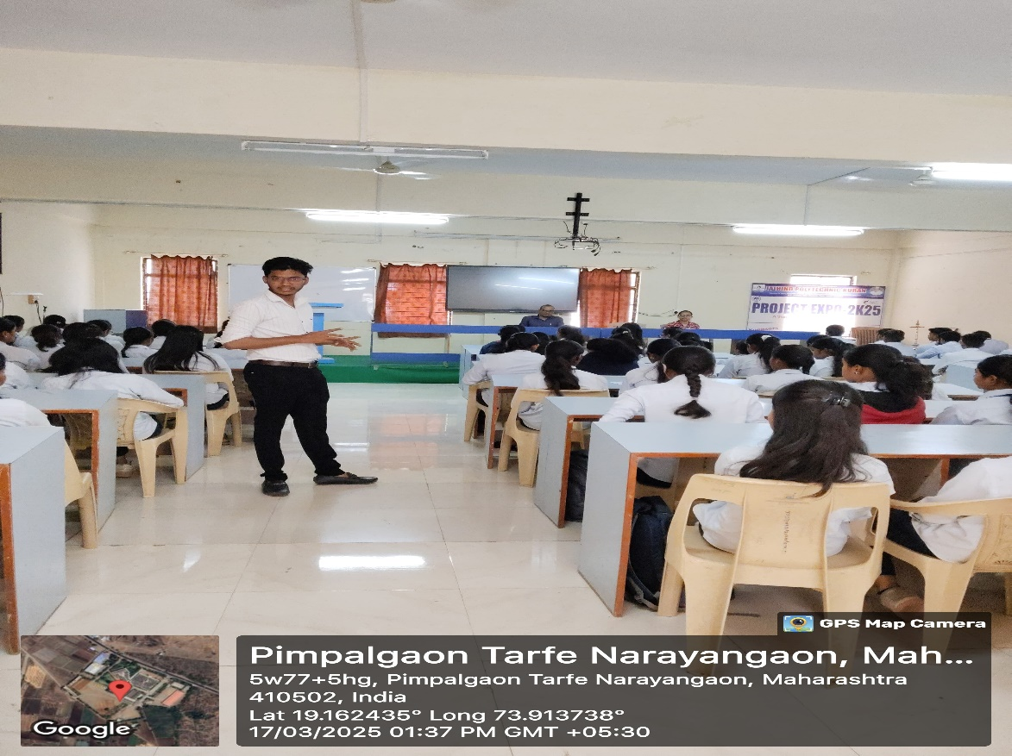
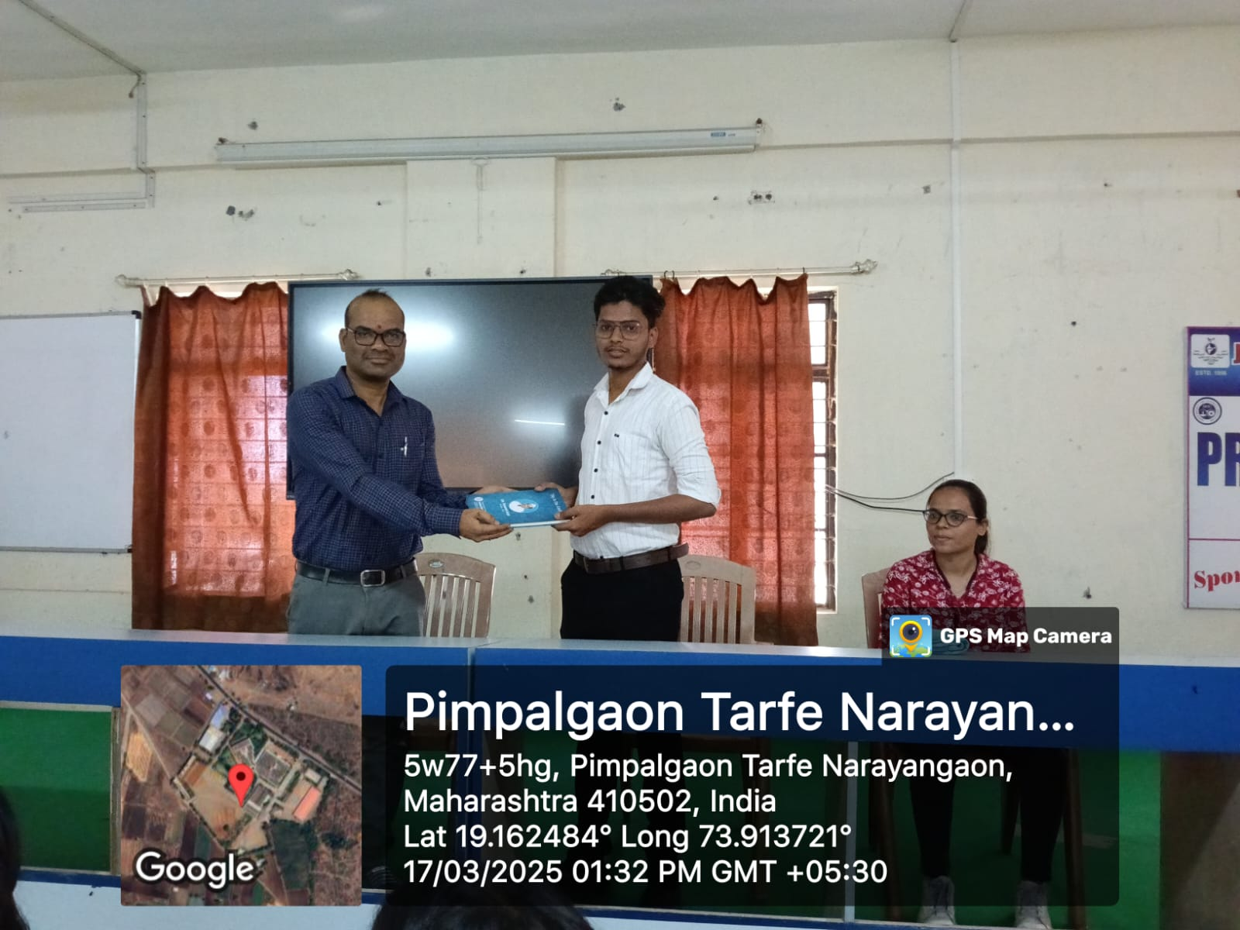

Expert Lecture No.:-5
- Name of Topic: “Emerging trends in IT Industries”
- Name of Guest Lecturer: Mr. Dilip Singh
- Date: 26 March 2025 12:30 PM

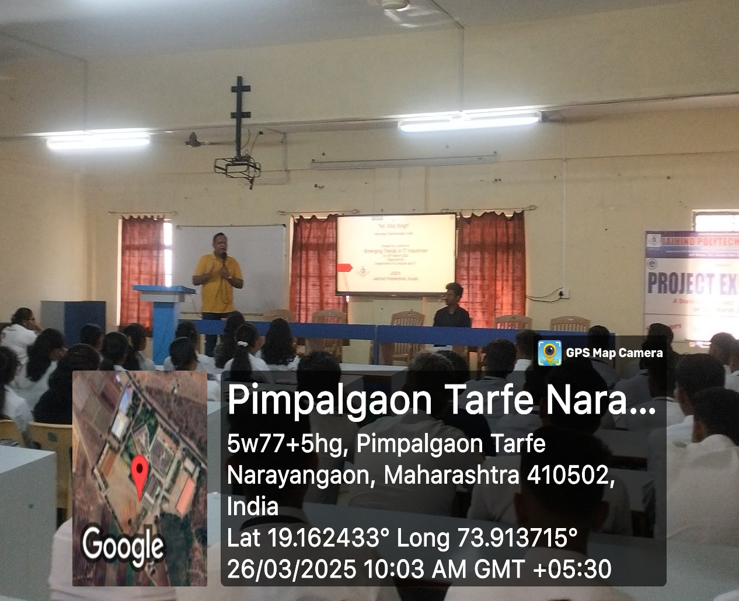
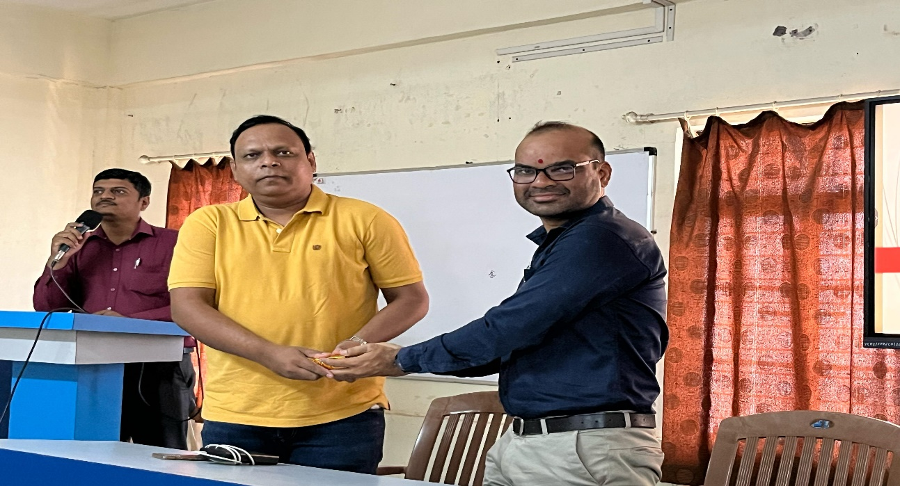

Teachers Day Celebration
Date:- 5th Sept 2024

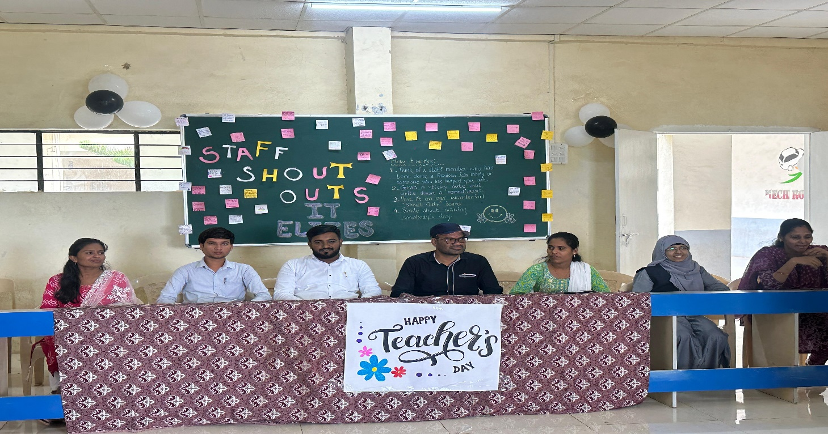
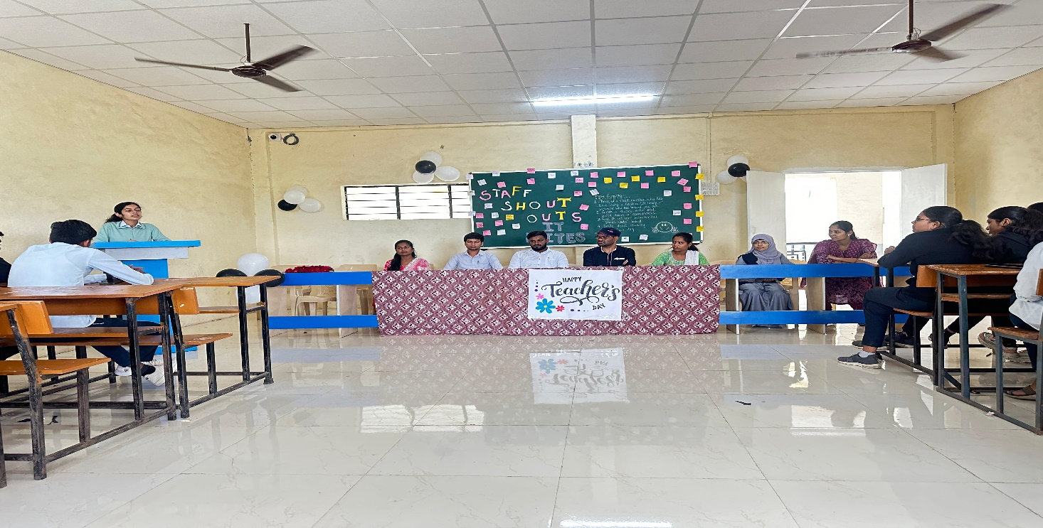

Industrial Visit First
Company Name: Sumago Infotech Pvt. Ltd., Shivajinagar, Pune
Date: 26/09/2024
Name of Staff: Mr. Tannu R. R., Mrs. Borhade K. G., Mrs. Lande R. S., Mr. Tattu S. P.
No. of Students: 60 (SY)

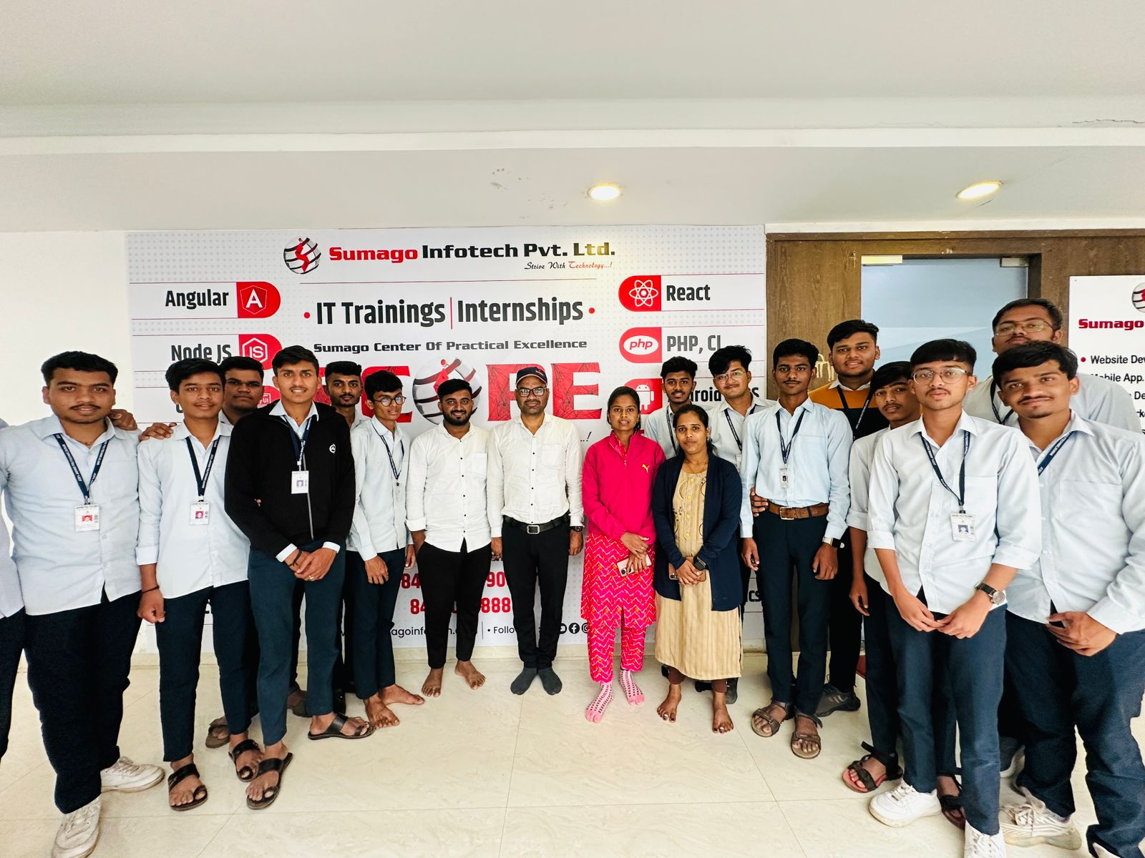
Industrial Visit Second
“Pimpri Chinchwad Science Park”
Date: 26/09/2024
Name of Staff: Mr. Tannu R. R., Mrs. Borhade K. G., Mrs. Lande R. S., Mr. Tattu S. P.
No. of Students: 60 (SY)

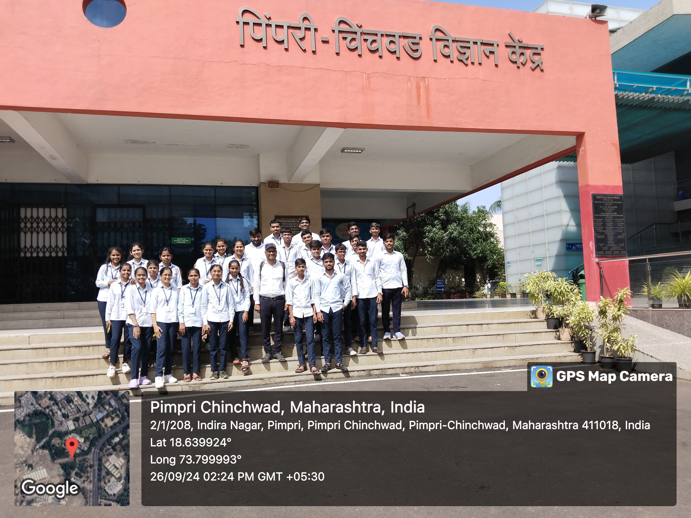

TECHNOPHILIA 2K24-25

Technical Poster Presentation Organized by Information Technology Department on dated 7th Oct -2024

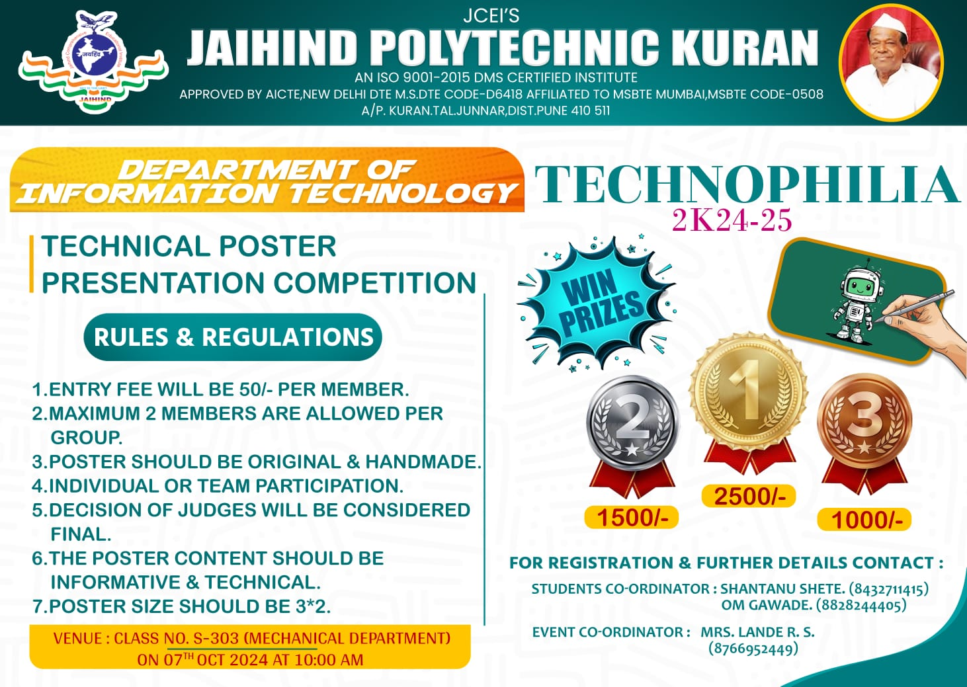

SR NO | EVENT NAME | EVENT COORDINATOR | NO. OF PARTICIPATED GROUP
1. | TECHNICAL POSTER PRESENTATION  (I.T. DEPT.) | Mrs. LANDE R. S. | 93 ENTRIES  (RS. 50 PER STUDENT)

INAUGURATION CEREMONY: -
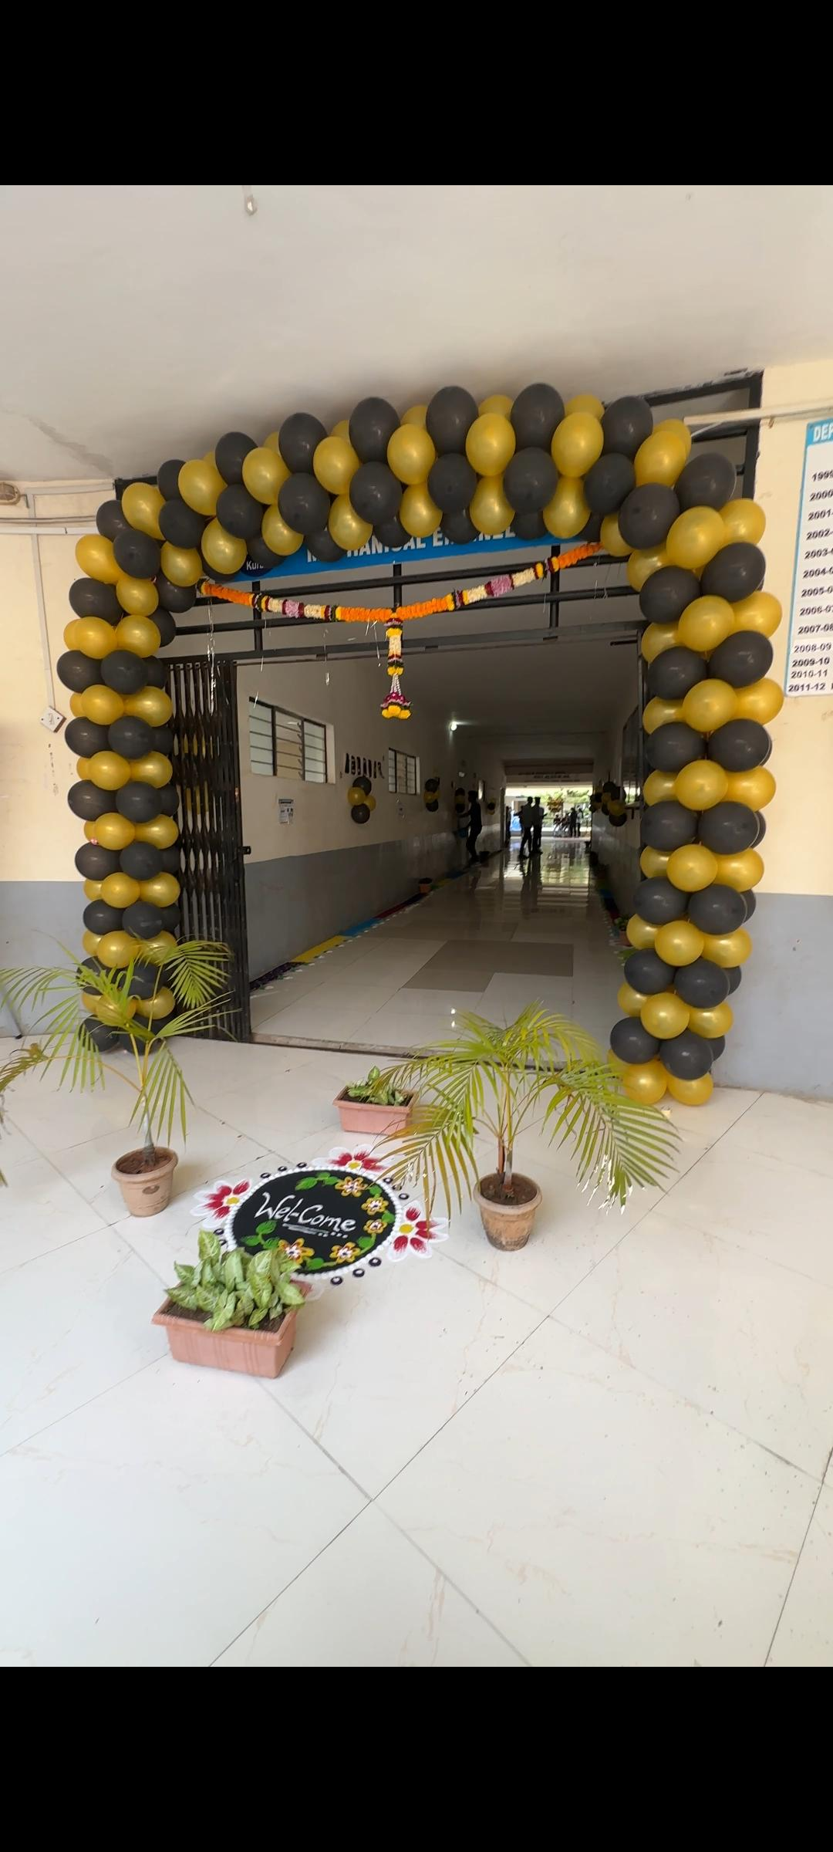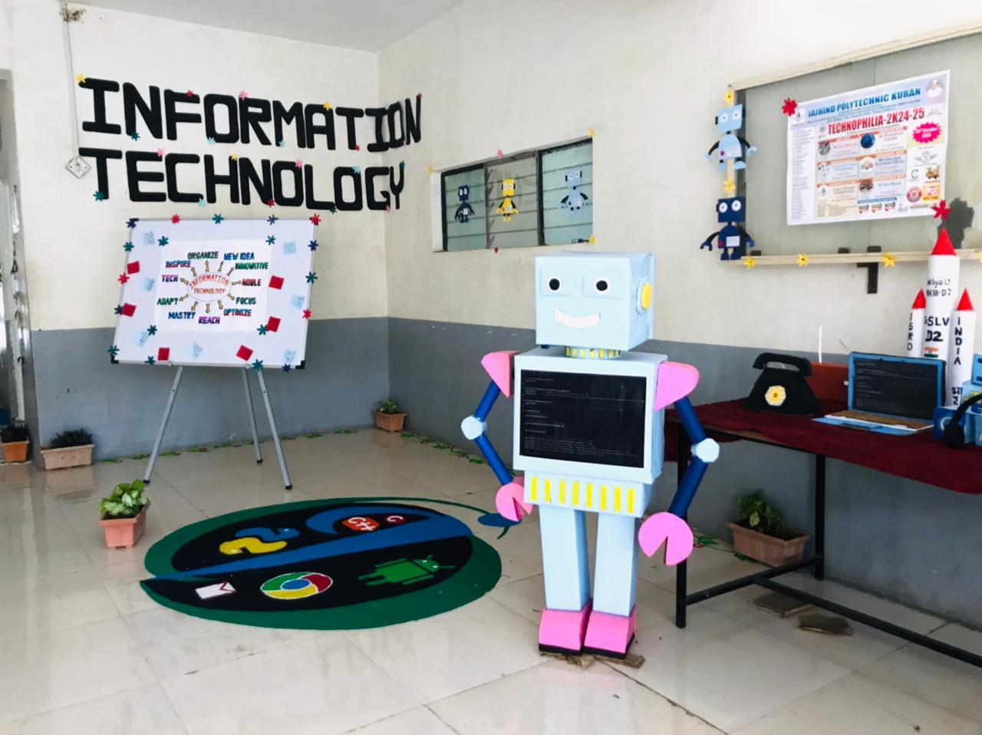

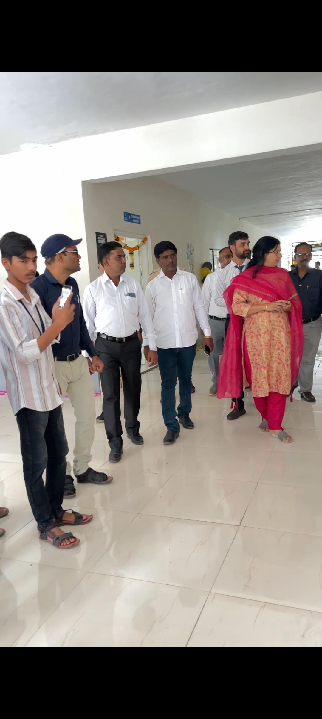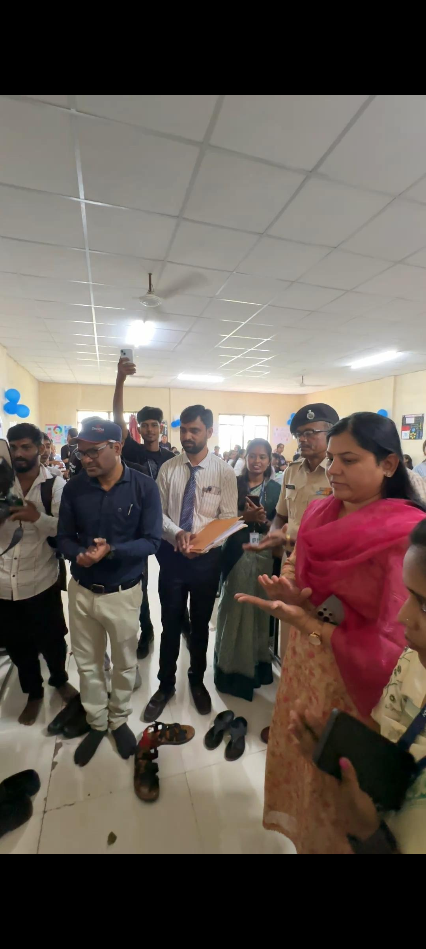

Sr. No. | Name of  faculty / staff | Details of Training (Industrial / Content Updating / Soft Skill Any Other) | Duration of Training (schedule) | Organizing Body | Organizing Institute
1 | Mr. Tannu R. R. | Artificial Intelligence and Machine Learning in industry | 18/10/2024 to 19/10/2024 | Dept. of Computer Engineering | SPM Polytechnic Kumathe Solapur
2 | Ms. Lande R. S. | Artificial Intelligence and Machine Learning in industry | 18/10/2024 to 19/10/2024 | Dept. of Computer Engineering | SPM Polytechnic Kumathe Solapur
3 | Ms. Lande R. S. | Recent Trend in Electric Vehicle and Artificial Intelligence | 23/1/2025 to 24/1/2025 | Dept. of Electrical Engineering | Marathwada IOT (Polytechnic) Chhatrapati Sambhajinagar
4 | Ms. Lande R. S. | NBA Awareness | 27/1/2025 To 31/1/2025 | Dept. of Mechanical Engineering | DY Patil School of Engineering (Polytechnic)Charholi (Bk) via Lohegaon Pune
5 | Ms. Borhade K. G. | NBA Awareness | 27/1/2025 To 31/1/2025 | Dept. of Mechanical Engineering | DY Patil School of Engineering (Polytechnic), Charholi (Bk) via Lohegaon Pune
6 | Ms. Lande R. S. | Data Analytics for Smart Mobility | 03/02/2025 To 08/02/2025 | College Engineering and Technology | AICTE Training and Learning (ATAL) Academy
7 | Ms. Lande R. S. | Advances in Engineering and Technology | 10/02/2025 To 14/02/2025 | Dept. of Mechanical Engineering | Vishwabharti Academy's COE, Ahilyanagr
8 | Ms. Lande R. S. | Road Map to NBA Accreditation | 11/02/2025 To 12/02/2025 | Dept. of Computer Engineering | JCEI'S Jaihind Polytechnic Kuran
9 | Ms. Borhade K. G. | Road Map to NBA Accreditation | 11/02/2025 To 12/02/2025 | Dept. of Computer Engineering | JCEI'S Jaihind Polytechnic Kuran
10 | Mr. Tannu R. R. | Road Map to NBA Accreditation | 11/02/2025 To 12/02/2025 | Dept. of Computer Engineering | JCEI'S Jaihind Polytechnic Kuran
11 | Ms. Kedari V. K. | Road Map to NBA Accreditation | 11/02/2025 To 12/02/2025 | Dept. of Computer Engineering | JCEI'S Jaihind Polytechnic Kuran

Faculty Training

Faculty Achievement
Book Publication:
Prof. Tannu R. R has published book for second year diploma students.
Book Name: “Data Structure Using C”
Publication: “Study Max Publication”
Date:15/07/2024
ISBN No:-978-81-975231-0-6
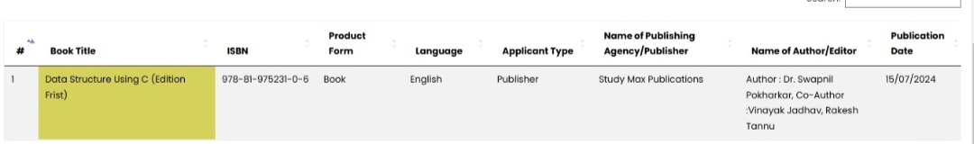
Paper Publication:
Prof. Tannu R. R has published two papers.
Published Paper on, “Enabling Identity-based Integrity Auditing and Data Shearing with Sensitive Information Hiding for secure Cloud Storage” in the International Journal of Emerging Technologies and Innovative Research, ISSN NO: 2583-0554 Certified Journal, Vol- 4, Issue – 10, October 2024.
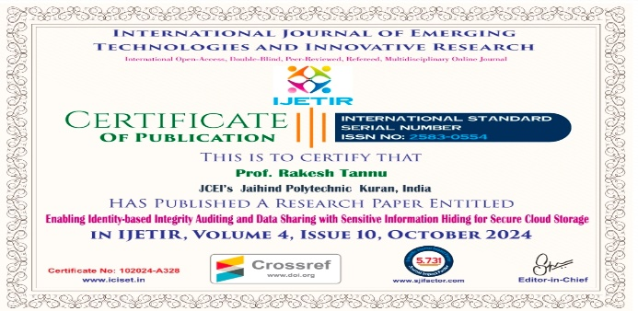

Published Paper on, “Secure Digital Voting System based on Blockchain Technology” in the International Journal of Advanced Research in Science, Communication and Technology, ISSN NO: 2581-9429 Certified Journal, Vol- 4, Issue – 3, October 2024.
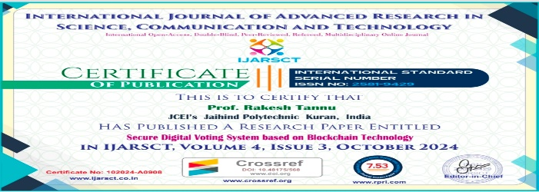

Students Achievements

Bhalekar Samadhan student of Second year Information Technology, Jaihind Polytechnic won 1st prize in State level Circuit Making Competition Organized by Jaihind College of Engineering 01/03/2025.

Co-curricular Activities
TECHNOLOPHILIA 2K24-Technical Poster Presentation
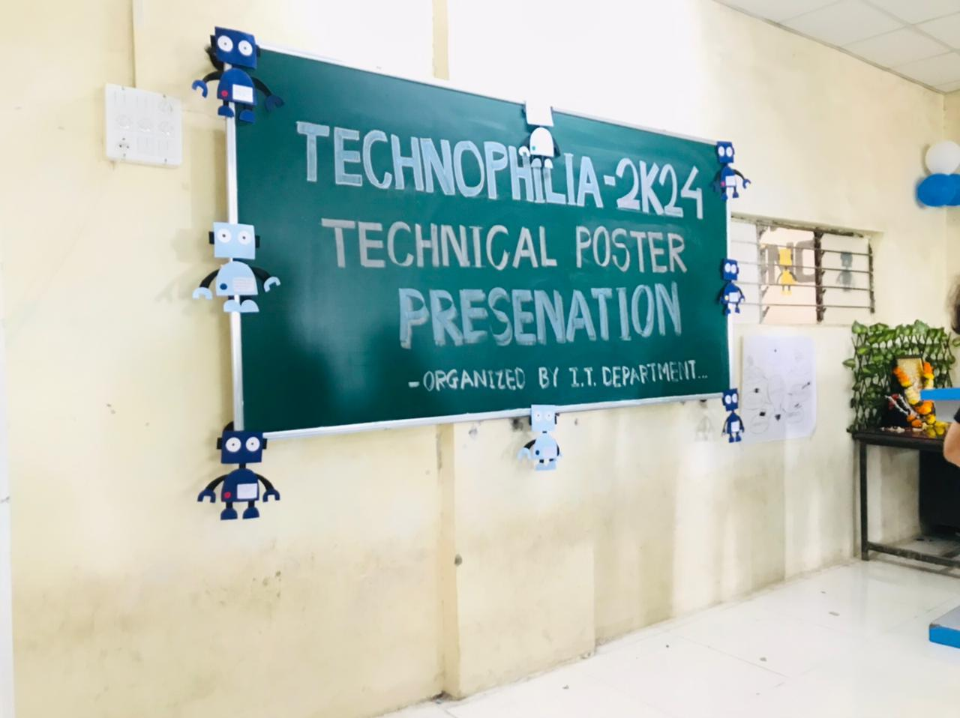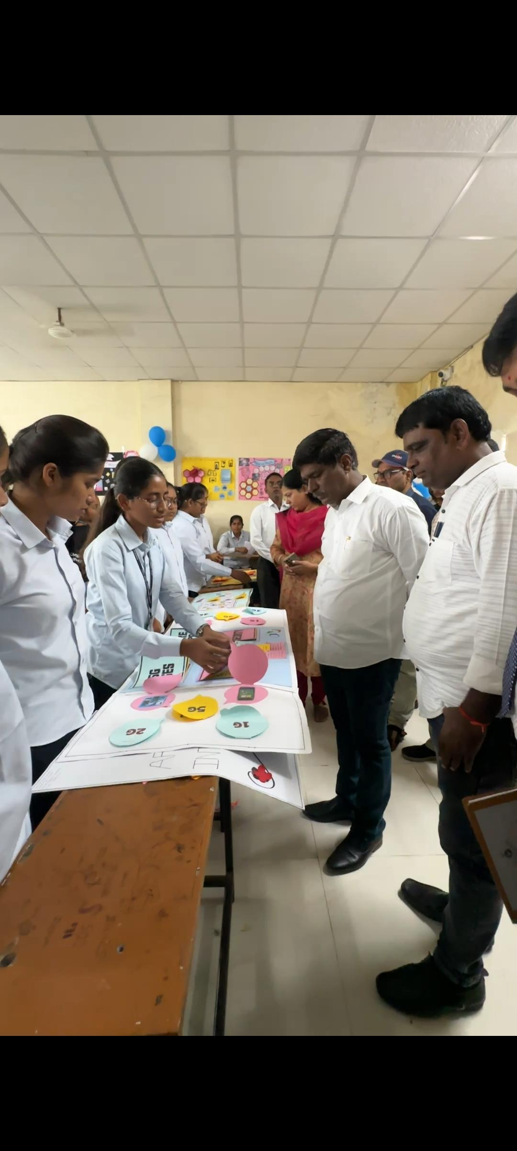

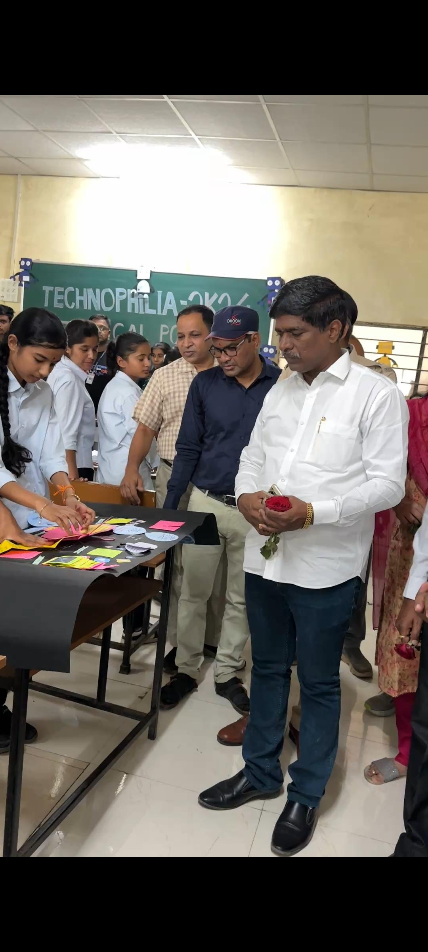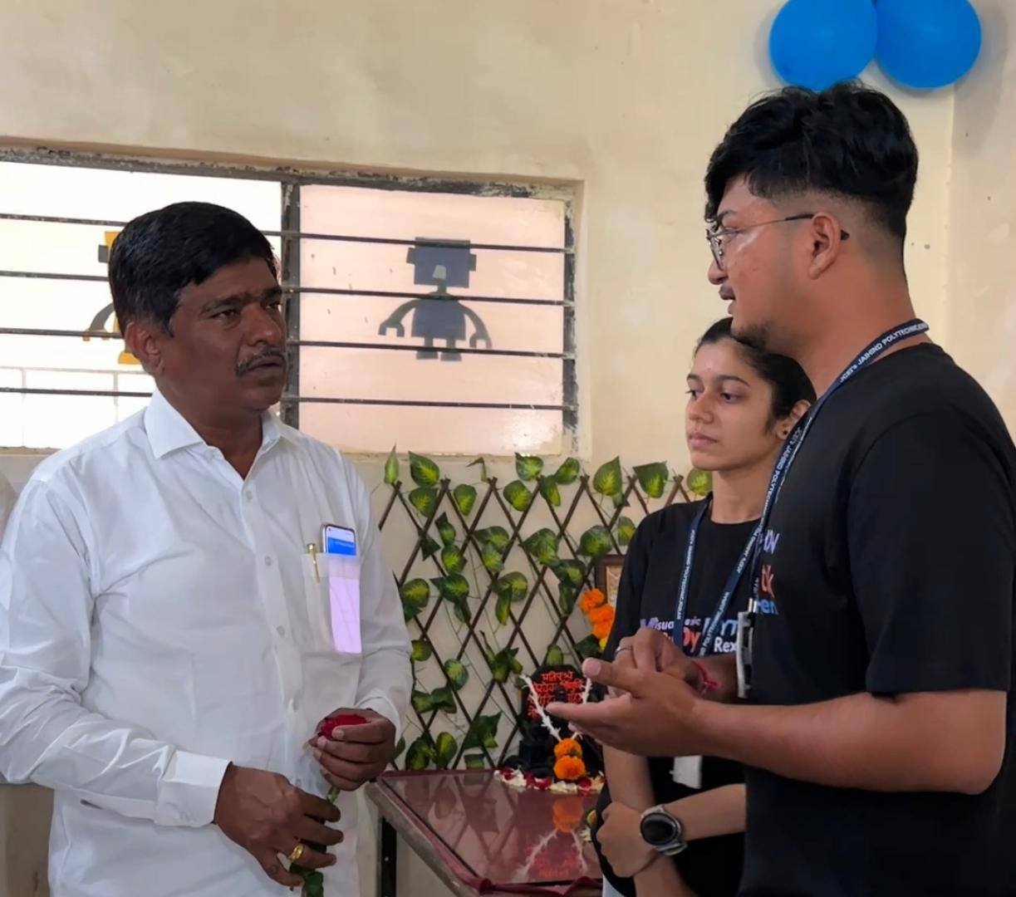

Sample Certificates
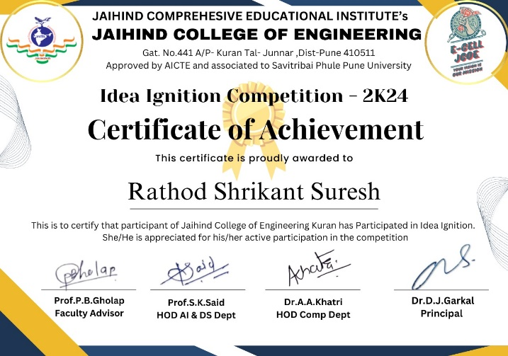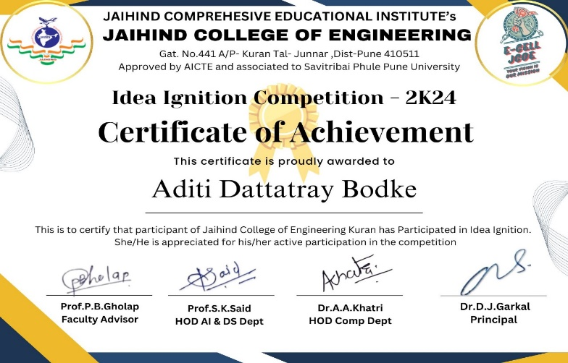

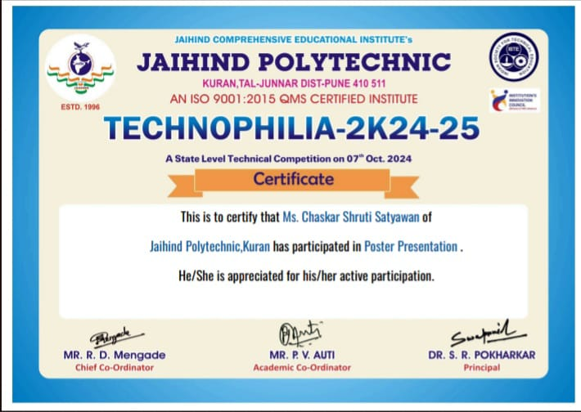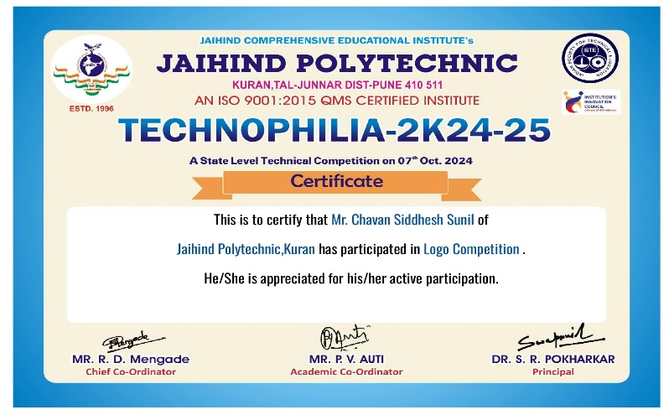

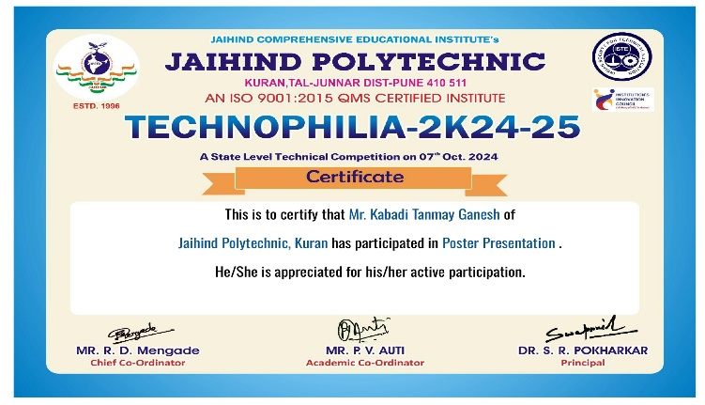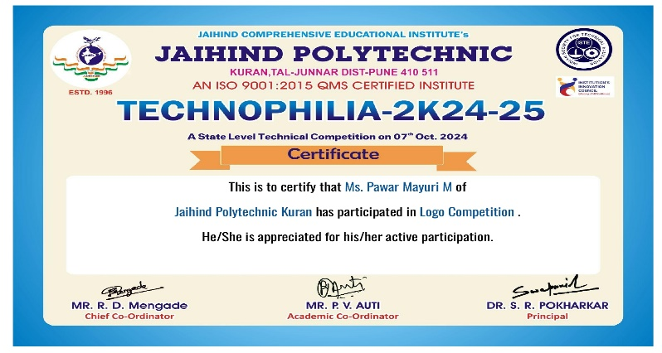

Extra-Curricular Activities

Zonal Sports-D1 Zone IEDSSA Achievements
- Winner Team in Inter Zonal for Volleyball
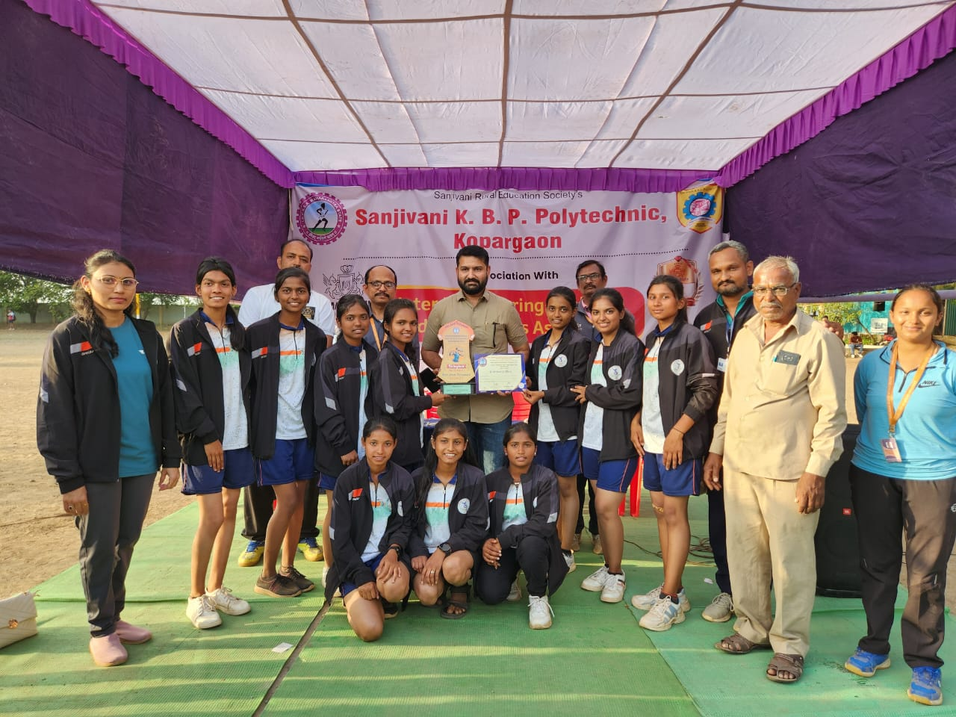

- Winner Team in Zonal for Volleyball
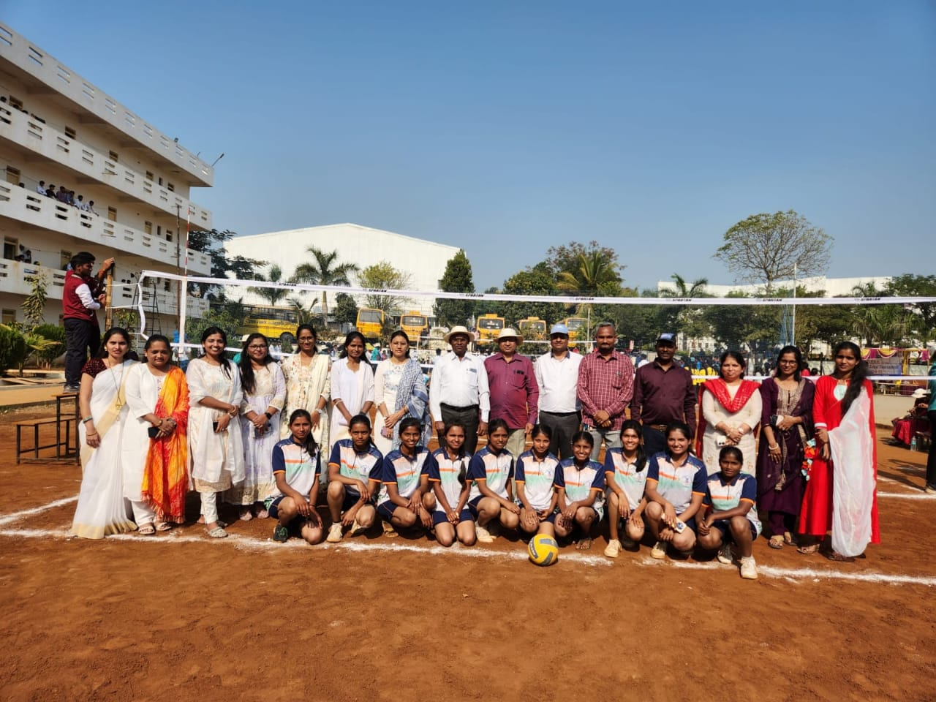

- Runner-up in Cricket
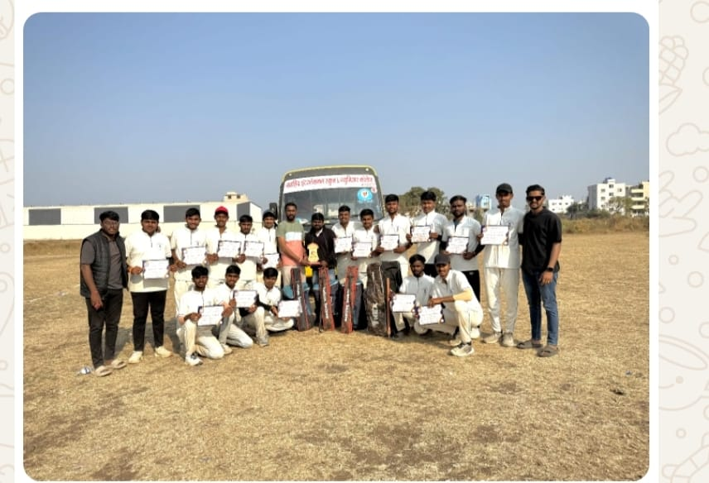

- Winner Team in KhoKho

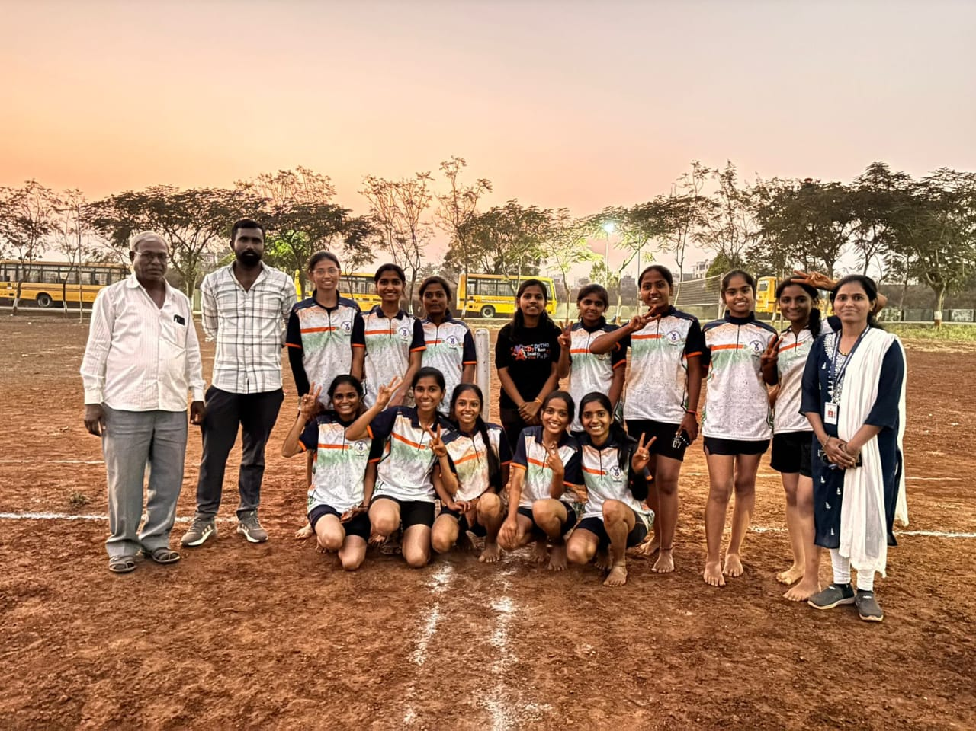

- Winner Team in Football

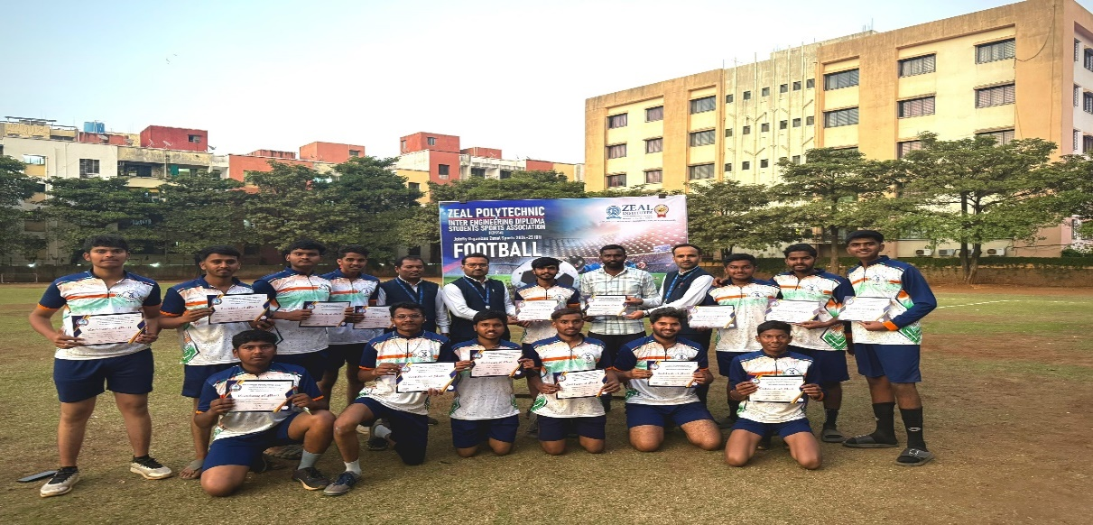

- Runner up in Weightlifting

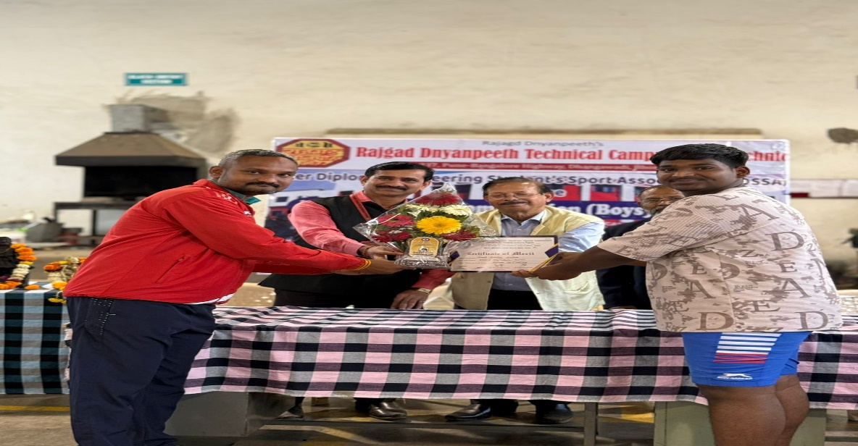

- Winner in Carrom

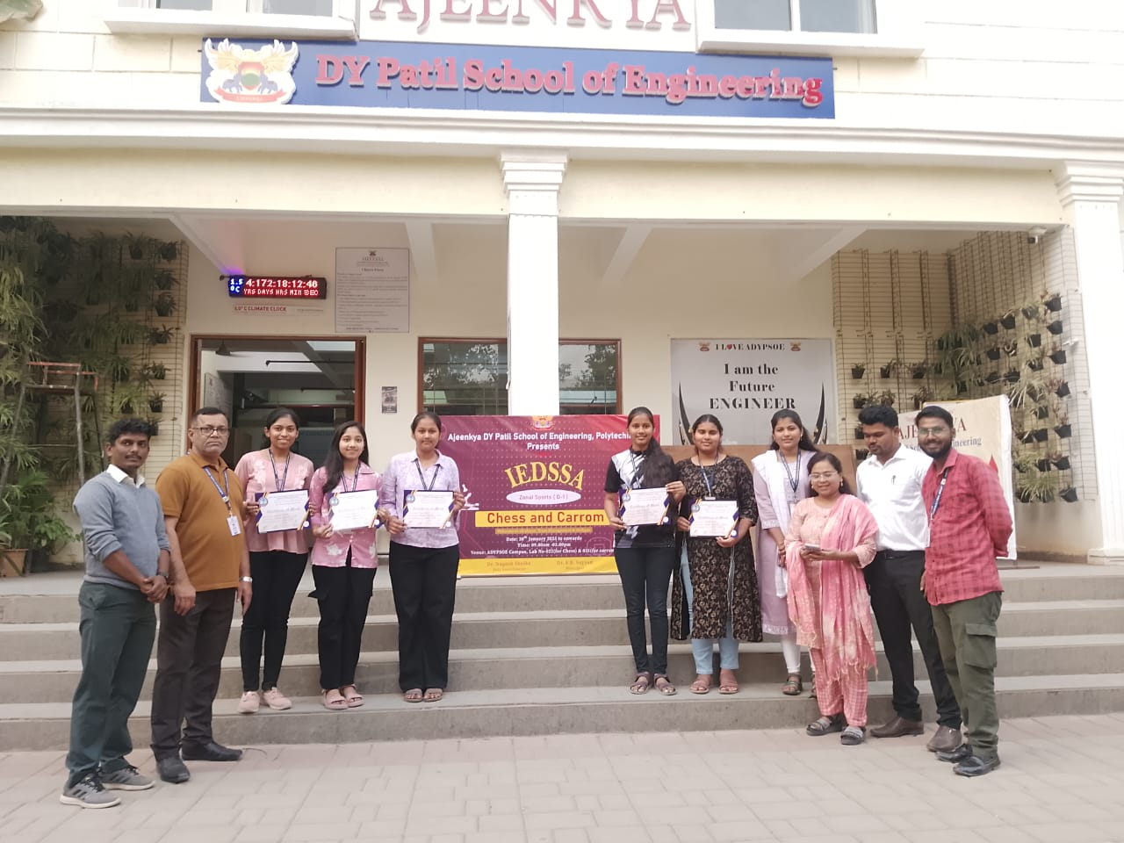

NSS Activity 1
Special Labor Camp on dated 08/02/2025
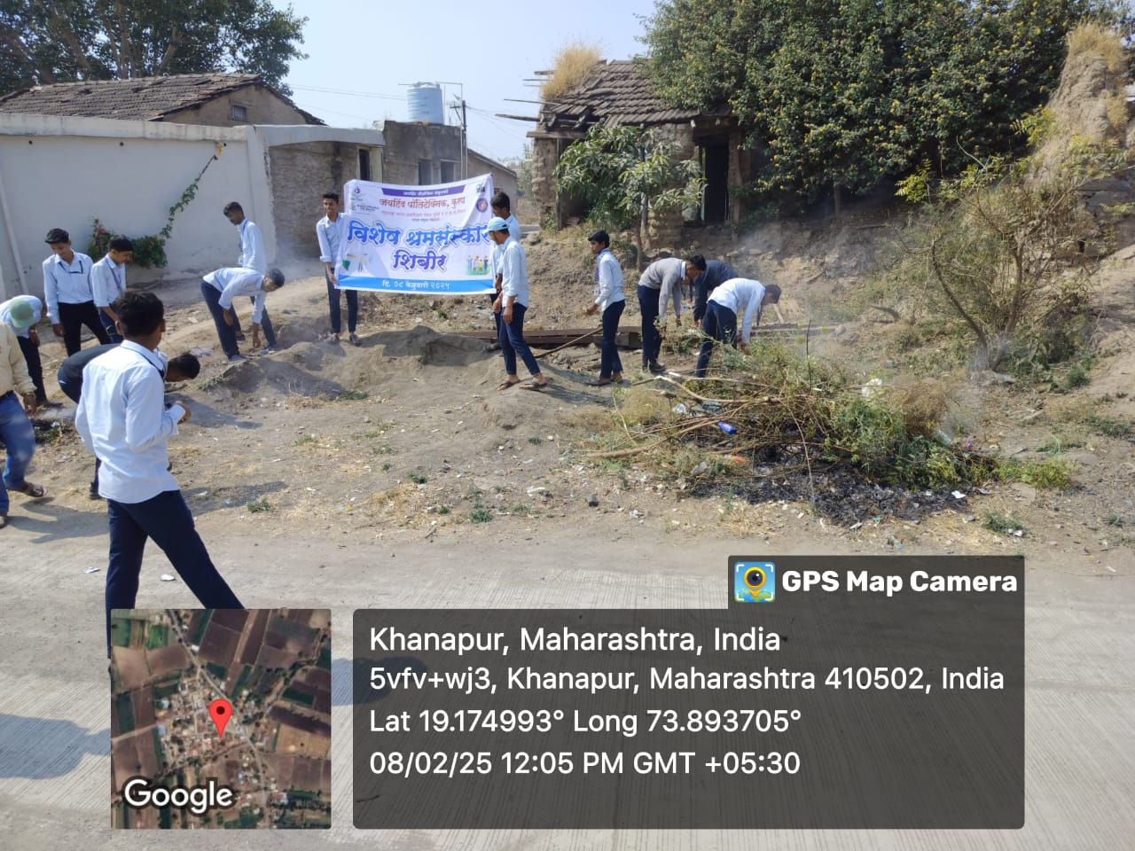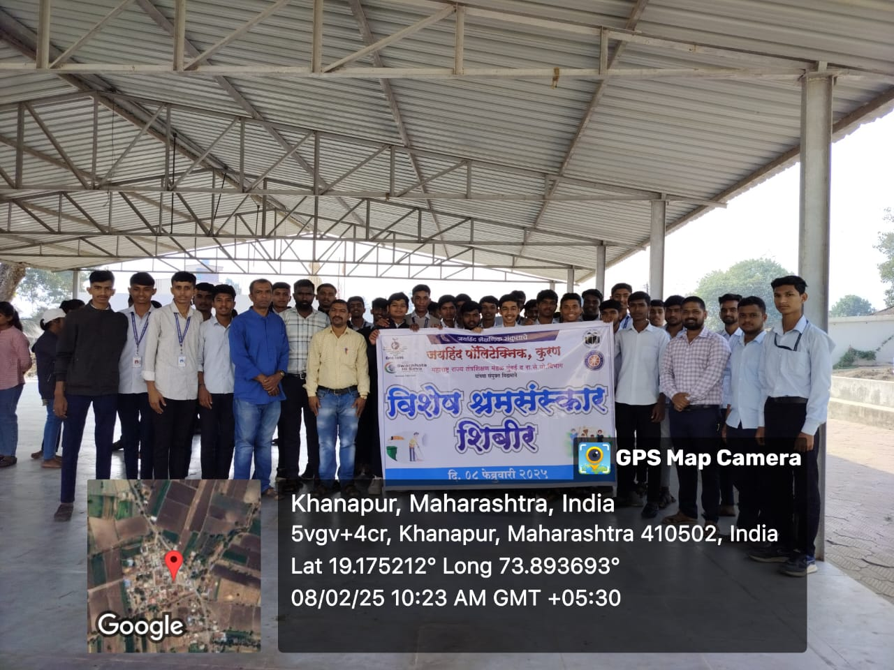

NSS Activity 2
Blood Donation Camp
Blood Donation Camp on dated 03/03/2025

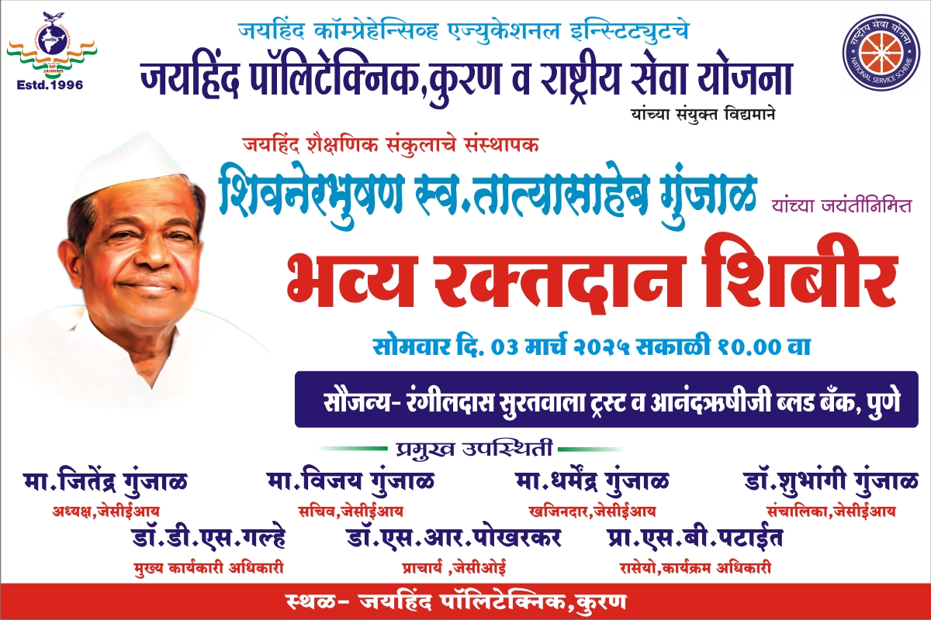
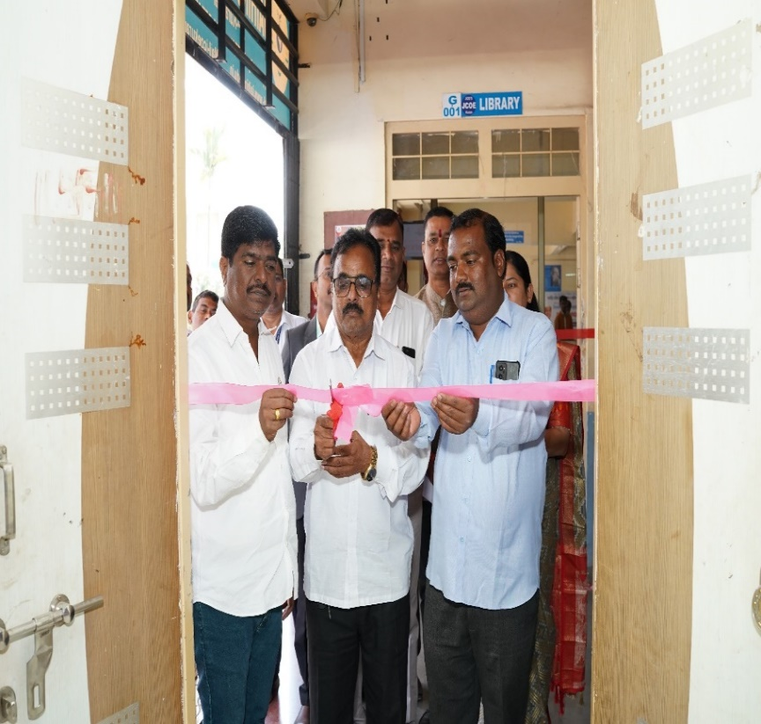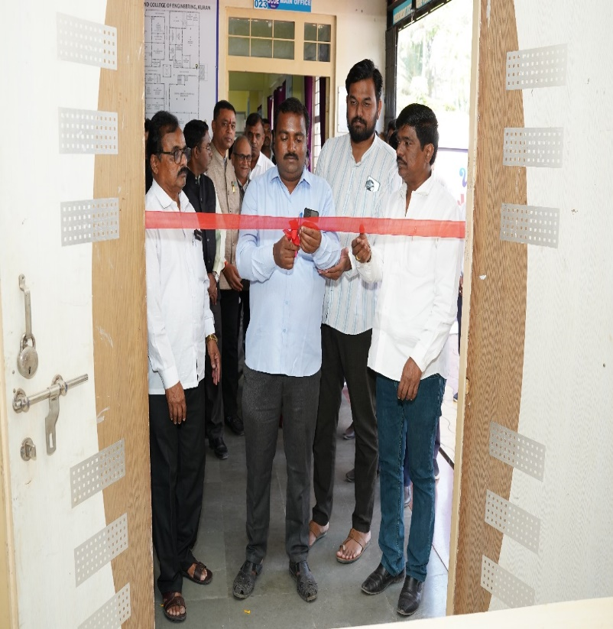
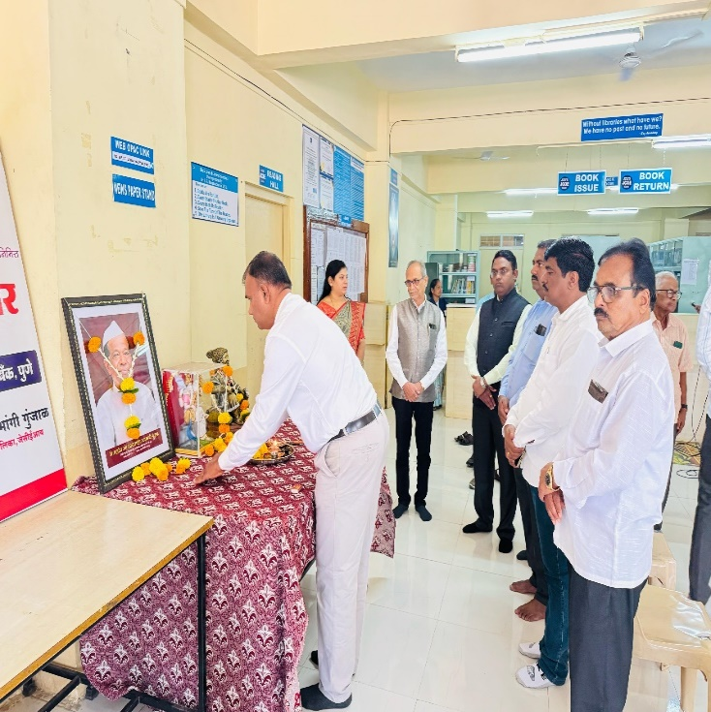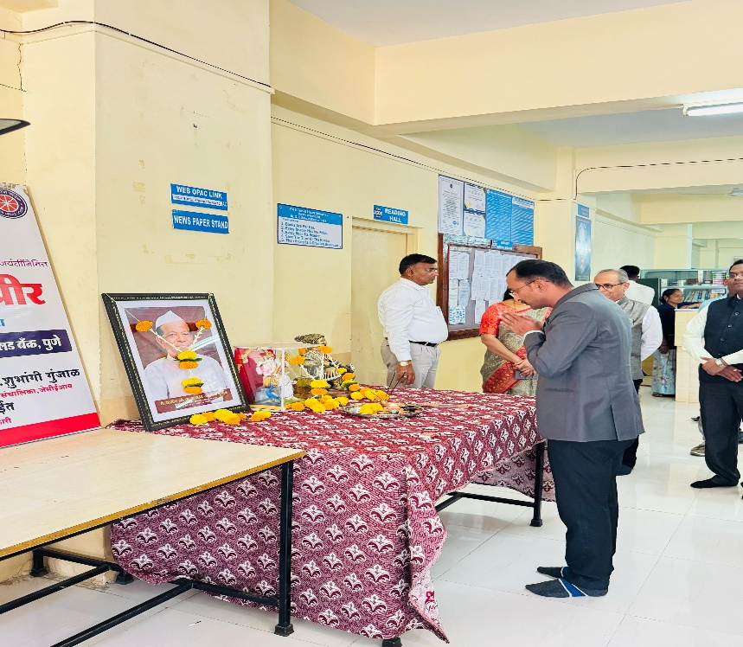
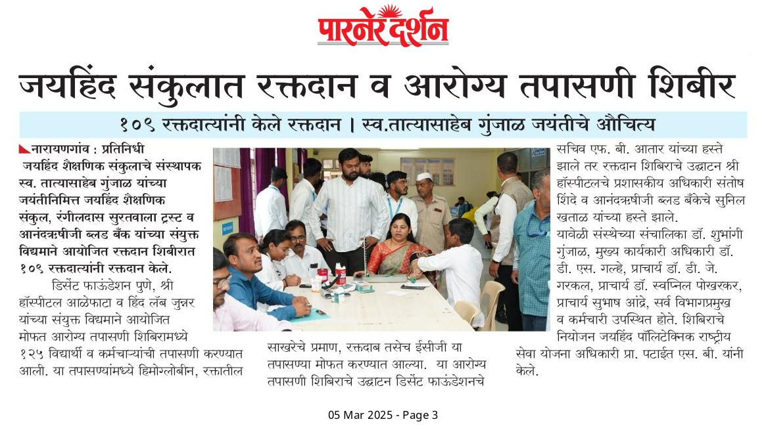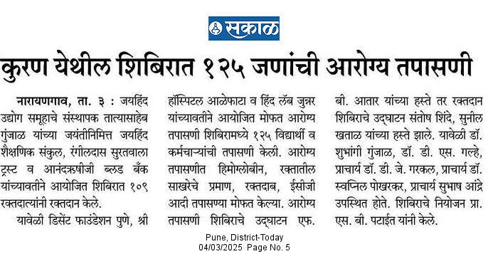

UMA Activity
Say to no Plastic Bag.

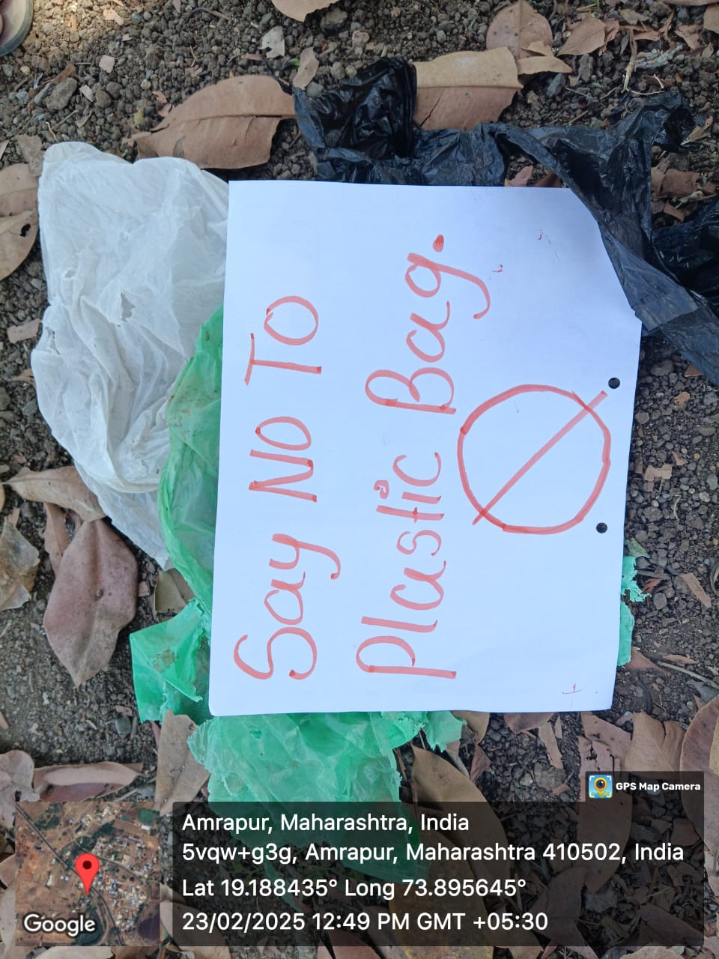

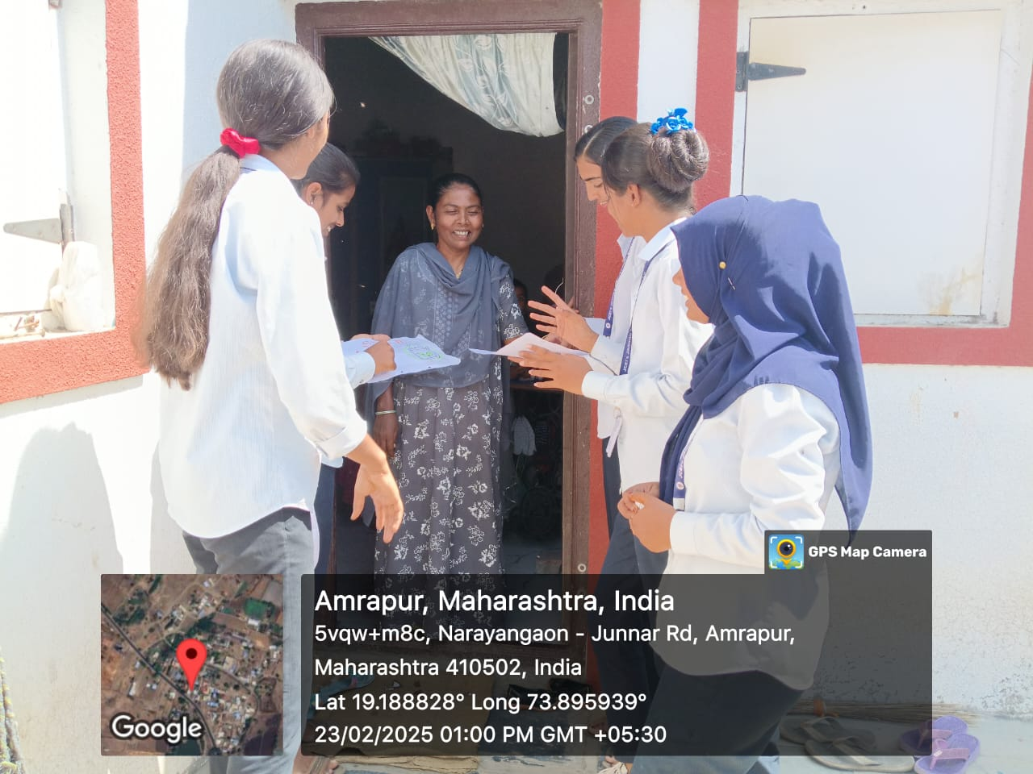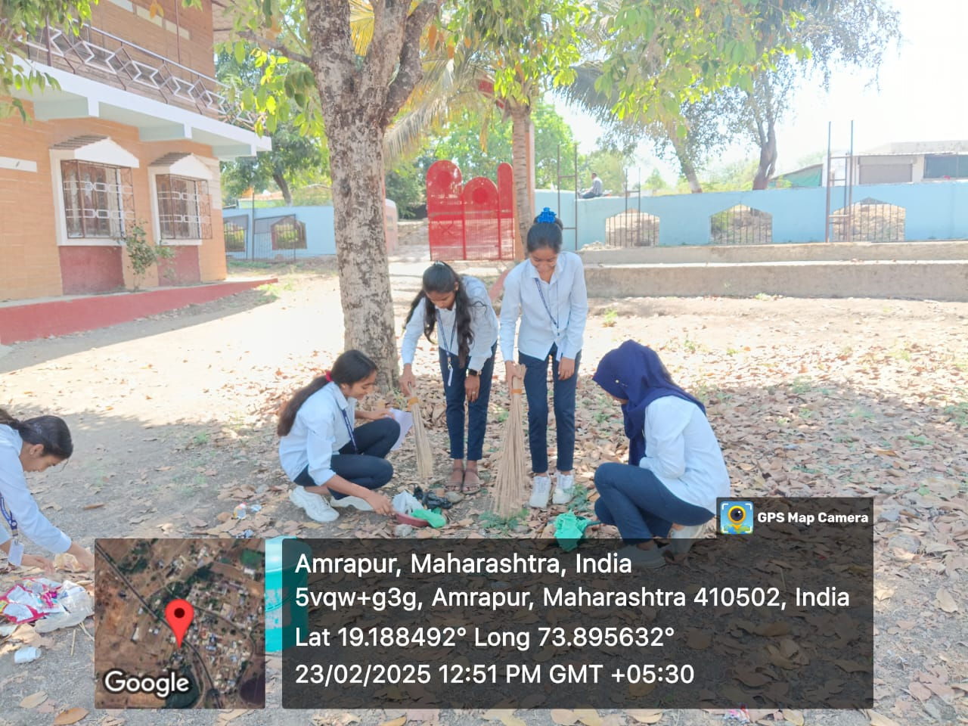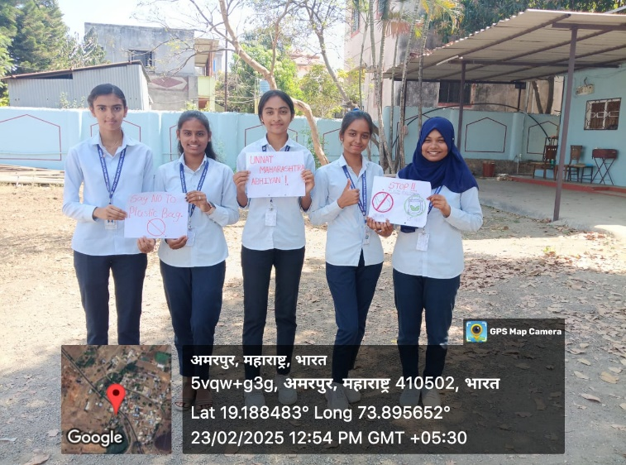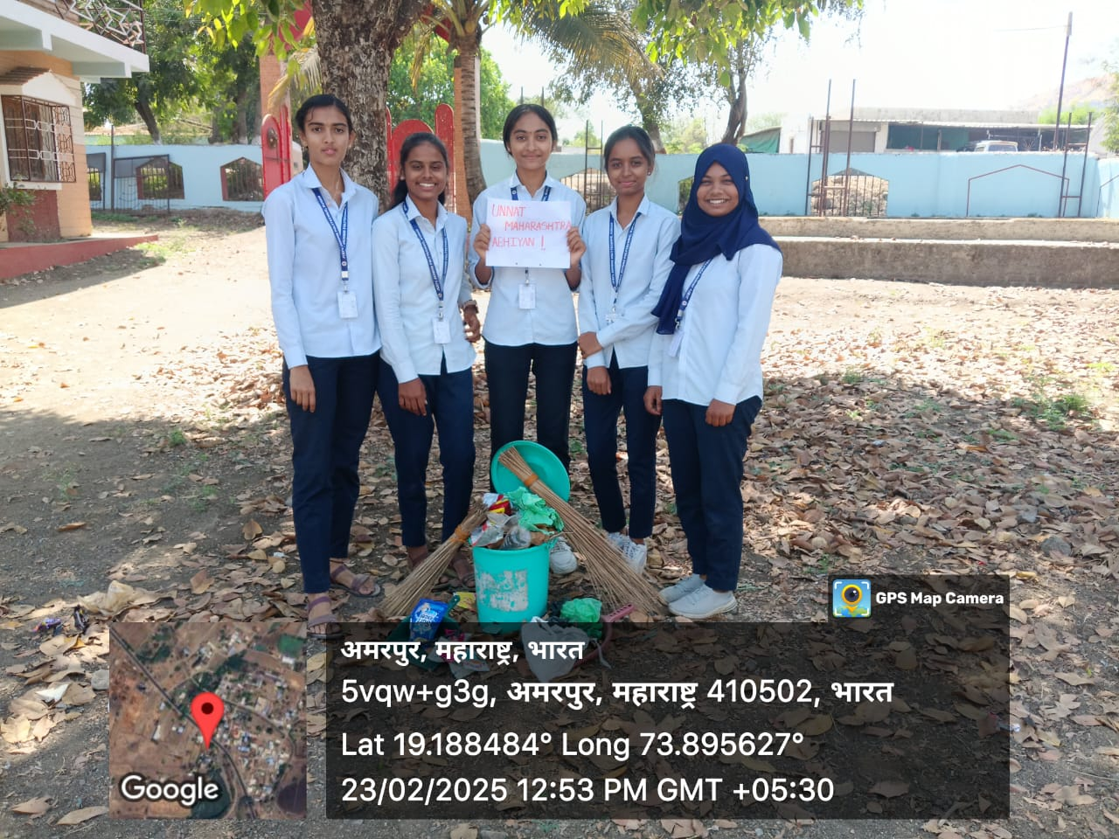

Parents Meeting Conducted on Dated 15th Feb 2025
Class: - FY
Total Parents Presents: 27

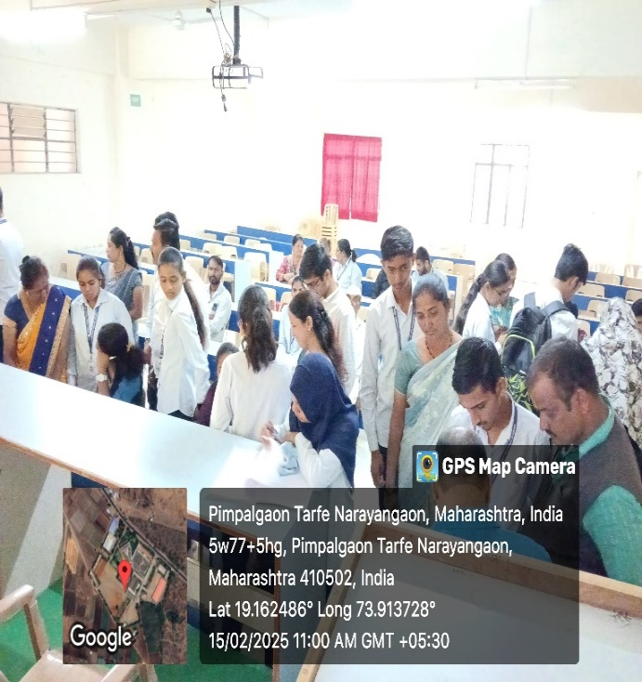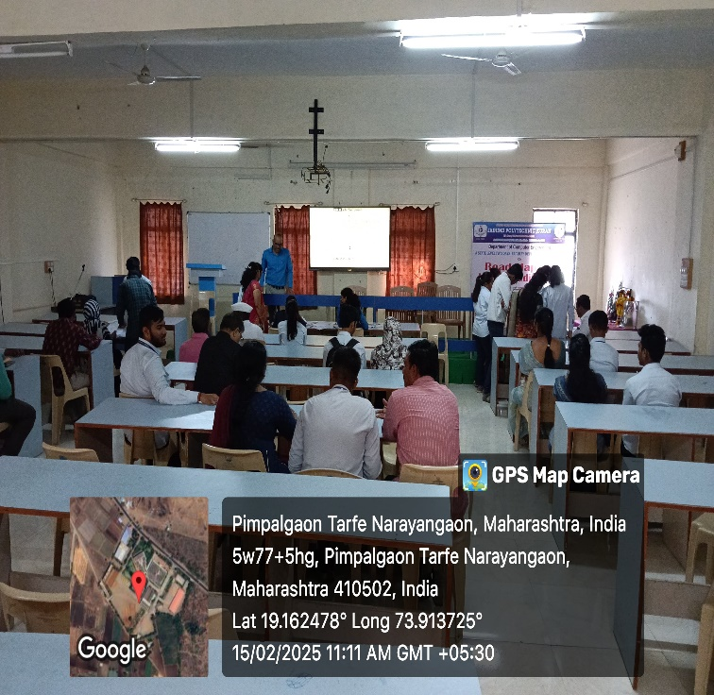
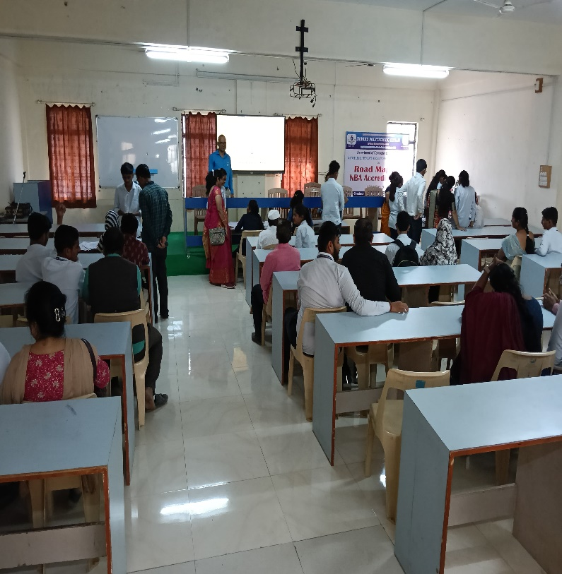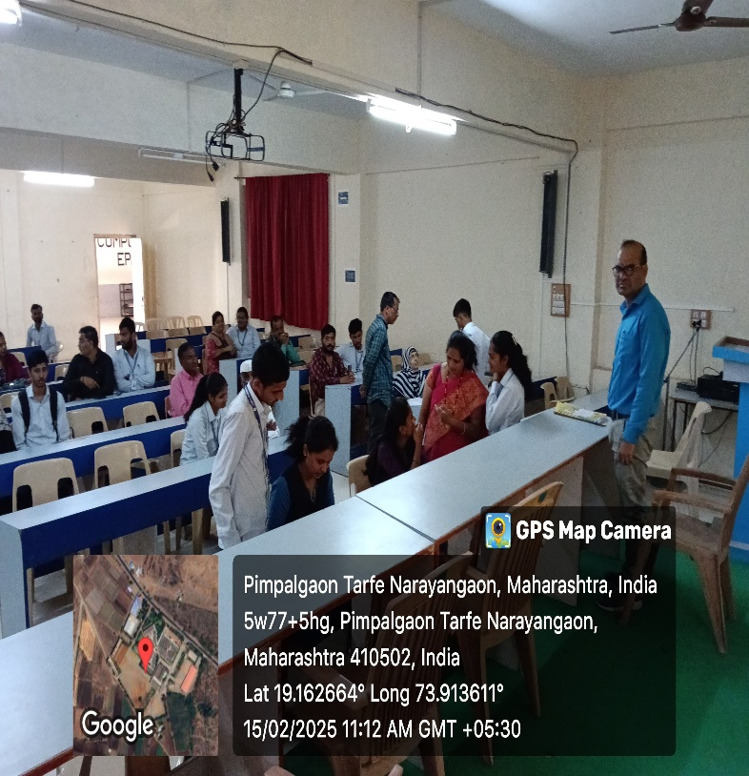

Social Activity
Social Activity - 1
SWACHHTA Abhiyan
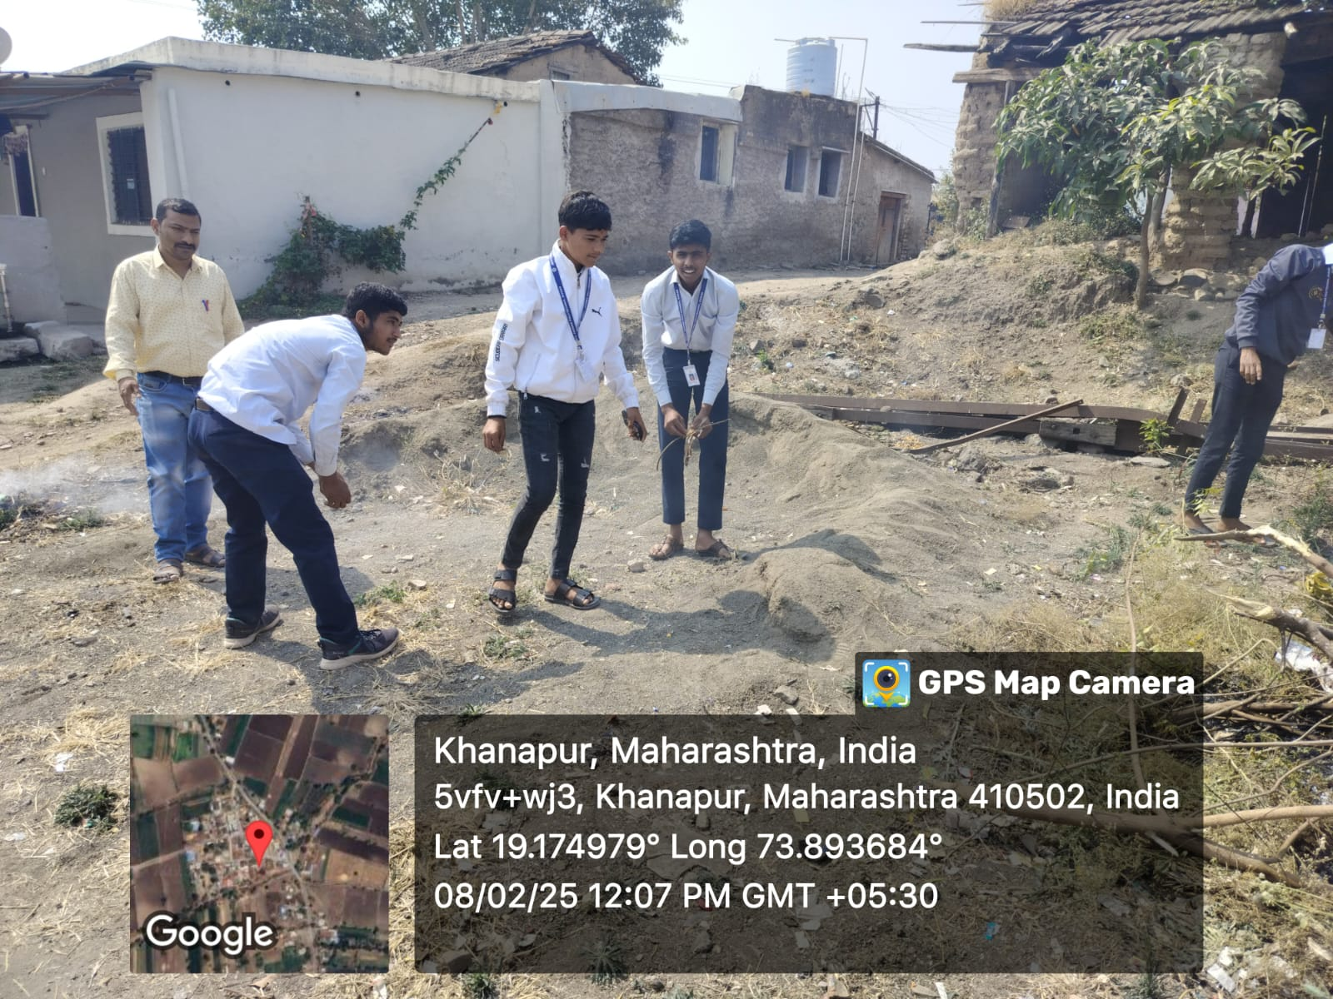

Social Activity - 2
Tree Plantation

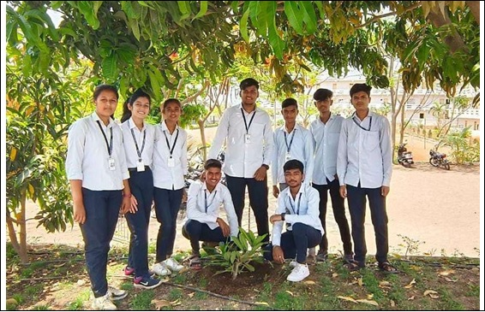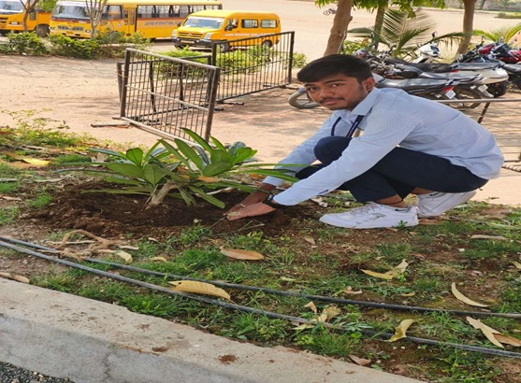

Examination Topper (Winter 2024)
Department of Information Technology

Winter 2024 Examination Topper List (AY 2024-25)
Ranking
IF3K | Rank | Photo | Name of the Candidate | Marks Obtained | Out of | %
 | 1 | 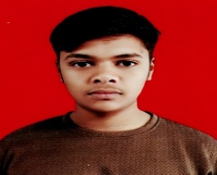 | KHAN MOHD AASIM SAJID | 778 | 850 | 91.53
 | 2 | 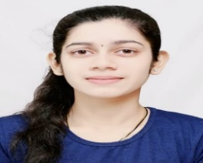 | CHASKAR RISHIKA SACHIN | 769 | 850 | 90.47
 | 3 | 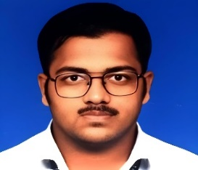 | GAWADE SAI RAJARAM | 768 | 850 | 90.35
IF1K | 1 | 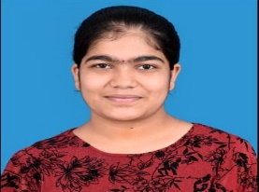 | MANKAR AARYA ARJUN | 742 | 850 | 87.29
 | 2 | 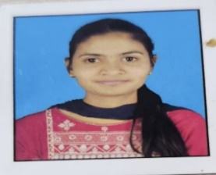 | WAGHULE SAMIKSHA SAKHARAM | 701 | 850 | 82.47
 | 3 | 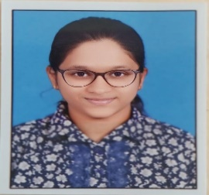 | CHASKAR SHRUTI SATYAWAN | 699 | 850 | 82.24

------------------------------------------ THANKS -------------------------------------

