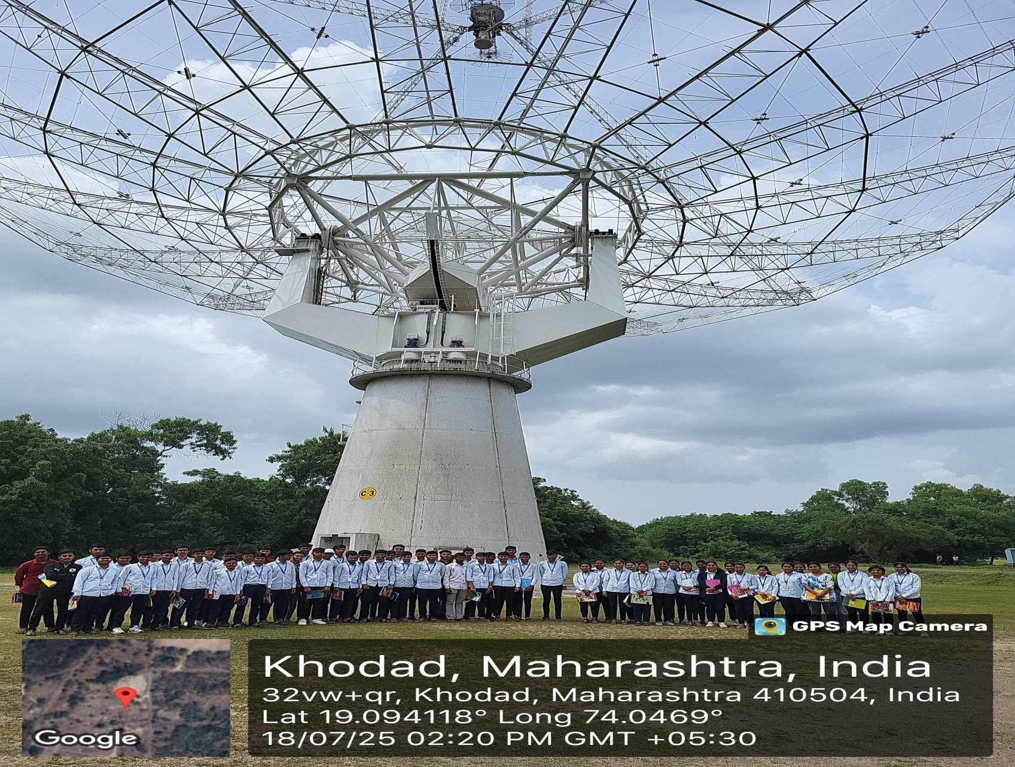

On 18/07/2025 , Students of second year Electronic and Telecommunication Engineering department Jaihind Polytechnic,Kuran visited GMRT,Khodad as a part of an industrial exposure program. The visit aimed to provide students with practical insight into industry. 61 students attended the visit and visit co- ordinator is Ms.Wakchaure A.P.