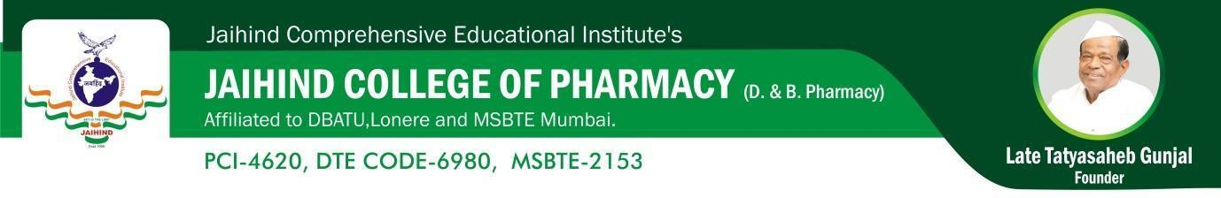
Hospital visits
B-Pharmacy

Sr. No | Class | No. of Hospital visit | No. of students visit | Name of Hospital | Name of the staff Members
2024-25
1 | F.Y.B.  Pharm | 01 | 50 | Dr Sonawane Multispecialty Hospital (Alephata) | Ms .Badhe P.D
2024-25
1 | F.Y.D.  Pharm | 01 | 20 | Dr Sonawane Multispecialty Hospital (Alephata) | Ms. Jadhav C.S.

Hospital visits
D-Pharmacy

Sr. No | Class | No. of Hospital visit | No. of students visit | Name of Hospital | Name of the staff Members
2024-25
1 | F.Y.B.  Pharm | 01 | 39 | Shree Chatrpati Shivaji Maharaj Gramin Hospital (Junnar) | Ms .Badhe P.D
2024-25
1 | F.Y.D.  Pharm | 01 | 30 | Shree Chatrpati Shivaji Maharaj Gramin Hospital (Junnar) | Mr. Abhang D.V.

