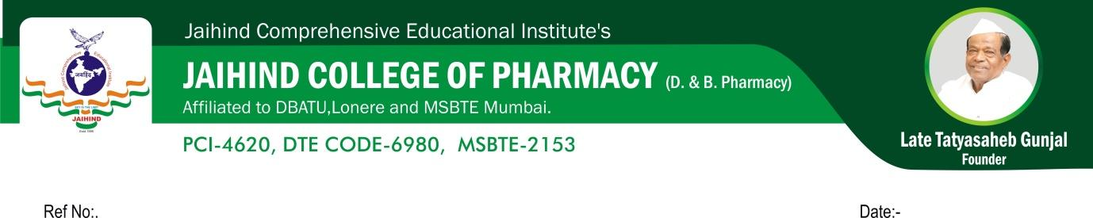
Hospital visits
B-Pharmacy

Sr. No | Class | No. of Hospital  visit | No. of students | Company Name | Name of the staff Members
2022-23
1 | F.Y.B. Pharm | 01 | 51 | Jiwan Multispeciality Hospital,Narayangaon 410504 | Ms.Deokar R.S
2023-24
1 | F.Y.B. Pharm & S.Y.B.  Pharm | 01 | 93 | Anantrao Kanse Homeopathic medical College & Hospital | Ms.Waykar G.R

Hospital visits
D-Pharmacy
Sr. No | Class | No. of Hospital  visit | No. of students | Company Name | Name of the staff Members
2022-23
1 | F.Y.D. Pharm | 01 | 37 | Jiwan Multispeciality Hospital,Narayangaon 410504 | Ms.Deokar R.S
2023-24
1 | F.Y.D. Pharm & S.Y.D.  Pharm | 01 | 45 | Anantrao Kanse Homeopathic medical College & Hospital | Ms.Rakshe S.S

