Report on World Hepatitis Day
Date: 29/07/2024
Venue: JCOP Campus
Attendance: All Students and staff.

Concept of program:
World Hepatitis Day, celebrated annually on July 28, is a global event dedicated to raising awareness about viral hepatitis, promoting prevention, encouraging testing and treatment, and advocating for policy changes to combat hepatitis-related health issues. The day serves as a focal point for efforts to address the impact of hepatitis and to advance the goals set by the World Health Organization (WHO) and other health bodies.

Program objective:
World Hepatitis Day aims to address the global burden of hepatitis by focusing on several key objectives. These objectives are designed to promote awareness, increase access to prevention and treatment, and support efforts to eliminate hepatitis as a public health threat. Here are the primary objectives of World Hepatitis Day:

1. Raise Awareness About Hepatitis
- Objective: Enhance public understanding of hepatitis, including its types, transmission methods, symptoms, and health impacts.
- Actions: Conduct educational campaigns through media (social media, television, radio), organize community workshops, and distribute informational materials.
2. Promote Prevention Measures
- Objective: Encourage behaviours and practices that reduce the risk of hepatitis infection.
- Actions: Advocate for vaccination (especially for hepatitis B), promote safe practices (such as using clean needles and practicing safe sex), and raise awareness about hygiene and sanitation to prevent hepatitis A and E.

3. Increase Testing and Diagnosis
- Objective: Expand access to hepatitis testing and improve early diagnosis rates.
- Actions: Provide free or low-cost testing services, organize mobile testing units, and collaborate with healthcare providers to increase screening efforts.

4. Enhance Access to Treatment
- Objective: Improve access to effective treatment and care for individuals living with hepatitis.
- Actions: Advocate for affordable and accessible treatment options, support programs that provide medication and care, and educate patients about available treatments.

5. Support Policy Advocacy
- Objective: Influence policy changes to strengthen hepatitis prevention, treatment, and care programs.
- Actions: Engage with policymakers, support legislative initiatives, and promote the integration of hepatitis services into national health plans and strategies.

Programme Summary:
This programme was conducted by Jaihind College of Pharmacy, Vadgaon Sahani. On 29 th July 2024 with all teaching staff and non-teaching staff.
The Chinmay Bhor, Simran Pathan, and Arfat Pathan gave a speech on the importance of World Hepatitis Day to students. He told World Hepatitis Day (WHD) is celebrated on World Hepatitis Day, celebrated annually on July 28, is a global event dedicated to raising awareness about viral hepatitis, promoting prevention, encouraging testing and treatment, and advocating for policy changes to combat hepatitis-related health issues.
Respected Principal madam honour him by giving a bouquet and lightening of lamp goddess Saraswati. All student and teaching staff was present for the programme.

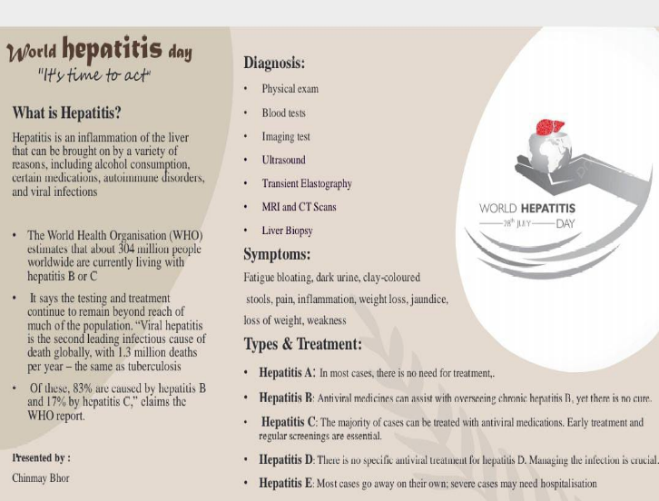
Photograph:
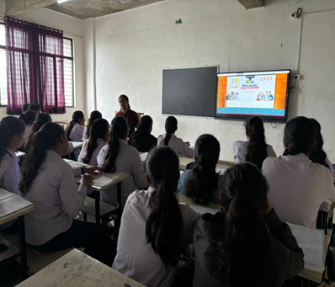
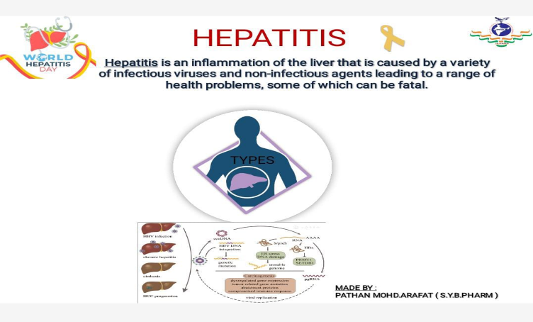
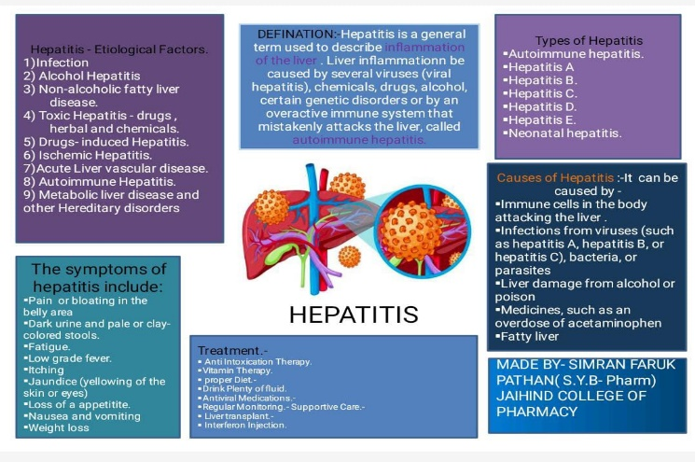

Report on
Kargil Vijay Diwas Celebration
Date : 26th July 2024
Time: 2.15PM-2.45PM
Venue: Diploma Classroom
Attendees: Students of D & b Pharmacy and faculties of JCOP.
Objectives of Event:
- To remember the sacrifice made by Indian Soldier in Kargil War 1999.
- To give condolence to Indian Soldier who lost their lives in Krgil war 1999.
Programme Summary:
Kargil vijay Diwas was celebrated on 26th July 2024 in Diploma Classroom of Pharmacy College. The Pragramme was started at 2.15 pm with the introduction of Kargil Diwas by Pooja Suryawanshi. On this occasion faculties of JCOP And students of d and B pharmacy was present. After that Dnyaneshwari Fadale (S.Y.D.Pharm) and Vaishnavi Shelke (T.Y.B Pharm) gave speeches on History of Kargil Vijay Diwas. At last all gave condolence to the Indian Soldier who lost their lives in Kargil War 1999.

Photographs:

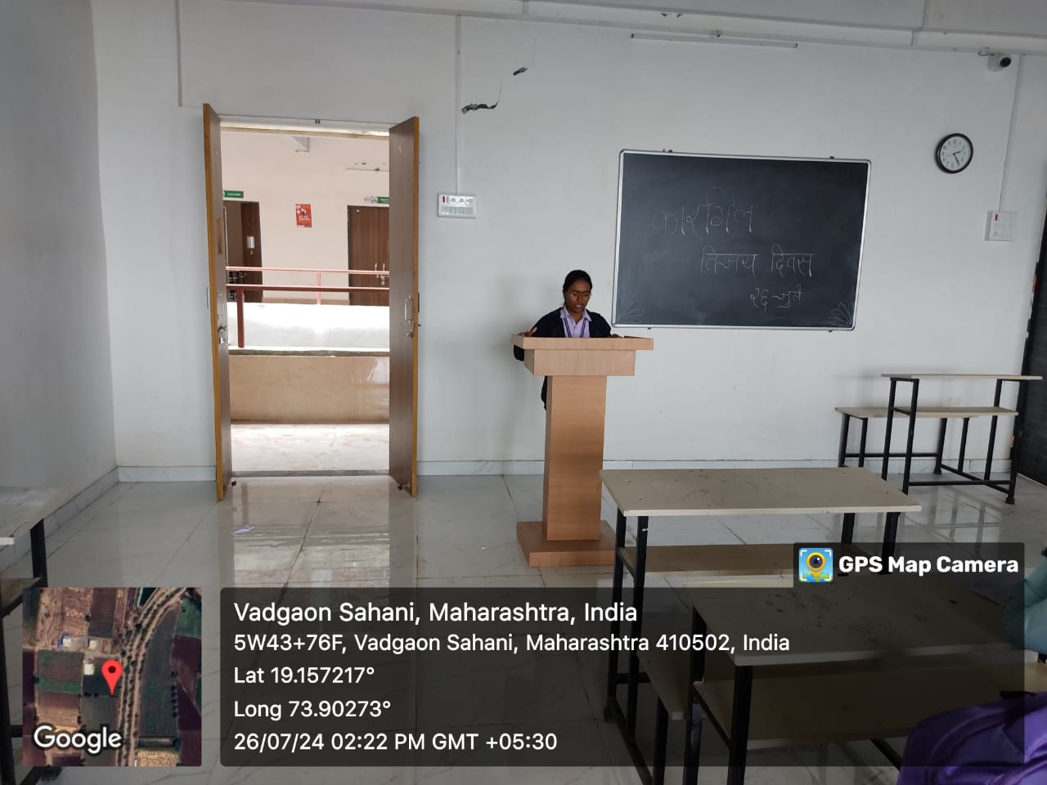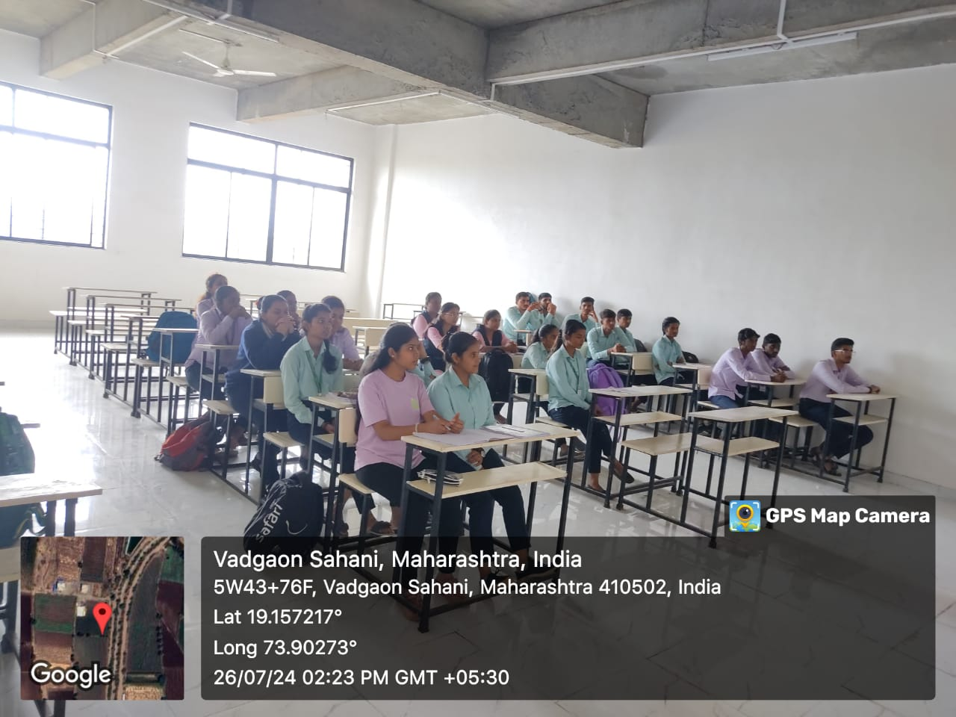
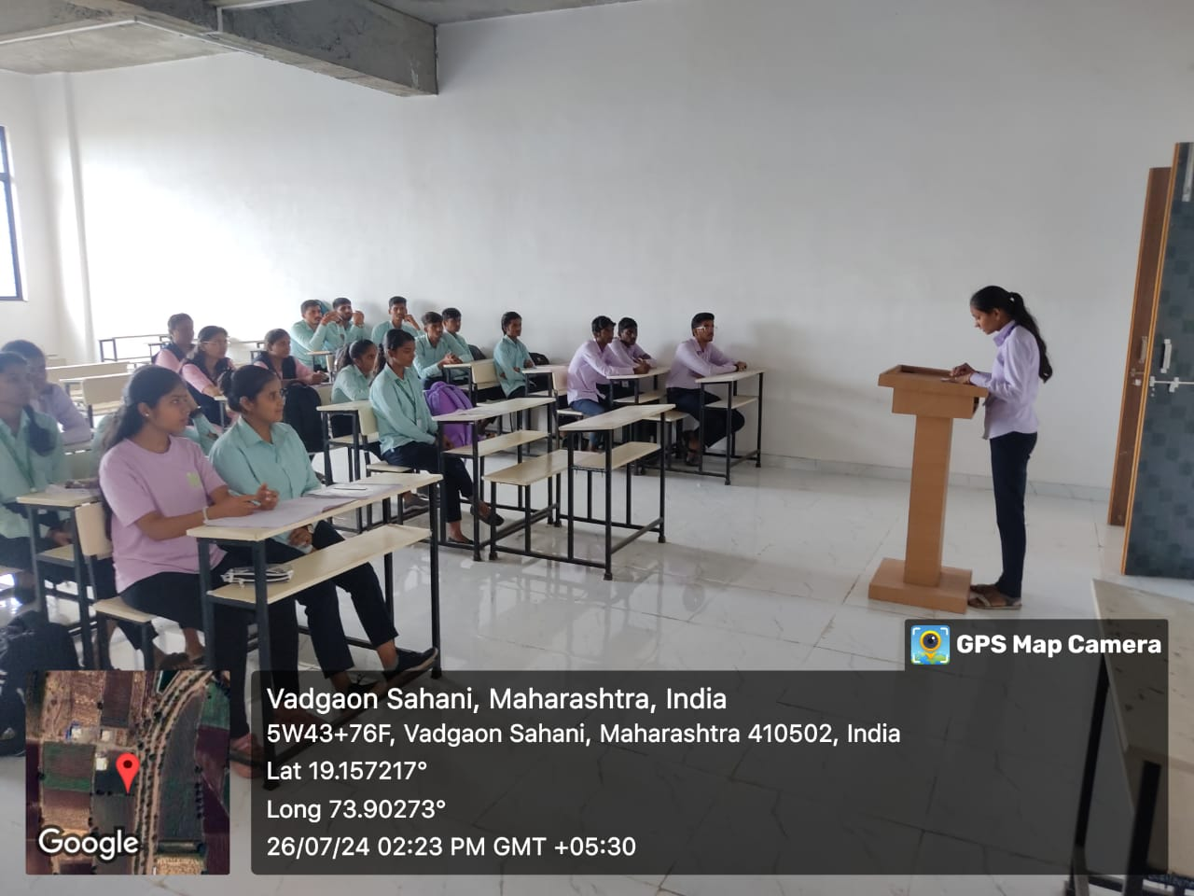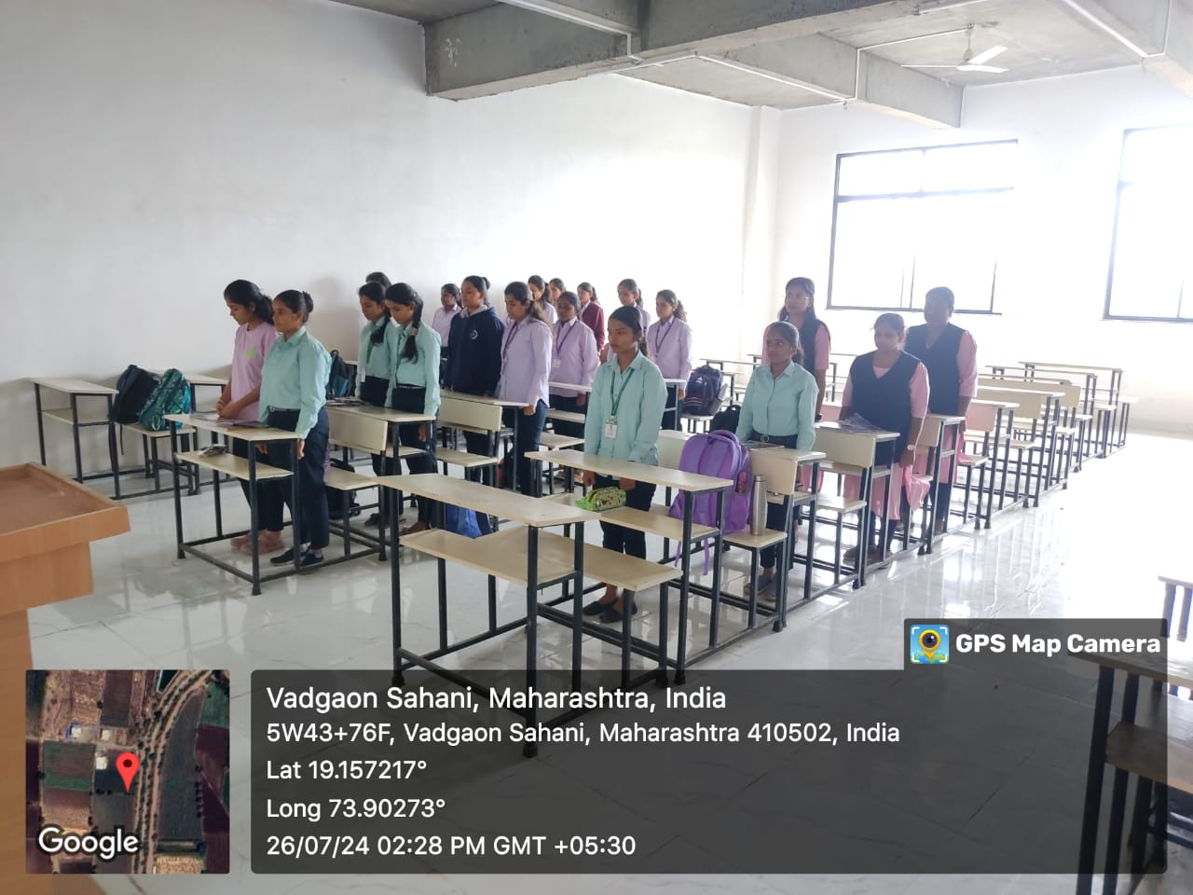

Date: 27th August 2024
Attendees: All Students and staff of JCOP.

Event Summary:
The Dahi Handi festival, also known as Gokulashtami or Krishna Janmashtami, is a popular Hindu festival celebrated with great enthusiasm across India. The Dahi Handi festival celebrated by engineering students typically involves several teams or groups from different departments or colleges coming together. The event begins with prayers and rituals invoking Lord Krishna's blessings. Teams then compete to form the tallest human pyramid possible to reach and break a suspended pot (handi) filled with curd, which is traditionally hung at a considerable height.
Jaihind college of engineering celebrated the Dahihandi festival on Tuesday, 27th August, 2024 in a well-disciplined manner. Dahihandi competition held at the college premises during festival for promoting students to show their hidden talent. There was separate Dahihandi for girls and boys. The participants form a pyramid consisting usually below 4-tiers for boys,3-tiers for girls and are given three attempts to break the earthen pot. Winner teams - B pharmacy boys. It was really very well organized event & students also showed very good response by participating in large numbers.
Photographs:
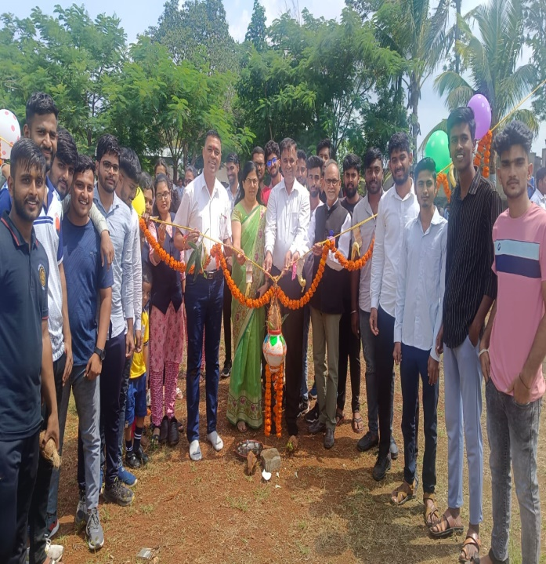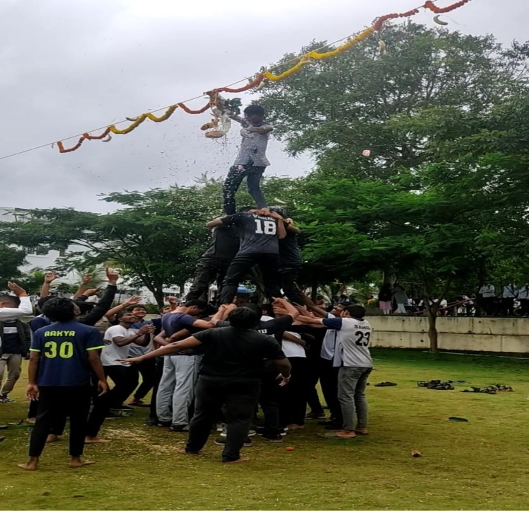

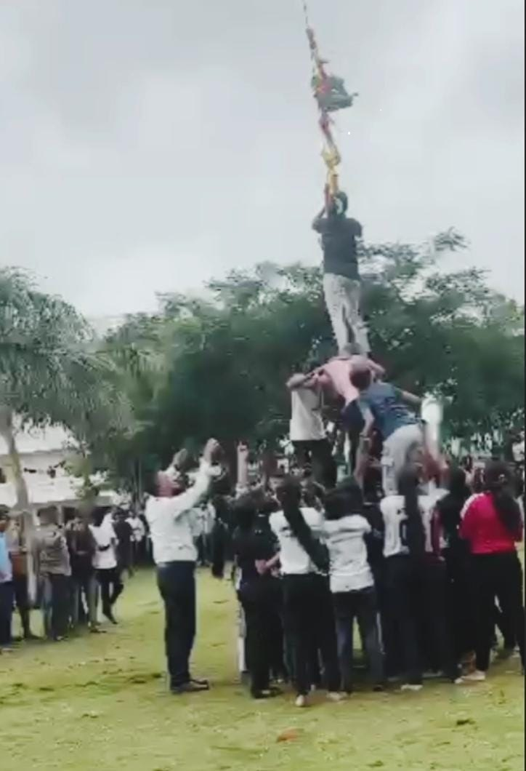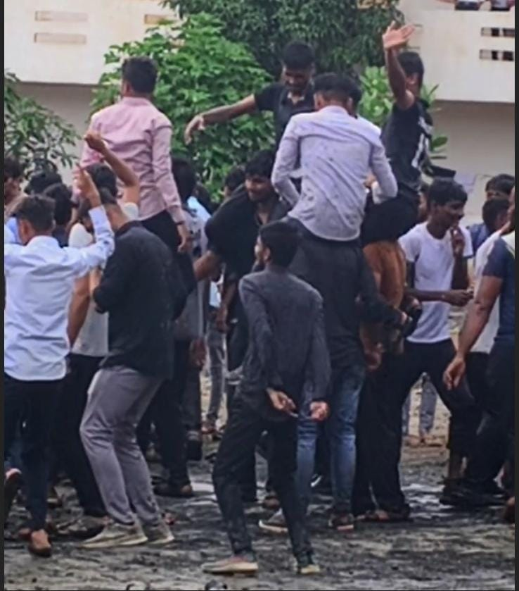

Report on
Celebration of Independence Day
Date: 15th August 2024
Venue: JCEI Campus
Attendees: All Students and Teaching and non-teaching faculties of JCEI
Concept of Event:
77th Independence Day was celebrated on 15th August 2024. The Independence Day of India, which is celebrated religiously throughout the country on the 15th of August every year, holds tremendous ground in the list of national days, since it reminds every Indian about the dawn of a new beginning, the beginning of an era of deliverance from the clutches of British colonialism of more than 200 years. It was on 15th August 1947 that India was declared independence from British colonialism, and the reins of control were handed over to the leader of the country.
Thousands of freedom fighters sacrificed their lives for cause, and their courage and determination are remembered on Independence Day. Independence coincided with the partition of India, in which British India was divided into Dominions of India and Pakistan; the partition was accompanied by violent riots and mass casualties.
On 15th August 1947, the first Prime Minister of India, Jawaharlal Nehru raised the Indian National Flag above the Lahori Gate of the Red Fort in Delhi. The day is also a time to reflect on the progress that India has made since independence, and to recommit to the ideals of freedom and democracy.
Independence Day is a day of joy and celebration, but it is also a day of remembrance. It is a time to honour the sacrifices of the freedom fighters, and to reaffirm our commitment to building a stronger and more prosperous India.
Programme Summary:
JCEI witnessed the celebration of the 77th Independence Day on 15th august 2023. Event started with flag hosting by Dr. Naykodi, our beloved trustee honourable Mr. Jitendra Gunjal, CEO of JCEI Dr. D.S Galhe and all principals of Institutions of JCEI, Then speeches given by the guest and all present Dignitories. The guest Dr. Naykodi briefly recounting the historical context of India's struggle for independence and the sacrifices made by freedom fighters and highlight iconic leaders and others who

played pivotal roles in the freedom movement. The Principal of I.T.I. Mr. Subhash Andre sir gave speech on Youth and the future. After this, students presented cultural activities which included patriotic songs, folk dances and speeches. The program ended with the message to create a great nation through collective efforts from all individuals. Sweets were distributed among the students. This was a very well organised event.
Photographs:
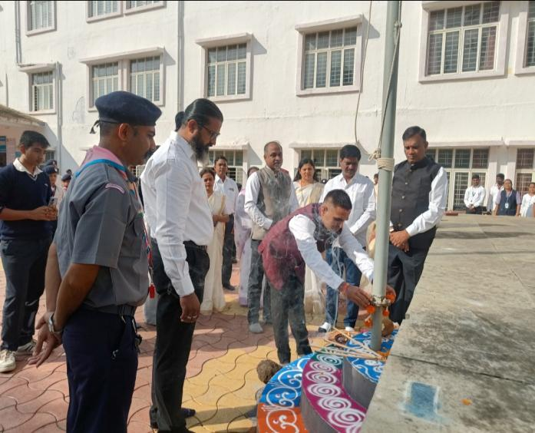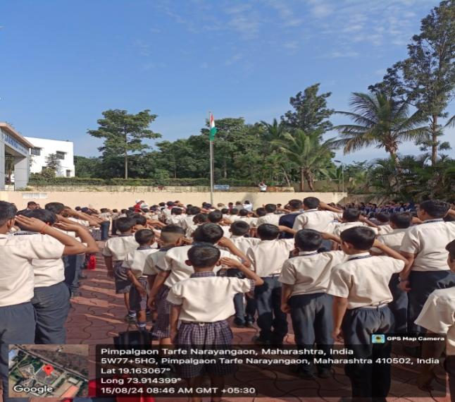
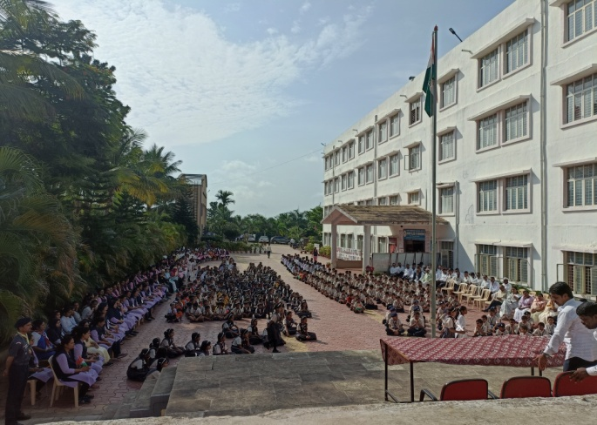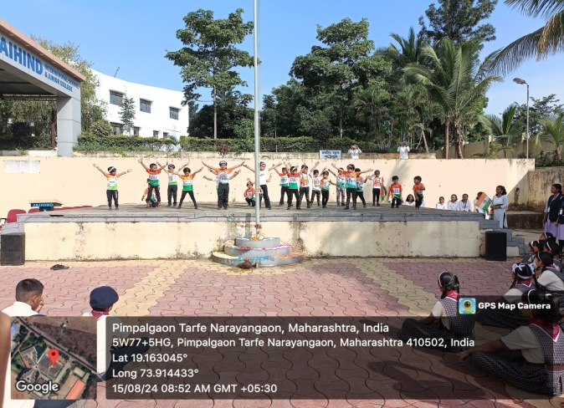

Report on
Nashamukt Bharat Abhiyan
Date: 12th August 2024
Time: 9.15 Am- 11.15 Am
Venue: Savargaon Grampanchayat
Attendees: Students of D & B Pharmacy and faculties of JCOP.
Objectives of Event:
- It aims to cut off the supply of drugs by catching those bringing them in and stopping everyone from making or selling them.
- It offers support to those who are already hooked on drugs, through counselling, rehab centres, and medication.
- It wants everyone to know how bad drugs are, how they hurt your health and life, and why it’s important to stay away from them.
- They especially focus on protecting young people and people in difficult situations. Who are more likely to get caught up in drugs?
Concept of Event:
With a view to prevent drug abuse and make India drug free, the ministry of Social Justice an Empowerment of the Union Government is implementing “Nashamukt Bharat Abhiyan” and this year’s concept is “Evolved Bharat ka Mantra, India Be Drug Free”
So, government has been suggested cultural competition, sports competition, seminar on 12th august in the line with drug free India Campaign like lectures, workshops, forming human chains against addiction, student rallies, plays, street plays, marathon walk, tree plantation etc should be organised with the participation of students and staff.
Event Summary:
All D and B Pharmacy students, Staff and Principal of Jaihind College of Pharmacy were reach to Savargaon at 9.15 am for Nashamukt Bharat Abhiyan rally. After completion of rally savargaon sarpanch Deepak Balsaraf Sir felicitate Principal mam, B. pharmacy HOD, D. Pharmacy HOD, and Event coordinator. We reach to Shree Dnyaneshwar Vidyalaya, Savargaon (basti) at 10.45 am. In this school Principal Dr. Leena Pathak Mam gave introductory speech on mobile addiction as well as tobacco, drink, Cigarrate addiction and spoke about how it is harmful to our health. HOD Dr. Tejas Pachpute sir spoke on how we should stay away from addiction. After that Mr. Ramkrishna Bhagwat gave Guest lecture on Nashamukt Bharat. In his speech they mentioned various examples through which student understood that how addiction is harmful to our health. We end this event with a pledge of Nashamukt Bharat in the presence of school students, pharmacy students, all teaching and non-teaching staff, and Principal.
Photographs:
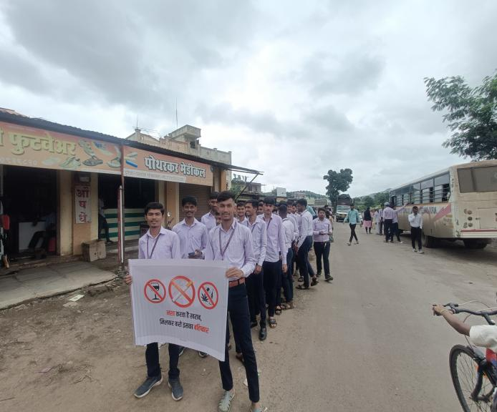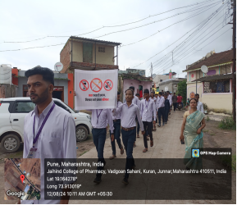
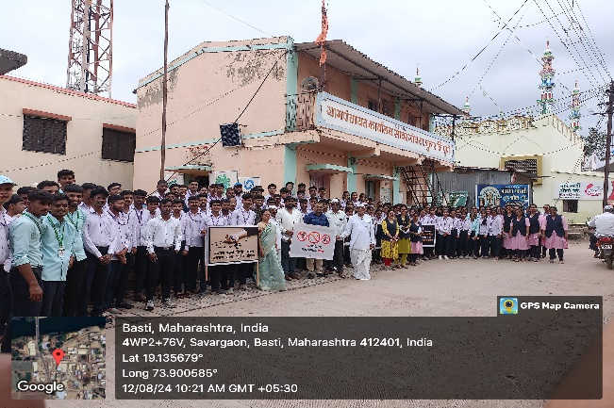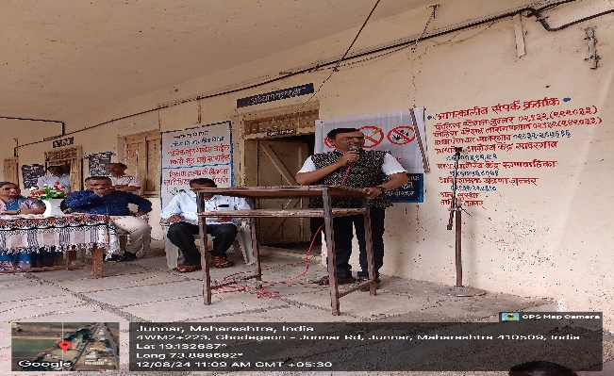

A Report on
National Sports Day
Date: 29th August 2024
Attendees: All Students and staff of JCOP.
Objectives of Event:
- To create a bridge for students to become involved in active co-curricular activities.
- To build confidence.
- It can help to improve physical fitness and mental health.
Concept Of Event:
National Sports Day all over the world is celebrated on August 29 every year. Sports are important for the physical and mental well-being of humans. Individuals who play sports remain healthy. India has produced many sporting legends like PT Usha, also known as Udanpari, Sachin Tendulkar, also known as Master Blaster, and Major Dhyan Chand, also known as 'Hockey Wizard'.
India celebrated the first National Sports Day on August 29, 2012. Sports Day marks the birth anniversary of Major Dhyan Chand who was born on this day.
The primary motto of National Sports Day is to promote awareness about the significance of sports and being physically active in the day to day life. The Government of India also organises various programs, events, seminars etc. to raise awareness about the significance of National Sports Day. According to the FIT Indian website, the day is celebrated with an aim to raise awareness about the values of sports: discipline, perseverance, sportsman spirit, and teamwork, and to encourage the public at large to take up sports and make it an integral part of their lives while emphasizing on the importance of being fit and healthy.
Event Summary:
We were celebrated National sports Day on 29th August 24 in Jaihind College of Pharmacy with the presence of All D & B pharmacy Students and Faculties. As we were organizes indoor games like Carrom and Chess for the students. Students also shown their active participation in that sports.
Photographs:
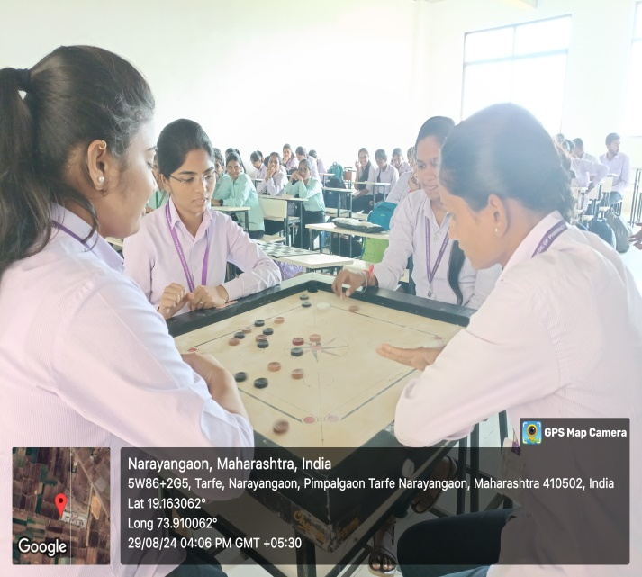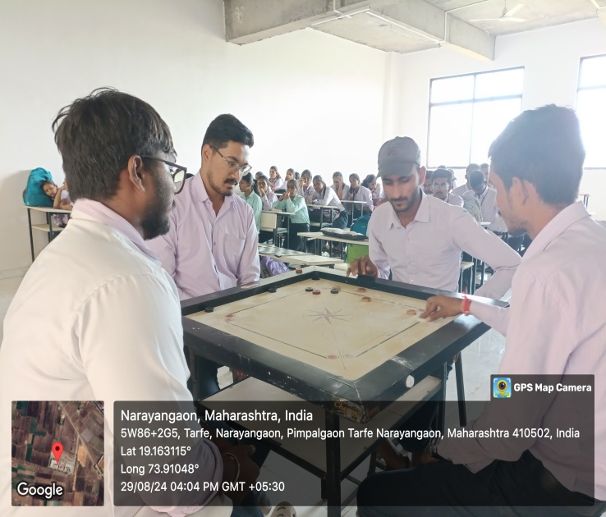
GANESH FESTIVAL REPORT
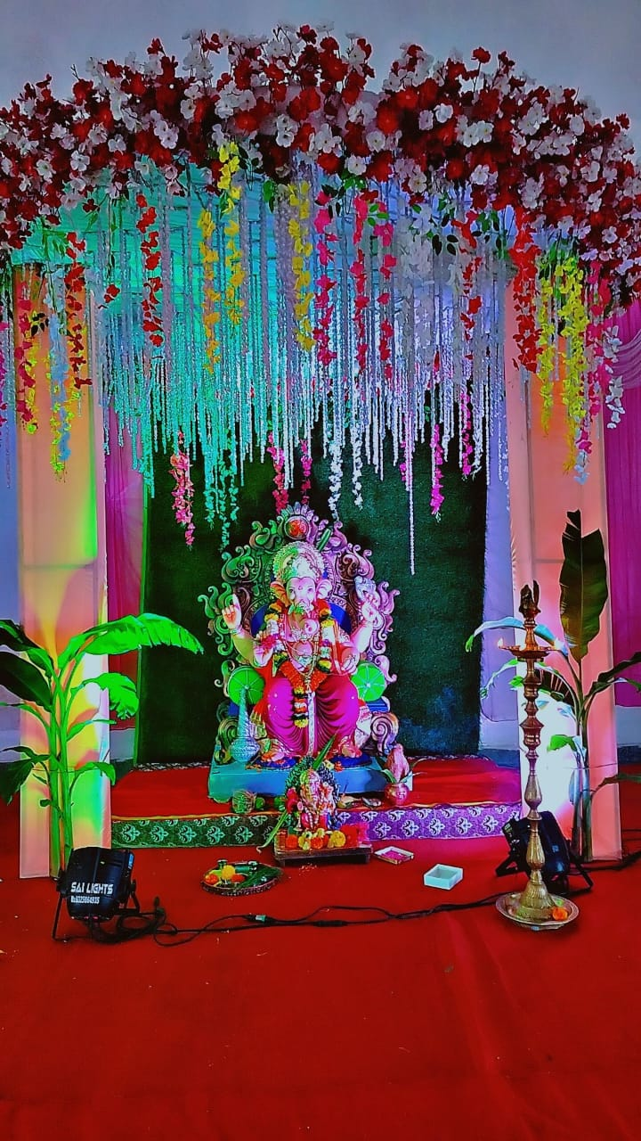

Report on:
- Date : 07 September 2024
- Venue : JCOE Campus
- Attendance: All Students and Staff.
- Programme Summary :
On 19th September 2023, Ganesh Chaturthi, the festival celebrating the birth of Lord Ganesha, was observed at campus of Jaihind College of Engineering with great devotion and enthusiasm. The entire college, including students and staff, came together to participate in various rituals and festivities during this auspicious occasion.
The celebration began with a ceremonial puja that was initiated by our respected CEO. Dr. Galle Sir & Principal of Pharmacy College Dr. Leena Pathak Mam showed devotees toward Lord Ganesha the puja was conducted with traditional rituals, including the lighting of the lamp, Vedic chants, and offerings to Lord Ganesha's idol.
Lord Ganesha's idol graced our campus for a five-day stay, which allowed students and staff to continue seeking His blessings. Every morning at 9:30 AM, Aarti was conducted, where members of the college came together to pay their prayers to the deity. The culmination of the Ganesh Chaturthi celebration was the 'Visarjan' or immersion ceremony, which took place on September 11th.
This ritual symbolized the return of Lord Ganesha to His celestial abode. The entire college participated in the procession, joyfully dancing and singing hymns to bid farewell to the deity

Photograph:

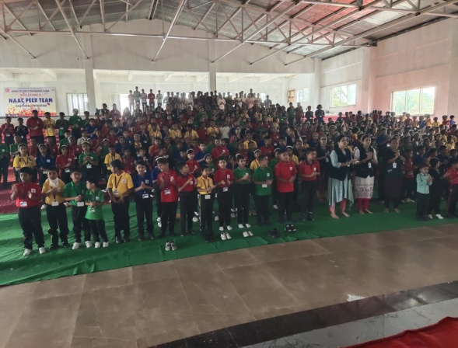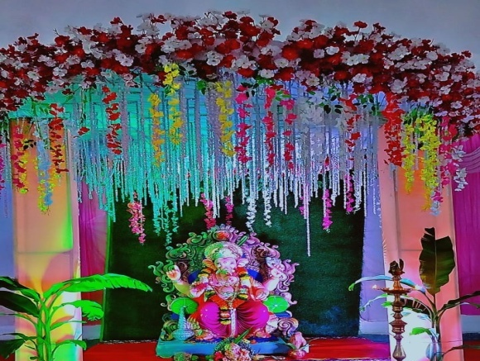

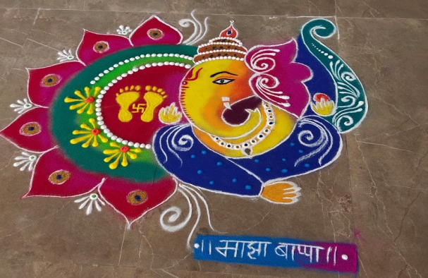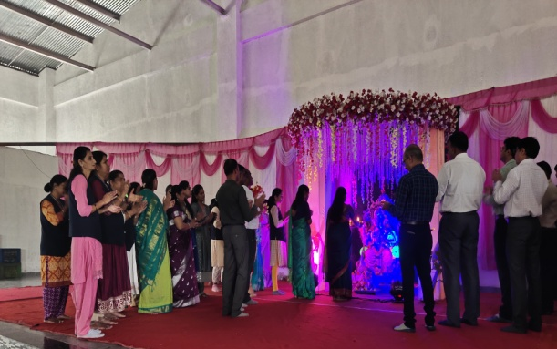

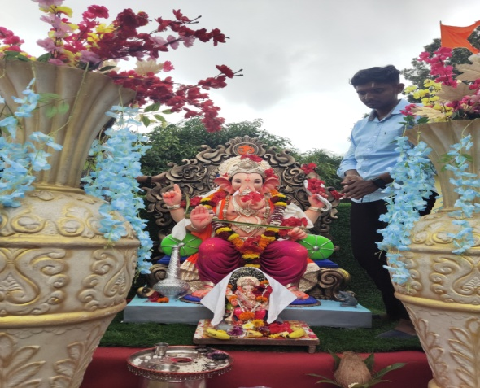

Date- 25th September 2024
Objectives:
To raise awareness about the vital role of pharmacists in healthcare and promote community health through a pharmacist-led rally.
Summary:
The IPA Local Branch at Alephata celebrated World Pharmacist Day on 25th September 2024, with the theme “Pharmacists: Meeting Global Health Needs.” As part of the celebration, regional pharmacy colleges organized a “Pharma Rally.” A total of 12 regional colleges participated in the rally, including Jaihind College of Pharmacy, Vadgaon Sahani.
The event commenced with an inauguration program at VJSM’s Institute of Pharmacy, Ale, and the rally proceeded from the institute to Alephata Bus Stop. Several members of the Junnar Taluka Zonal IPA were present during the event. Mr. Sandip Korde delivered a valuable speech on the occasion of Pharmacist Day. Following the rally, the principals and staff members of all participating colleges were felicitated by the Junnar Taluka Zonal IPA members. The students of VIPER, Ale, and Samarth College of Pharmacy, Belhe, performed a Pathnatya on the theme “Pharmacists: Meeting Global Health Needs.”
The program concluded with the distribution of snacks to all students. The event was anchored by Ms. Kawde Mam, who ensured the smooth conduct of the entire celebration.

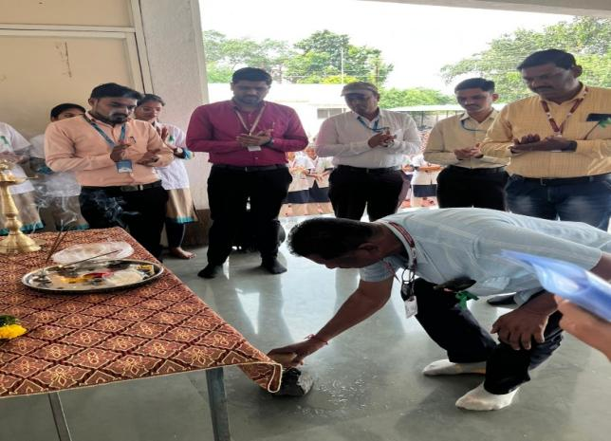
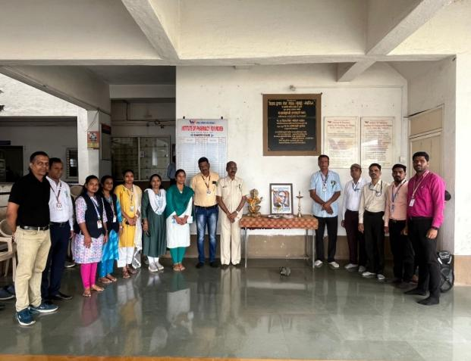

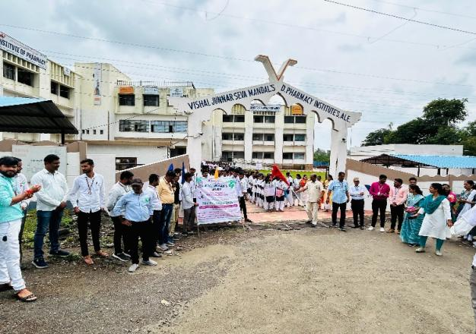
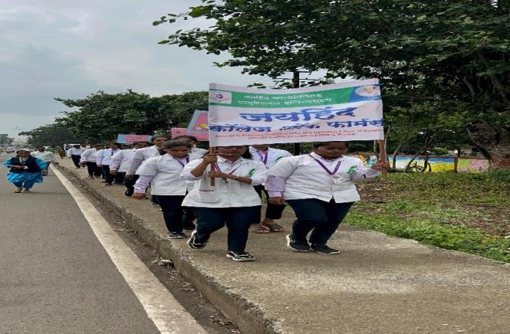
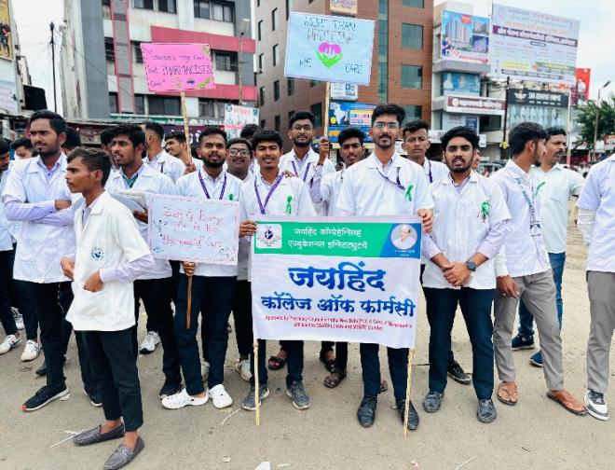
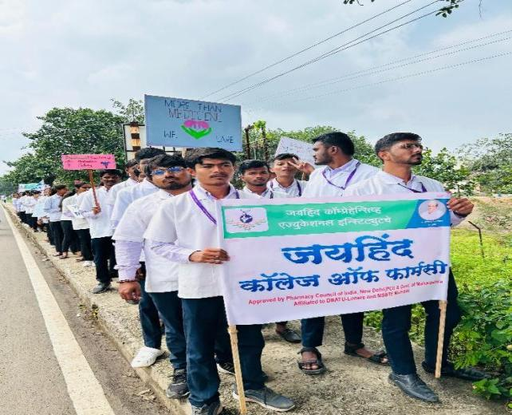

Report on Teachers day
On September 5, 2024, Jaihind College of Pharmacy celebrated Teachers' Day with a heartfelt and engaging event that honored the dedication and impact of educators. The event was attended by 140 students along with esteemed faculty members, creating a vibrant and respectful atmosphere.
The program began with a warm welcome from the Principal, Dr. Leena Pathak, who highlighted the significance of Teachers' Day. She emphasized the crucial role teachers play in shaping not just academic knowledge but also the moral and ethical foundation of students' lives. He referred to teachers as the "guiding stars" who illuminate the path of learning and growth, underscoring their invaluable contribution to personal and professional development.
The highlight of the event was a series of speeches delivered by students, each reflecting their appreciation and admiration for their teachers. These speeches were not only a testament to the students' respect but also an insightful reflection of the deep impact teachers have had on their academic journeys and personal growth.
One of the notable speeches was given by Vaibhavi Patil , a third-year pharmacy student, who spoke eloquently about the guidance and support she received from her faculty members. Vaibhavi shared personal anecdotes of how her teachers' encouragement had helped her overcome challenges and achieve her goals. Her speech resonated with many, capturing the essence of the student-teacher relationship.
Another memorable speech came from Pratham Thorat , a second-year student, who praised the teachers' dedication and their role in nurturing critical thinking and problem-solving skills. Pratham's speech highlighted the teachers' efforts to make complex subjects understandable and their commitment to creating a stimulating learning environment.
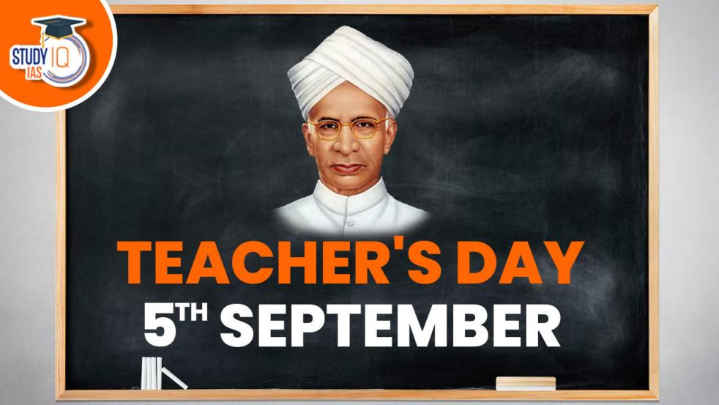

Report On Maha Swachata Abhiyan

- Date : 03 October 2024
- Venue : JCOP Campus
- Attendance: All Students and Staff.

- Concept of The Programme:
Swachh Bharat Abhiyan (Campaign Clean India) is a national stationary level Campaign by the Government of India covering 4041 statutory towns to clean the streets, road and infrastructure of the country.

- Programme Objective :
The Swachh Bharat Mission has made significant stride in improving sanitation coverage, promoting behavioural change, and creating awareness about cleanliness and hygiene. It has positively impacted public health, contributed to economic growth, and the overall quality of India.

- Programme Summary :
This programme was conducted by Jaihind College of Pharmacy on 3rd Oct. 2024 with the presence of Principal Dr. Leena Pathak, all teaching and non- teaching staff.
The Principal Dr. Leena Pathak gave speech on importance of Maha Swachata Abhiyan Swachh Bharat: Swachh Vidyalaya is the national campaign driving ‘ Clean India : A key feature of the campaign is to ensure that every school in India has a set of functioning and well- maintained water, sanitation and hygiene facilities.

Photographs:

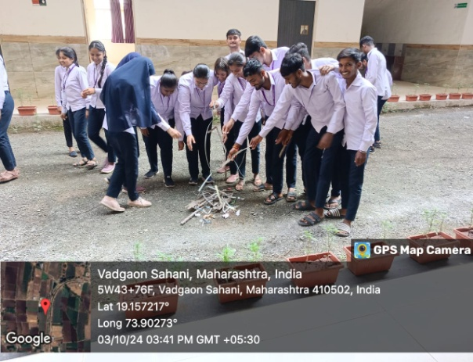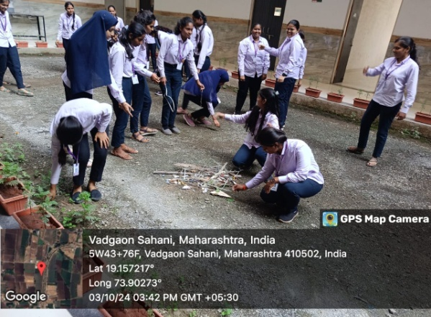

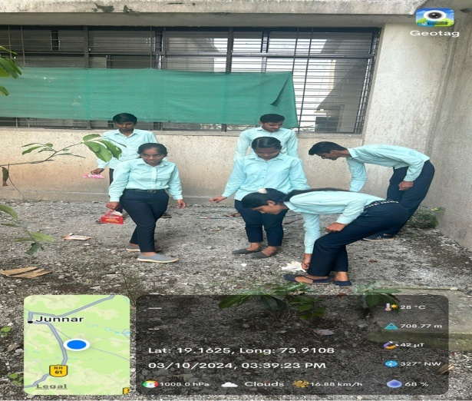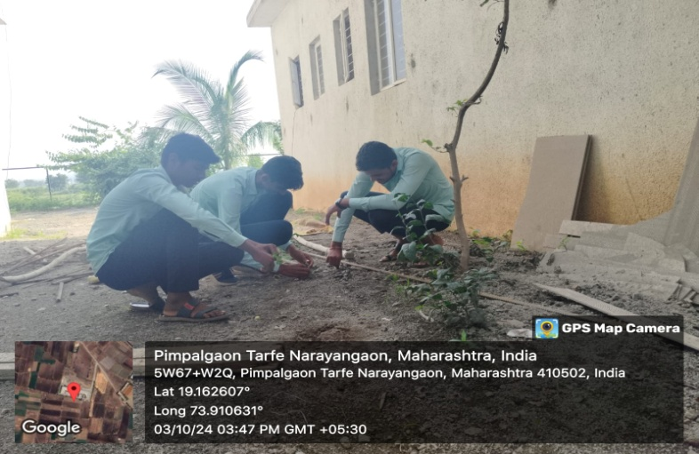
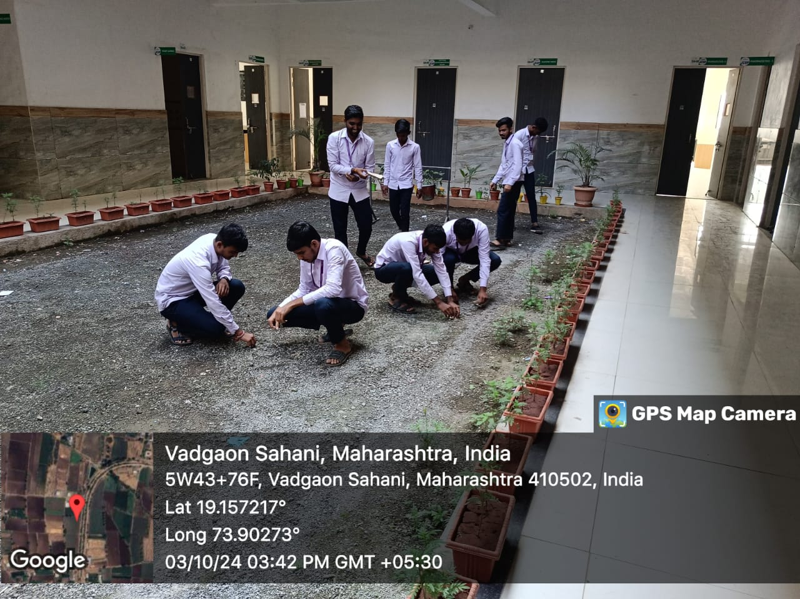

Dandiya Celebration Report
Date: October 11, 2024
Venue: JCOP
Attendance: All Students and Staff
Concept of Event
The Dandiya celebration at Jaihind College of Pharmacy was a vibrant and energetic event held on October 11, 2024, as part of the Navratri festivities. The event aimed to promote cultural awareness and encourage community bonding among students.

Event Summary

1. Venue Setup
- The venue was beautifully decorated with colourful lights, traditional decorations, and posters showcasing the significance of Dandiya.
- A designated dance area was created to facilitate smooth movement during the dance performances.

2. Attendance
- The event saw participation from over [number] students, faculty members, and guests, fostering a sense of community and celebration.

3. Traditional Attire
- Participants were encouraged to wear traditional Gujarati attire. Many students embraced this, showcasing vibrant chaniya cholis and kurtas.
- Activities

1. Dandiya Dance
- The main highlight was the Dandiya dance, which began with a brief introduction to its cultural significance.
- Professional dancers led the session, demonstrating various steps and formations to guide beginners.

2. Music
- The event featured live music, including traditional folk songs, enhancing the festive atmosphere.
- A DJ also played popular Bollywood numbers, blending traditional and contemporary styles.

3. Competitions
- Fun competitions, such as best dancer and best traditional attire, were held, with winners receiving small prizes.

Conclusion
The Dandiya celebration at [College Name] was a resounding success, bringing together students in a joyful and culturally rich environment. The event not only celebrated the spirit of Navratri but also strengthened the bonds within the college community.

Photographs:

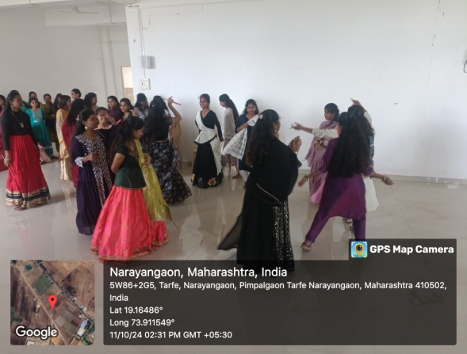
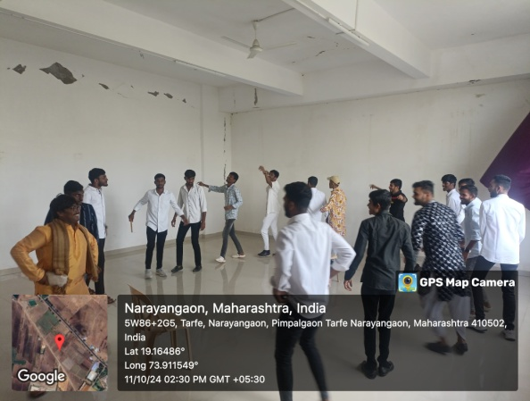

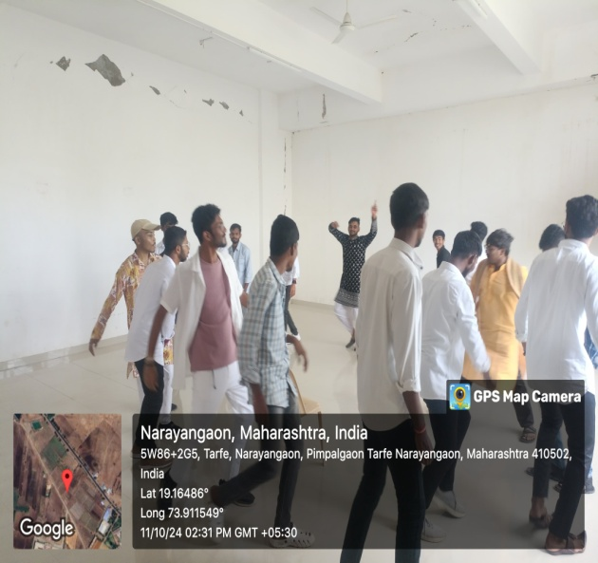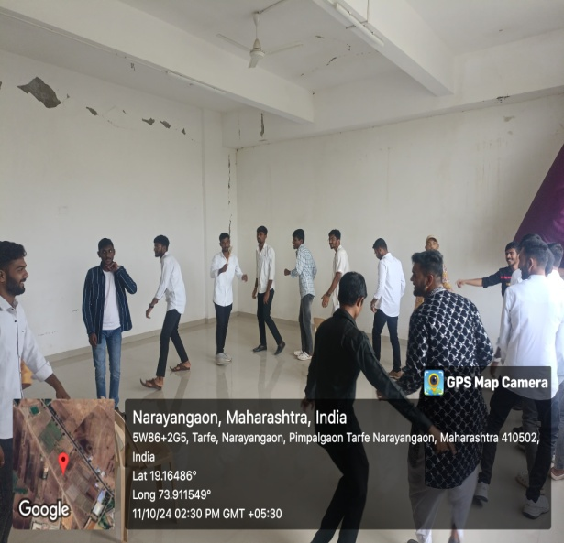

A Report on
26/11 Attack on Mumbai

Date: 26thNovmber2024
Venue: JCOP
Attendance: Student and staff of B.Pharm and D.Pharm.

Objectives of Event:
- Targeting Iconic Locations
- Instil Fear and Chaos
- Destabilize India
- Focus on International Attention
- Inflict Harm on Foreign Nationals
Event Summary:
The 26/11 celebrations at our college aimed to honour the memory of the 2008 Mumbai terror attacks and fosters a deeper understanding of the resilience and unity that emerged in response to the tragedy. The primary objective of the event was to educate students about the significance of national security, the impact of terrorism, and the importance of standing together in times of crisis. A moment of silence to remember the victims and the heroes who sacrificed their lives. The college organized a series of informative activities, including a lecture on the events of 26/11, where experts discussed the attack's aftermath and the lessons learned. A documentary screening highlighted the courage of the security forces and survivors, followed by a panel discussion that allowed students to engage with real-life accounts of the tragedy. The day concluded with a candlelight vigil, symbolizing solidarity and remembrance. Through these events, the college aimed to instil a sense of patriotism, resilience, and awareness among students, reminding them of the importance of standing united against terrorism and promoting peace and security in society.
Photographs:
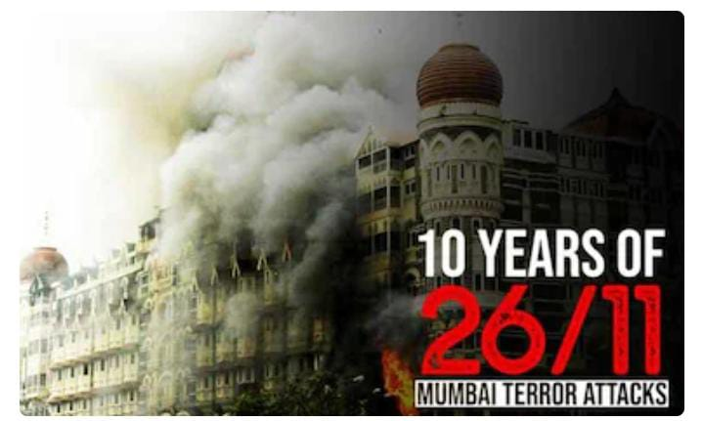
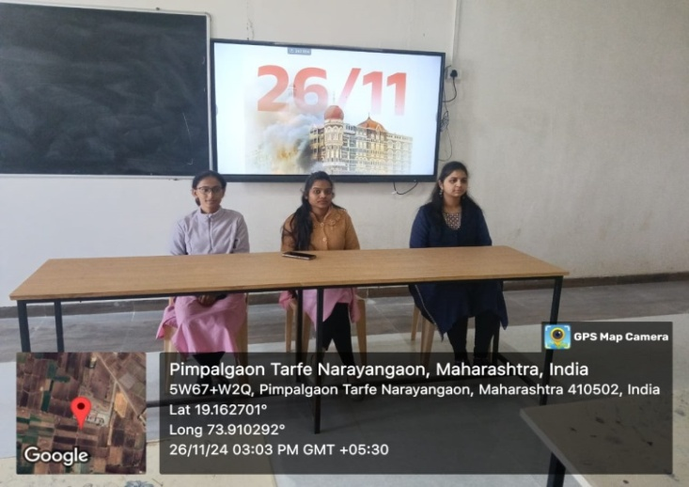

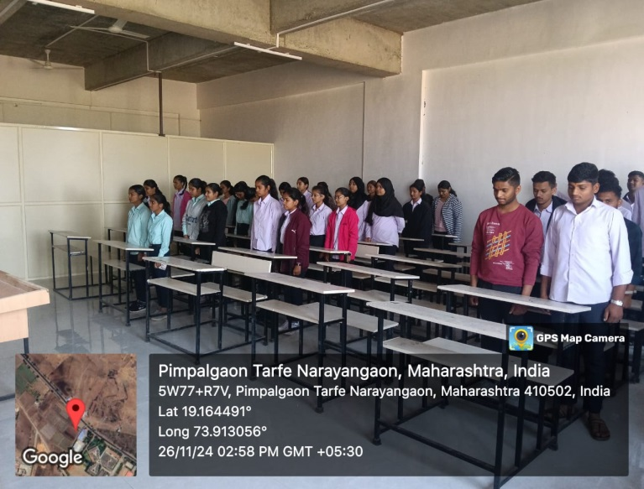

A Report on
National Constitution Day

Date: 26thNovmber2024
Venue: JCOP
Attendance: Student and staff of B.Pharm and D.Pharm.

Objectives of Event:
- Understanding the Constitution
- Key Constitutional Values and Principles
- Understanding the Preamble and Its Significance
- Role of Constitution in Governance
- Constitutional Amendments and Their Impact
Event Summary:
The National Constitution Day celebration at Jaihind College Of pharmacy was a meaningful and enriching experience for all involved. Through the various activities and discussions, students gained a deeper understanding of the Indian Constitution and the core values it upholds. The event also helped in fostering a sense of respect for democracy and the rights and duties that every citizen is entrusted with. The celebrations were a reminder of the importance of constitutional literacy, particularly in today's rapidly changing world, and the need for individuals to actively contribute to strengthening democratic institutions. The day ended with a vote of thanks by the event coordinator, Prof. Rushali S. Deokar and Event supporter Mr. Omkar C. Jadhav, who expressed gratitude to all the participants, and volunteers for making the event success. The students left the venue with a renewed sense of responsibility and pride in being part of a democratic nation governed by one of the world's longest and most comprehensive constitutions.

Photographs:
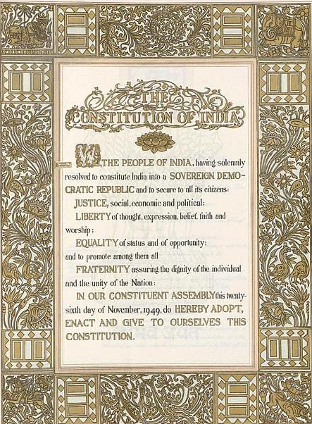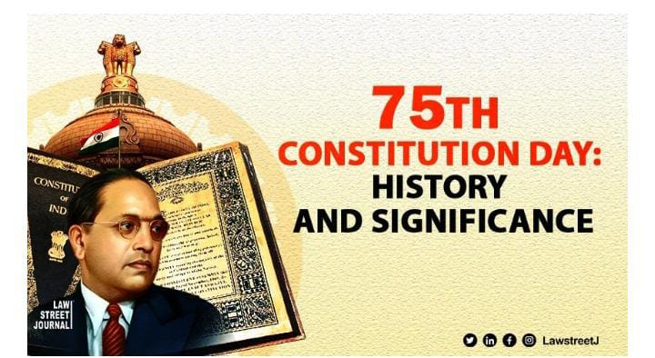

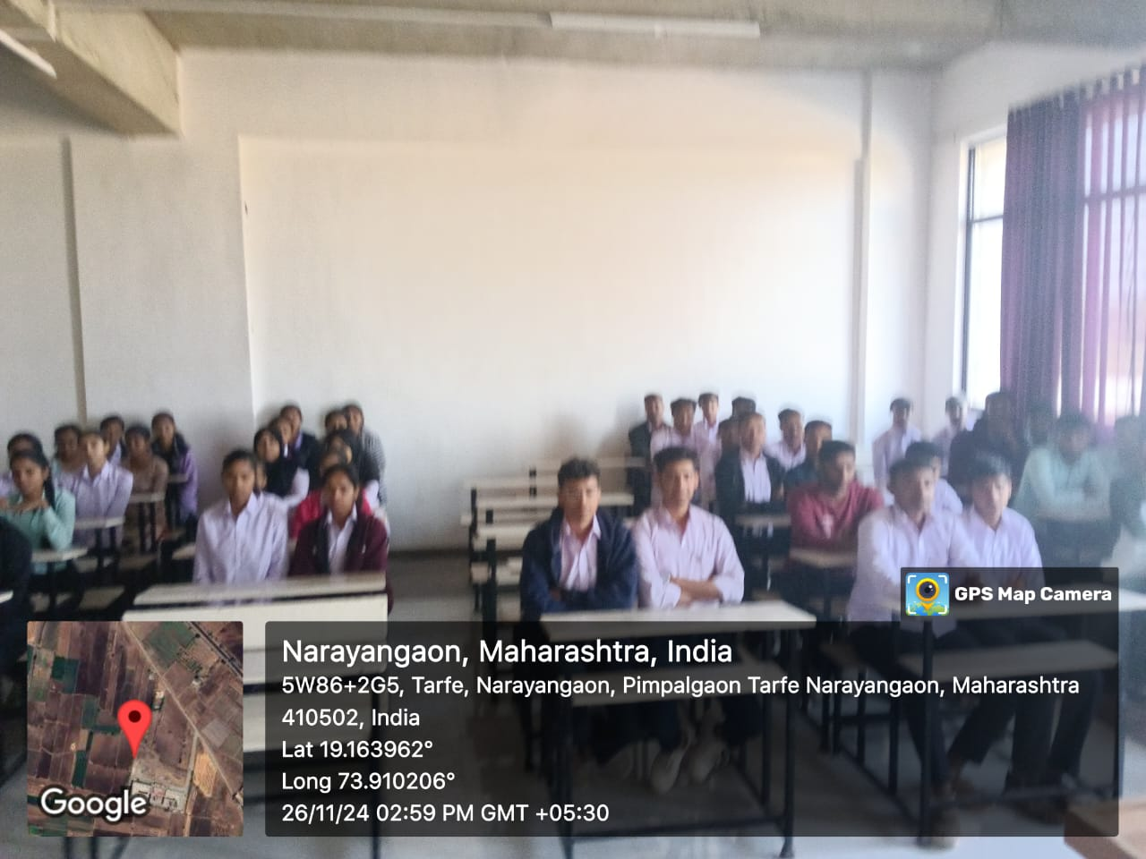

A Report on
World AIDS Day

Date: 2 ^{nd}December2024
Venue: JCOP
Attendance: Student and staff of B.Pharm and D.Pharm.

Objectives of Event:
- Raise Awareness
- Foster Empathy
- Encourage Advocacy
- Promote Social Responsibility

Event Summary:
The college celebrated World AIDS Day on December 2nd, aiming to raise awareness about HIV/AIDS, promote prevention, and reduce stigma associated with the disease. The event included informative sessions, interactive discussions, and activities such as poster exhibitions and screenings of educational videos. . The celebration featured guest speakers from local health organizations, who shared insights on the latest developments in HIV treatment and the importance of supporting those living with HIV/AIDS. The event successfully fostered a sense of empathy, social responsibility, and advocacy, inspiring students to be more informed and engaged in public health efforts.

Photographs:
