To,
The Coordinator,
IQAC Cell,
Jaihind College of Engineering,
Kuran-410 511

Subject: Permission to organize Event in the month of OCT academic Year 2018-19.
Respected Madam,
With reference to above mentioned subject, Department of National service Scheme, wish to organize the Health Check up Camp for 01 days with the following details.
Sr.No | Name of Event | Level  (State/National/Intern.) | No. of Days | Date of Conduction | Approx. Participants | Approximate Expenditure | Funding Agency | Name of Resource Person
01 | Health Check up Camp | ------------ | 01 | 01/10/18 | 300 | 500=00 | SPPU | Dr. VILAS NAYKODI,La SACHIN BHOR,La SHITALM PATVA,La AJAY CHORDIYA
Kindly accept the same and do the needful.
Thanking You.

Name and Sign of Event coordinator Name and Sign of Head of Department
Prof.R.S.Kajabe Prof.R.S.Kajabe
For IQAC Cell Only
Date of Meeting
IQAC Coordinator | IQAC, Chairman

To,
The Coordinator,
IQAC Cell,
Jaihind College of Engineering,
Kuran-410 511.

Subject: Submission of “Health Check up Camp “Event Report Conducted in the Month of OCT of Academic Year 2018-2019.

Respected Madam,
With reference to above mentioned subject, Department of National service Scheme, wish to submit the Report of Health Check up Camp for 01 days with the attaching details.
Kindly accept the same and do the needful.
Thanking You.

Name and Sign of Event Coordinator
Prof.R.S.Kajabe

EVENT NAME: HEALTH CHECK UP CAMP
Date-01/10/2018
Organizing Department | : | NSS
Event location | : | AT-JCOE,KURAN TAL-JUNNAR DIST-PUNE(LAIBRARY)
Duration in time/Days | : | 01 DAYS
- No. of Students attendees | : | 157
- No. of Faculty Attendees | : | 17
- No. of Other Attendees | : | 00
- Total attendance (a+b+c) | : | 174
Funding body (if any) | : | SPPU
Total expenditure in INR | : | 350=00
Fund allocated  - By Institute | : | 00=00
- By Funding Body |  | 350=00
- Fund raised through other sources | : | 00
Total Expenditure in INR | : | 350=00
Promotional materials | : | nil
Event Summary Report with photos | Health Check up camp organize on birth date of hon.chairmen JCEI’S Tatyasaheb Gunjal. Health Check up camp event present Dr. Vilas Naykodi,la SachinB bhor,la Shital Patva,la Ajay Chordiya,Mr.Babu Pate ,JPP Principal Y.S. Gunjal, JCOE Pricipal Dr D.J Garkal ,CEO Prof D.S. Galhe, All HOD’s,NNS PO,SWO HEAD, IQAC Member Present.

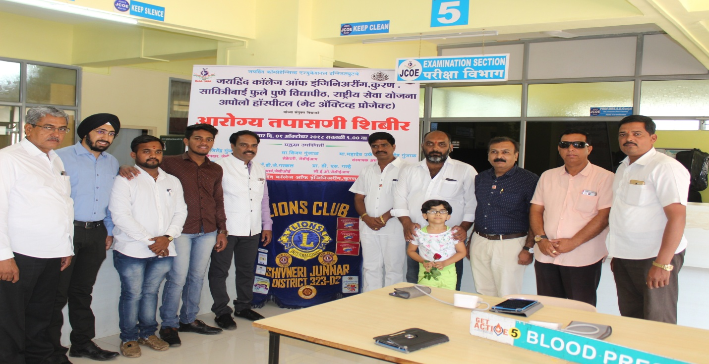
Mr.Babushet pate, Chairman Tatyasaheb Gunjal, Director, CEO, Principal, Inaugurating the Health Check up Camp.
