Event Name: - “Gad Swachata Abhiyan” on the occasion of Shiv Jayanti 2022 Organized by NSS Department of Jaihind College of Engineering
Date-23/03/2022
Organizing Department | : | NATIONAL SERVICE SCHEME
Event location | : | JCOE ,Kuran
Duration in time/Days | : | 01 Day
- No. of Students attendees | : | 50
- No. of Faculty Attendees | : | 02
- No. of Other Attendees | : | -----
- Total attendance (a+b+c) | : | 52
Funding body (if any) | : | JCOE
Total expenditure in INR | : | 1500
Fund allocated  - By Institute | : | ----
- By Funding Body |  | Nil
- Fund raised through other sources | : | Nil
Total Expenditurein INR | : | Fifteen hundred only.
Promotional materials | : | Email, Whats app…..

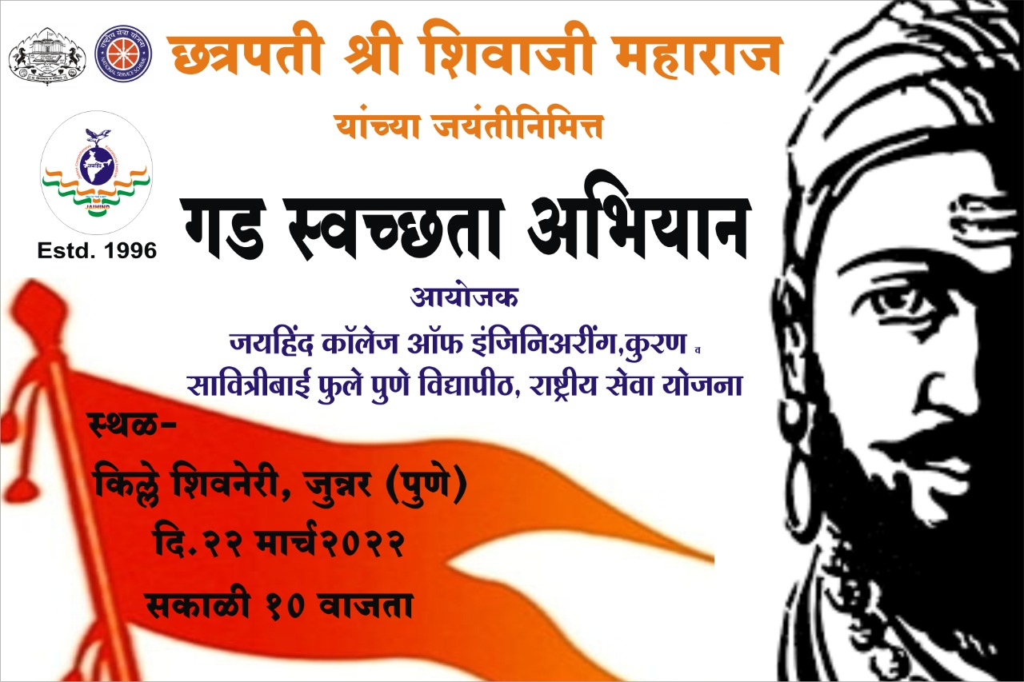
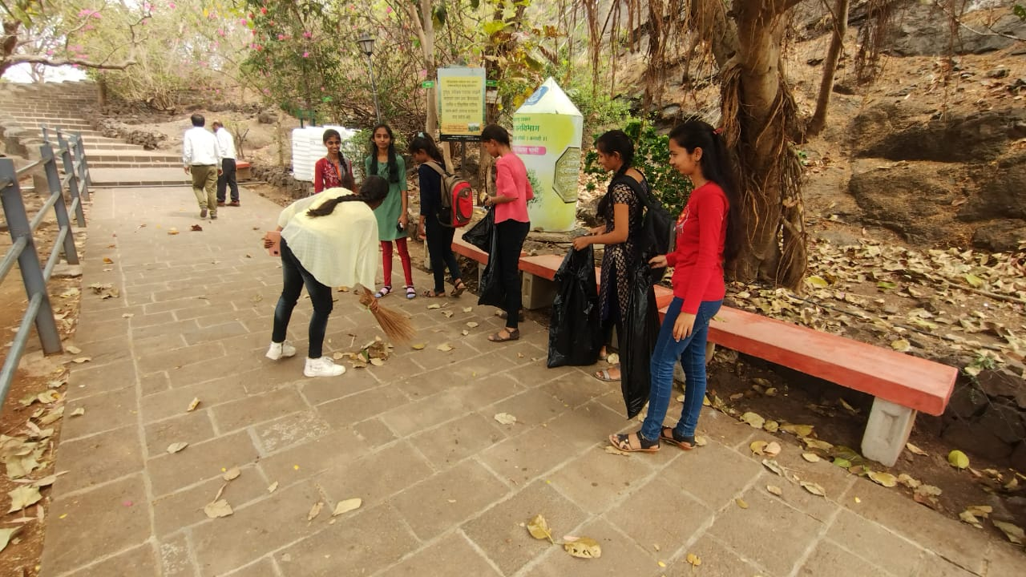

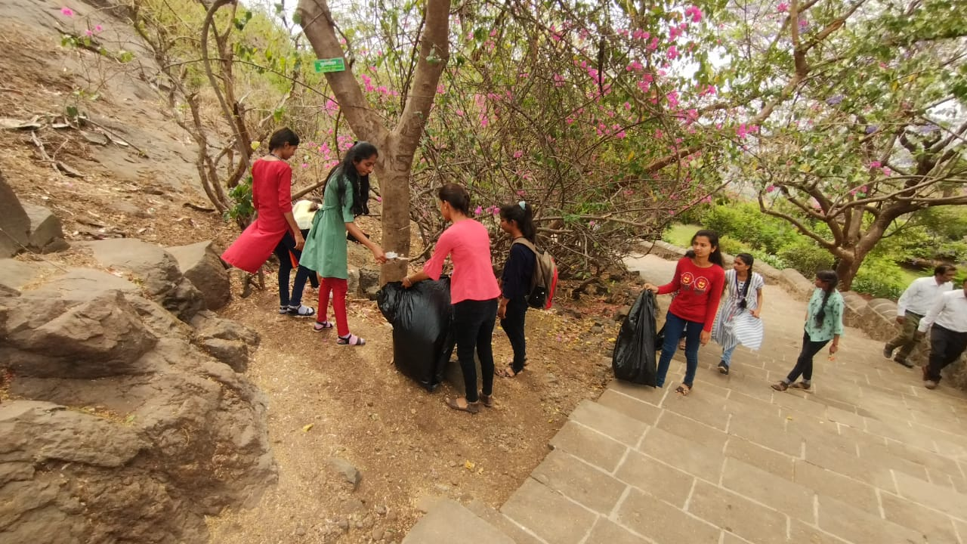

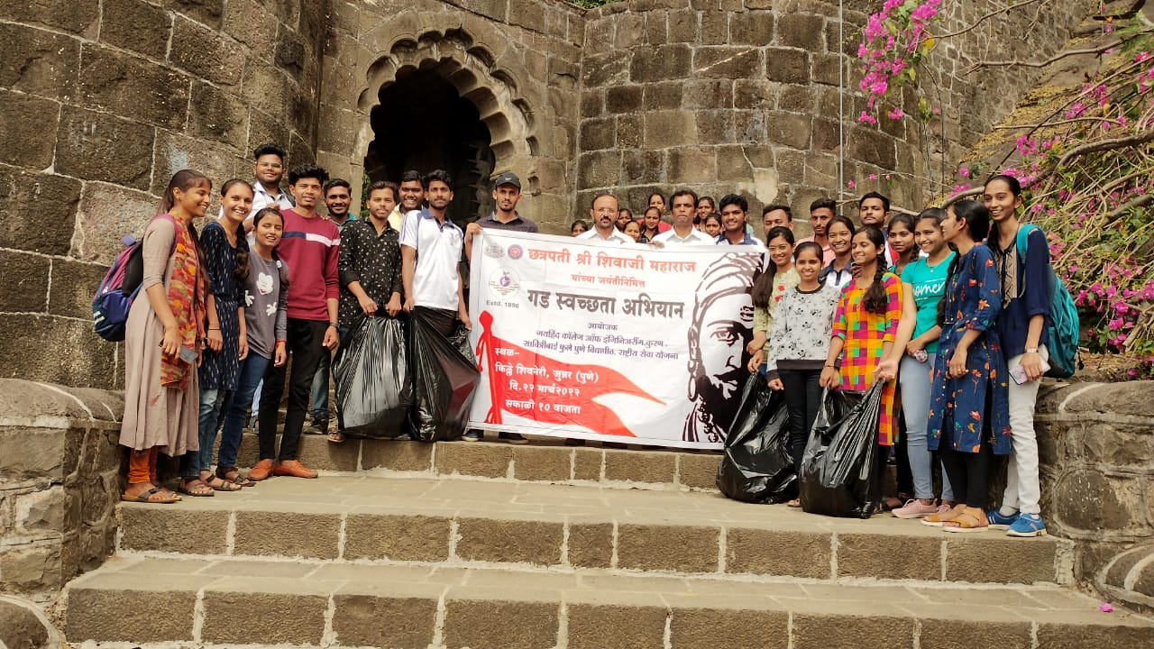

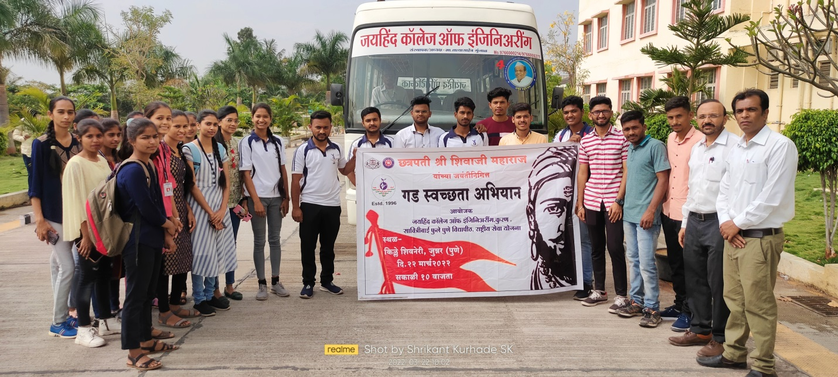

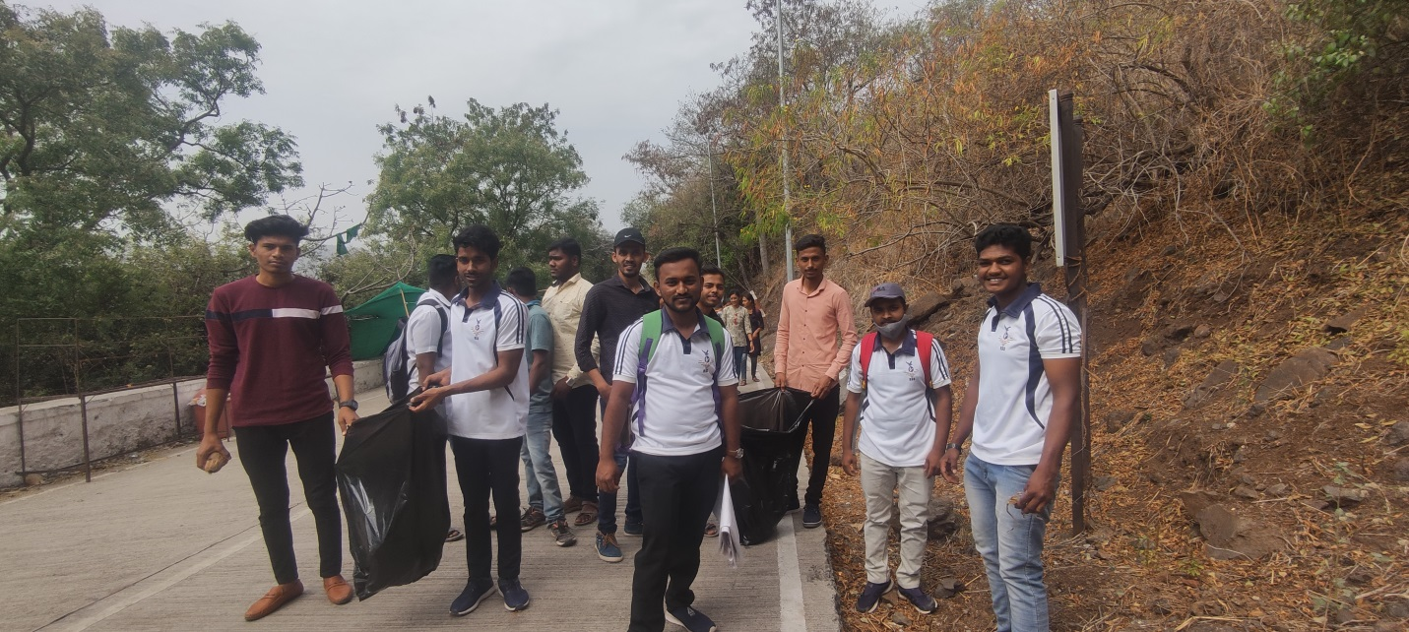

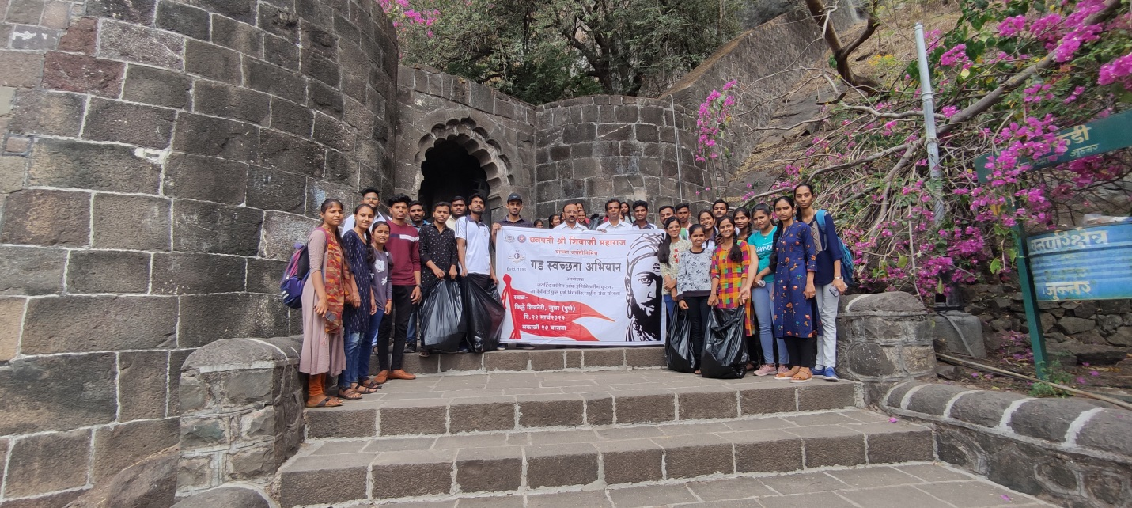

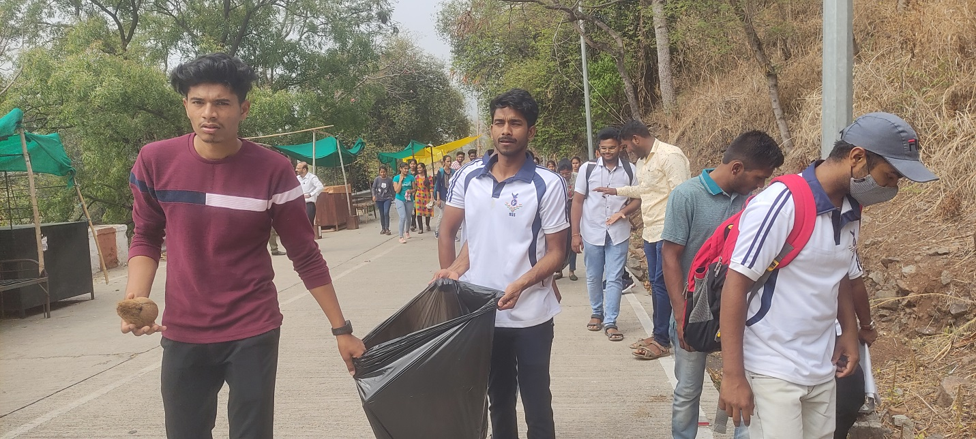

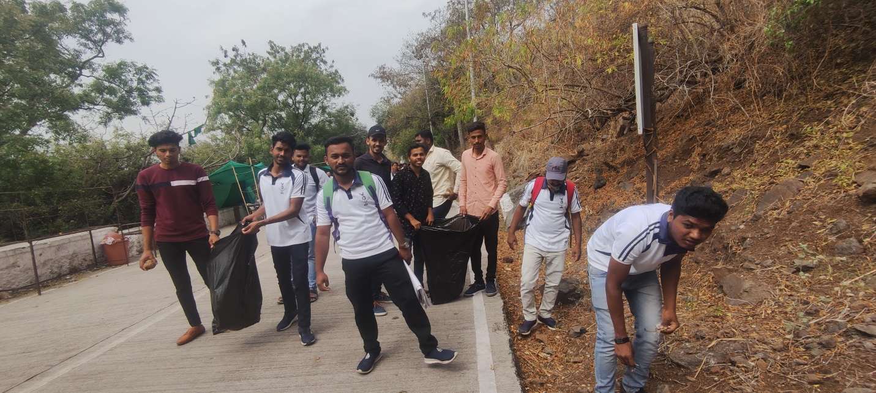

NSS Department of Jaihind college of Engineering took to Shivneri Fort, as they organized a cleanliness drive where in students from the different streams participated. The students of NSS department cleaned the fort in less than three hours. Shivneri Fort Also known as Birth place of Shivaji Maharaj, the facade of the fort and other interiors were cleaned under the guidance of college authorities.
All volunteers and youngster spent the day in shramadan in spite of a gloomy weather and occasional fun activity. They not only cleaned the platform to keep it safe, also cleaned the water tanks by removing debris and other things.

