**Event Name: -‘Surynamaskars’under the mission of ‘75 crore Suryanamaskar Date-27/01/2022**

|  |  |  |
| --- | --- | --- |
| *Organizing Department* | *:* | NATIONAL SERVICE SCHEME*& DEPARTMENT OF GENERAL SCIENCE (FIRST YEAR)* |
| *Event location* | *:* | **JCOE,Kuran** |
| *Duration in time/Days* | *:* | *21 Days* |
| 1. *No. of Students attendees* | *:* | *227* |
| 1. *No. of Faculty Attendees* | *:* | *24* |
| 1. *No. of Other Attendees* | *:* | *----* |
| 1. *Total attendance (a+b+c)* | *:* | *251* |
| *Funding body (if any)* | *:* | *JCOE ,Kuran* |
| *Total expenditure in INR* | *:* | *-----* |
| *Fund allocated*   1. *By Institute* | : | *----* |
| 1. *By Funding Body* |  | *Nil* |
| 1. *Fund raised through other sources* | *:* | *Nil* |
| *Total Expenditurein INR* | *:* | *-----------* |
| *Promotional materials* | *:* | *Email, Whats app…..* |

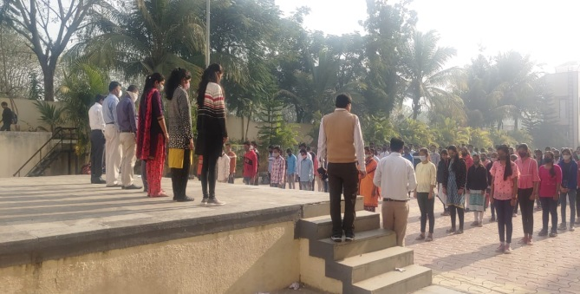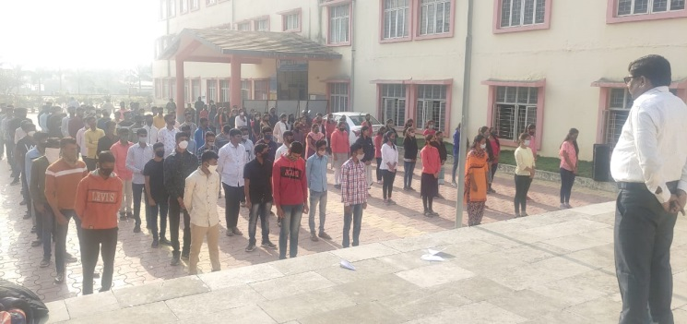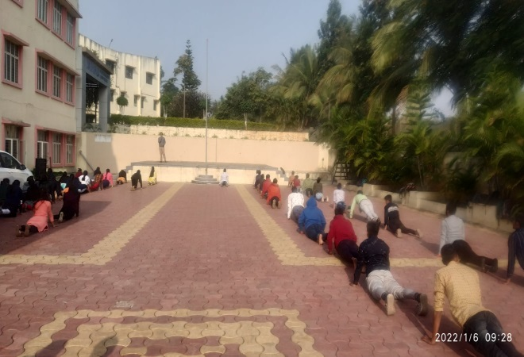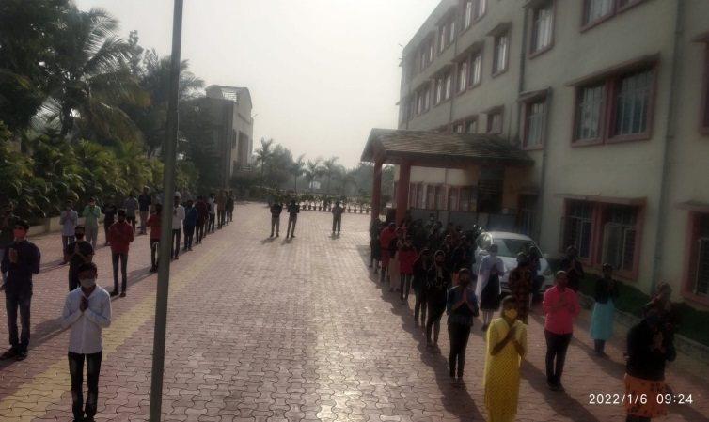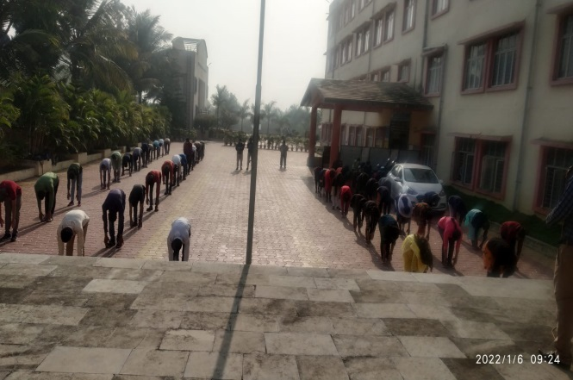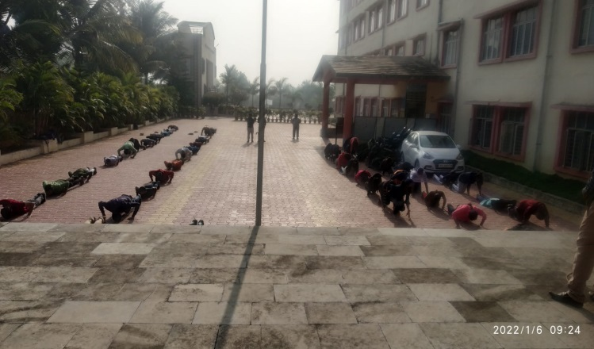

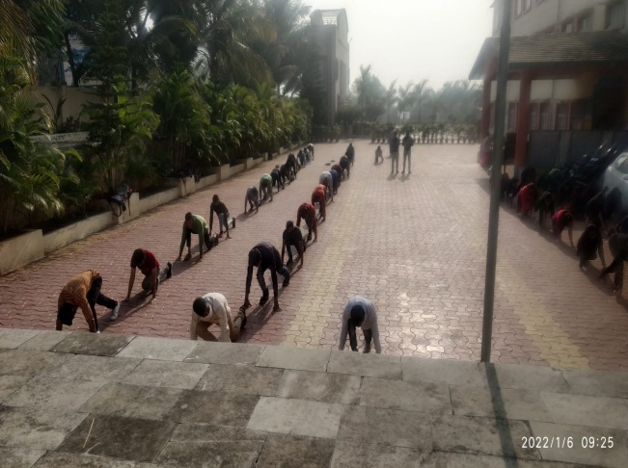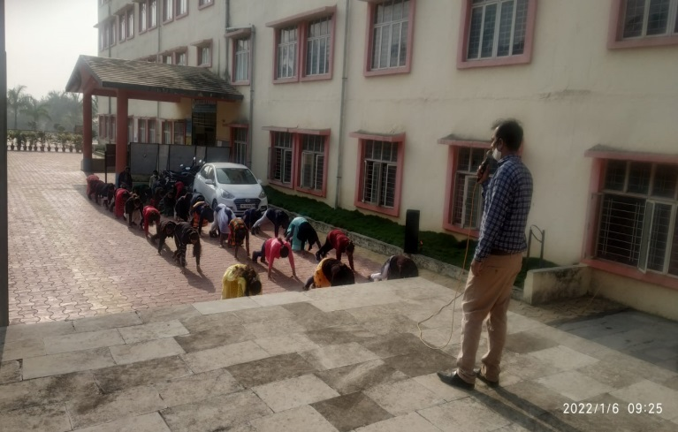

Students are doing ‘Surynamaskars’under the mission of ‘75 crore Suryanamaskar.

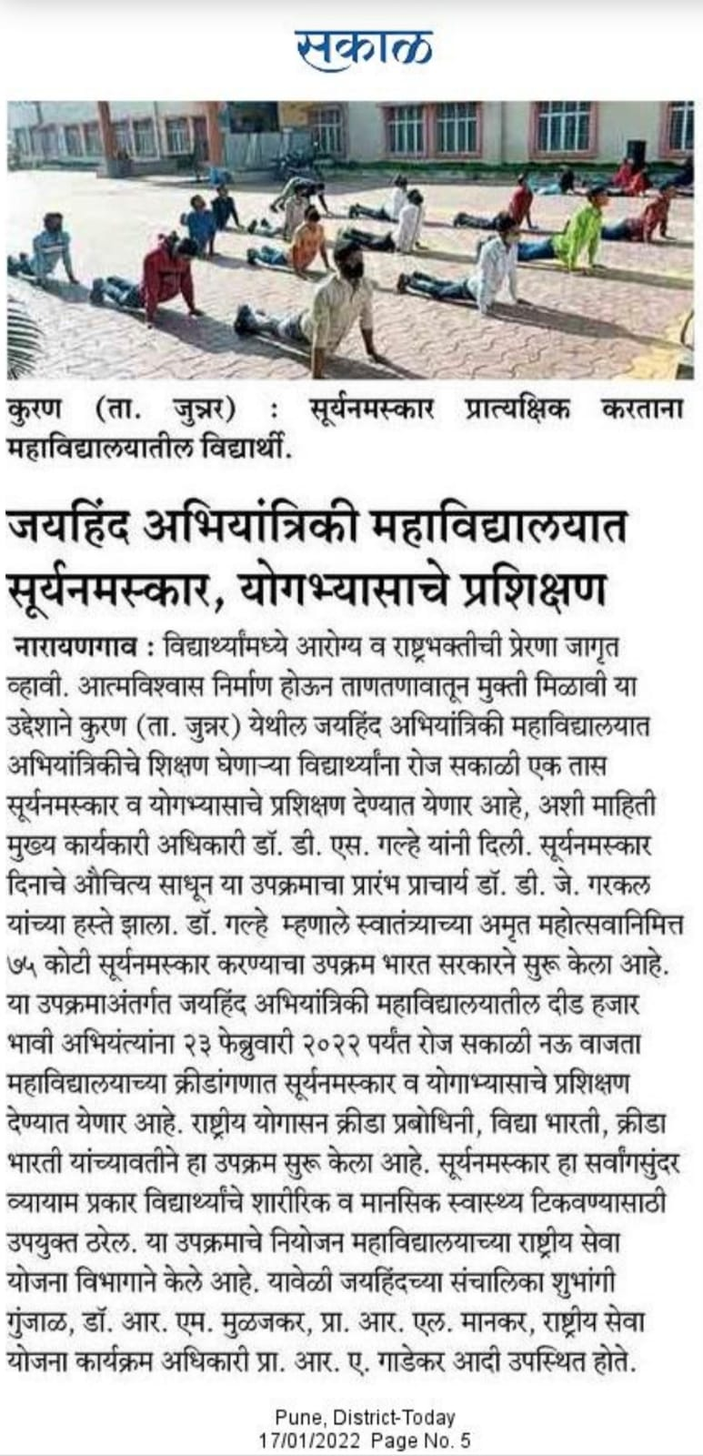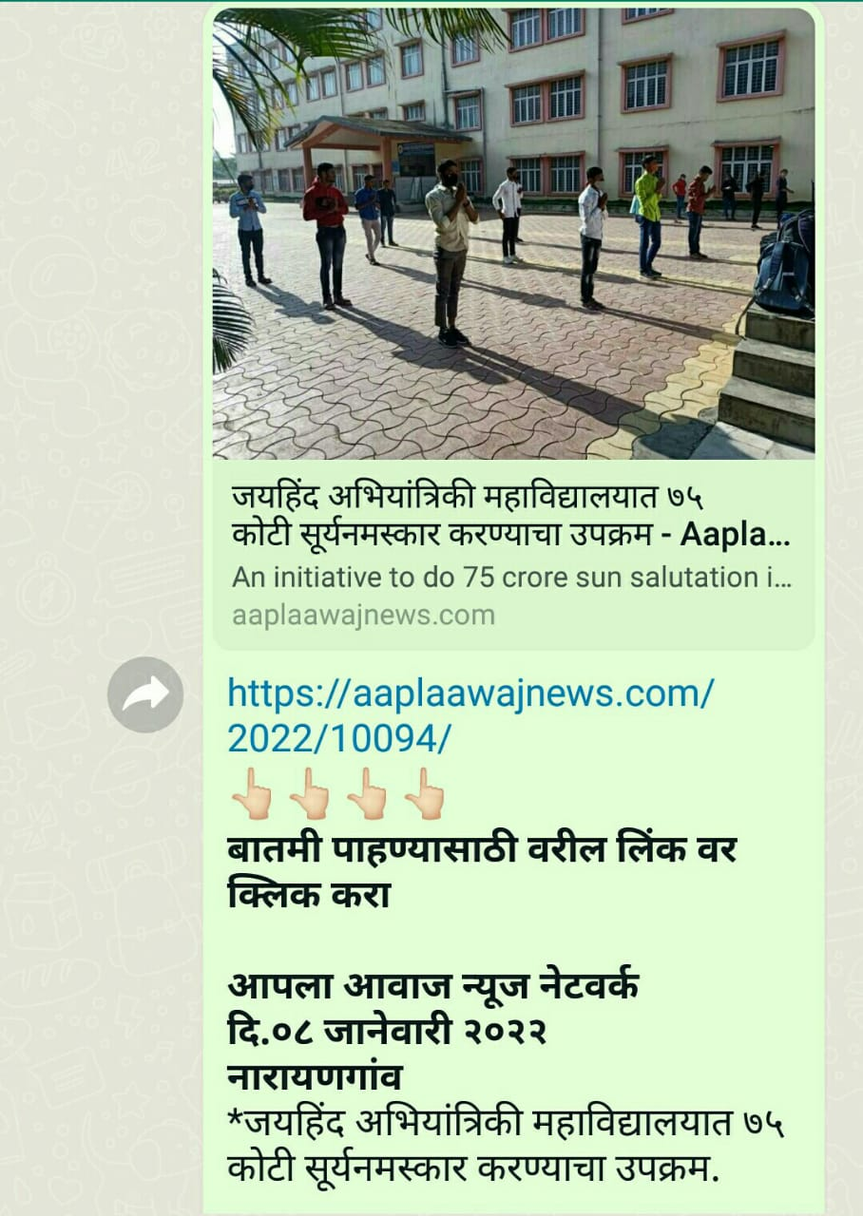

News Bulletin.

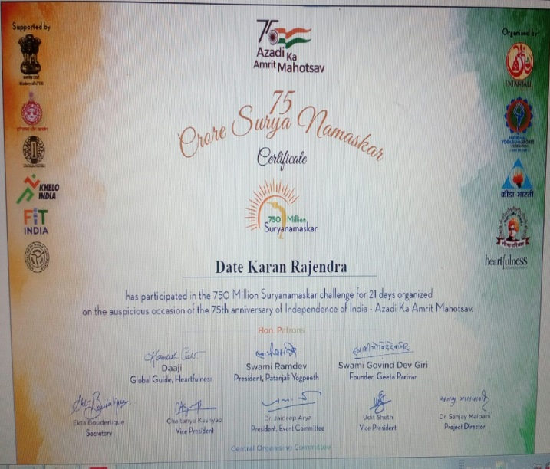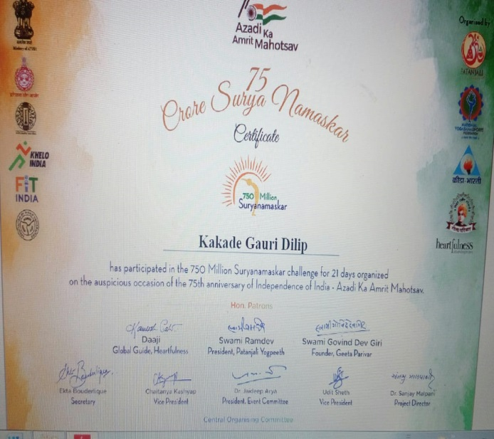

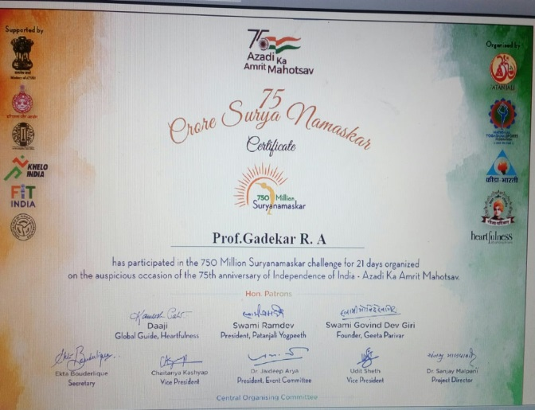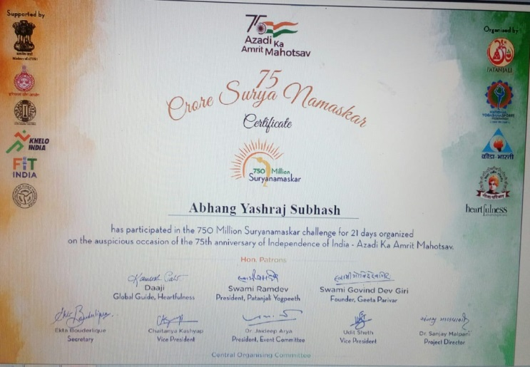

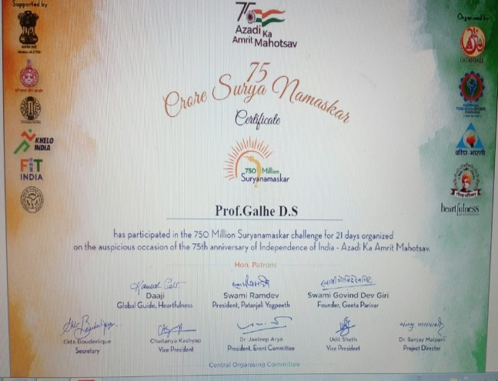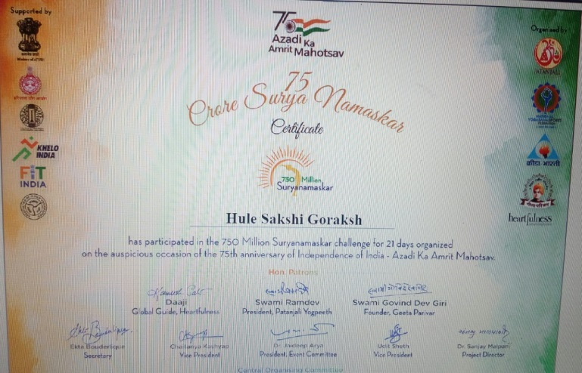

Certificates

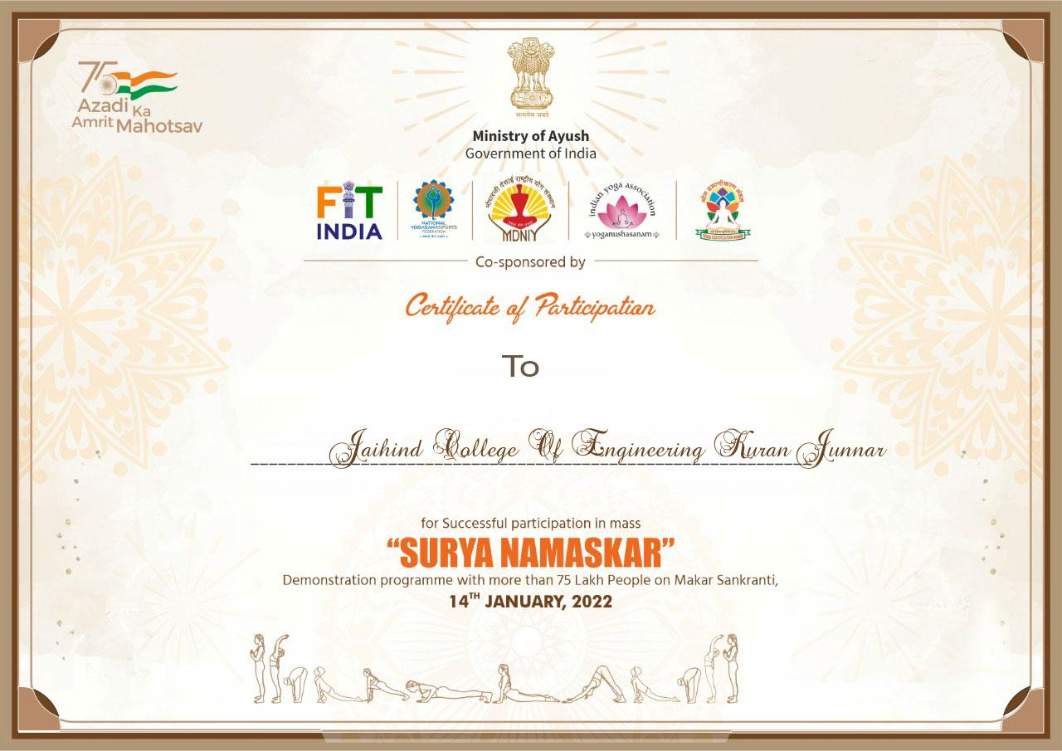

Institute certificate

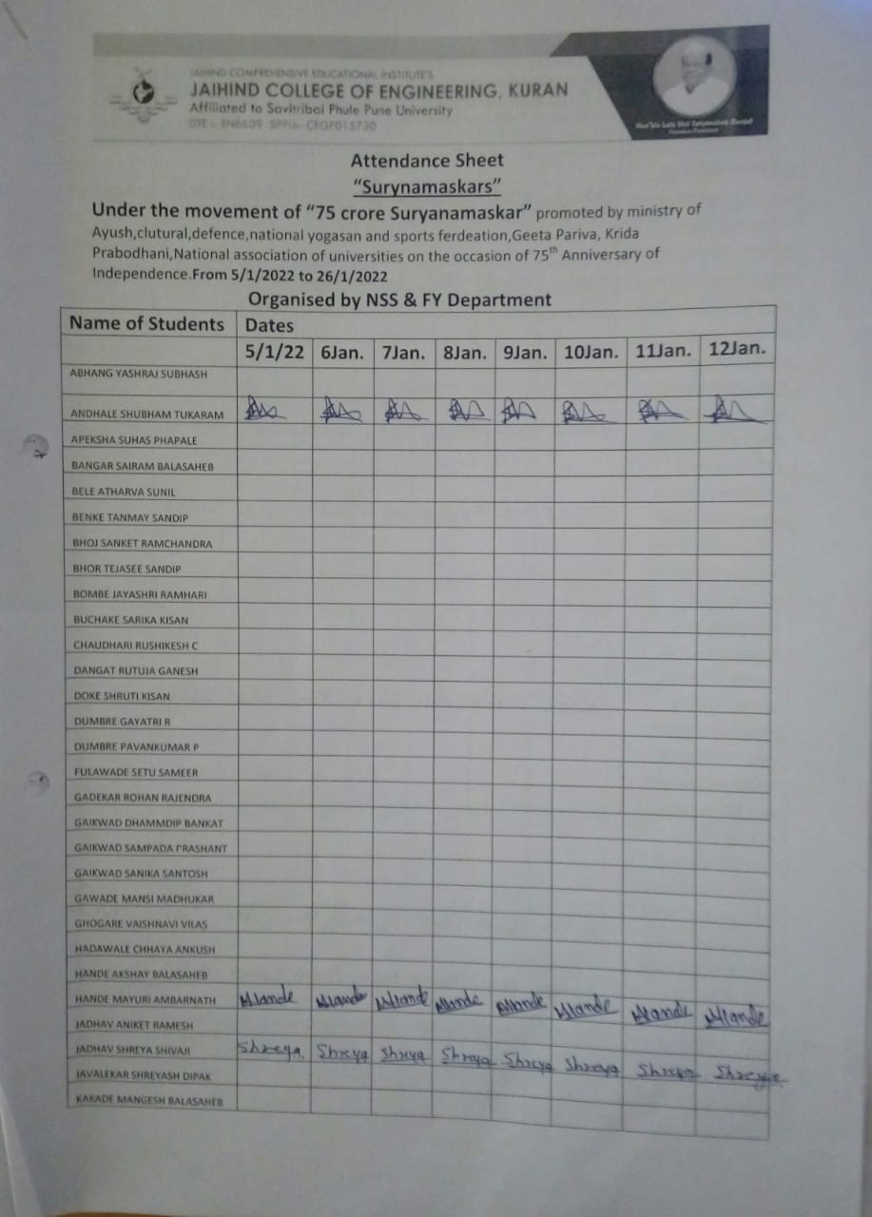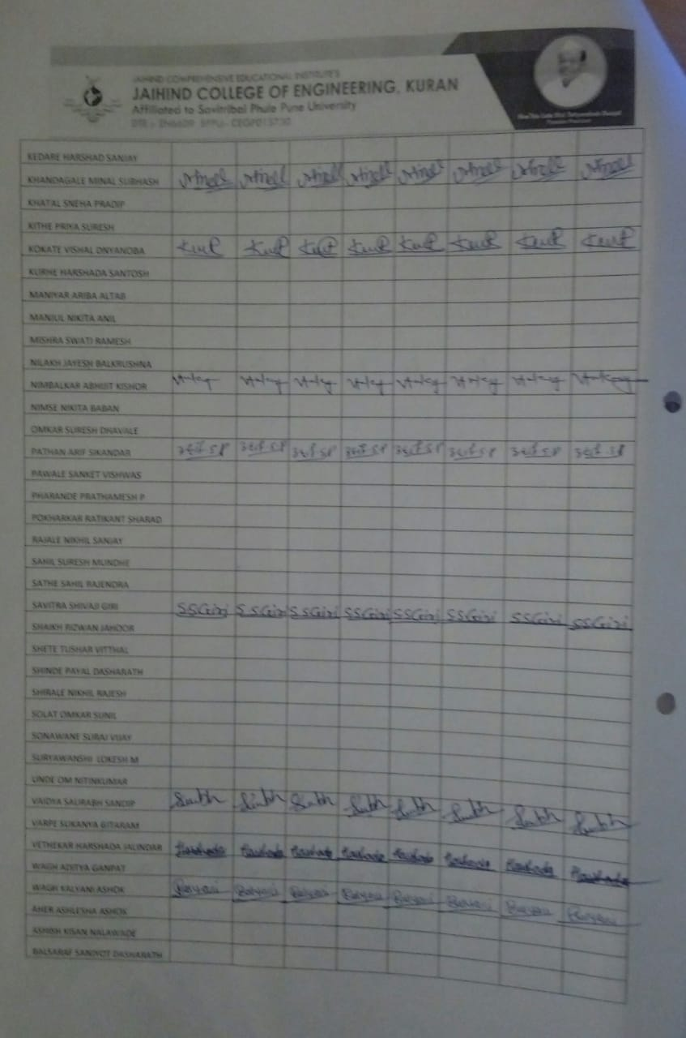

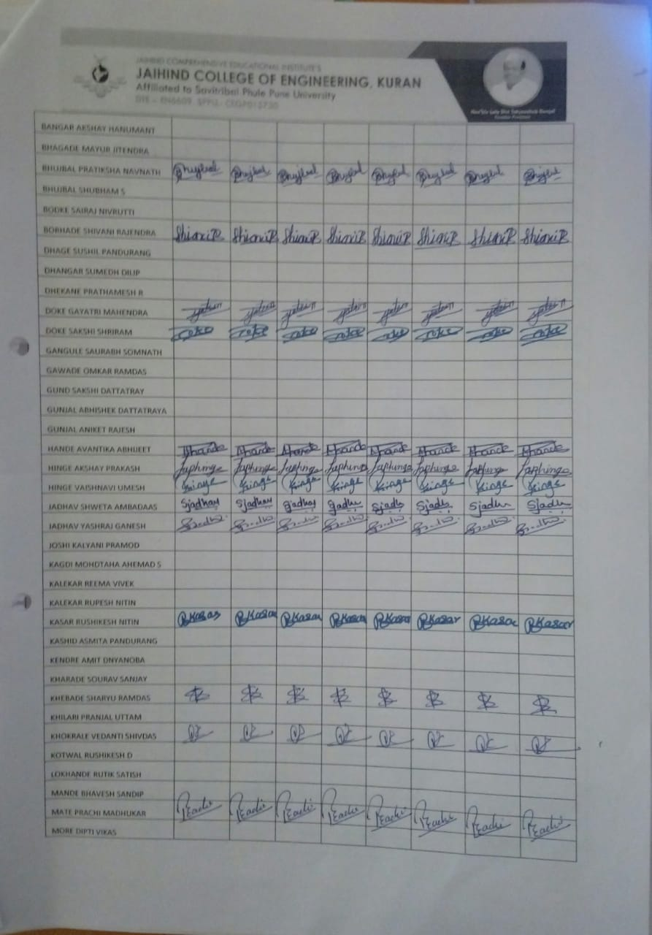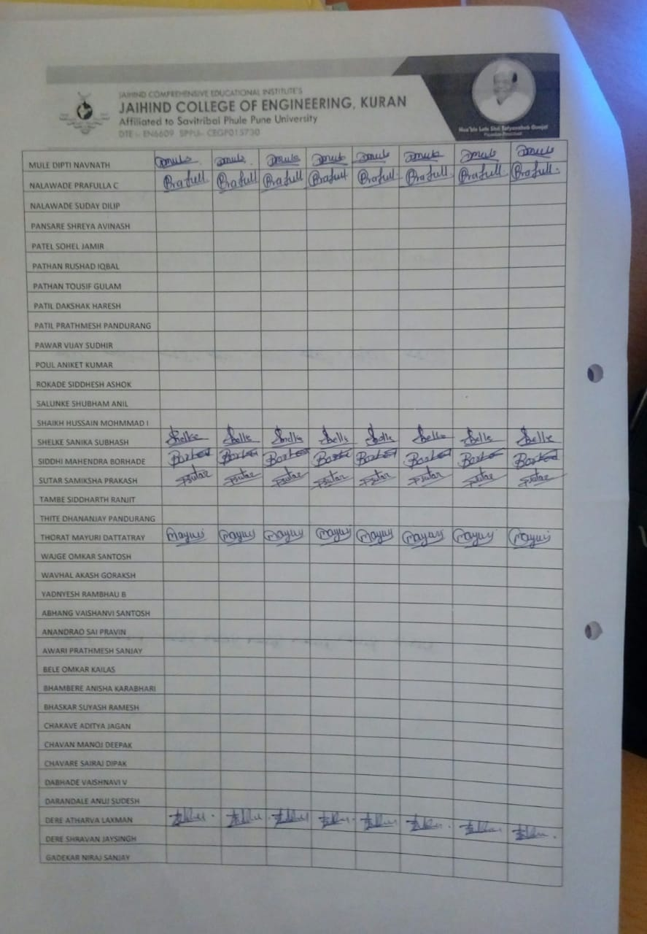

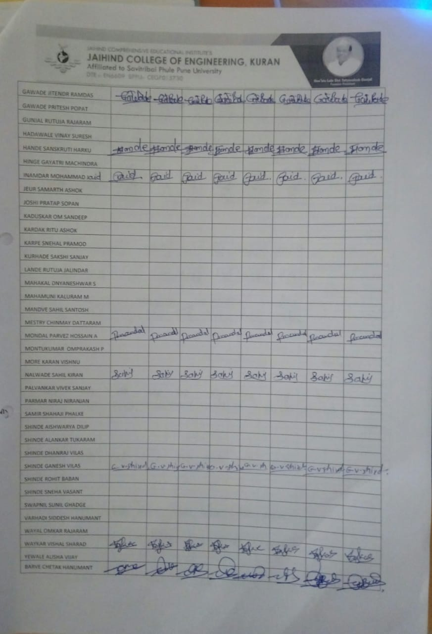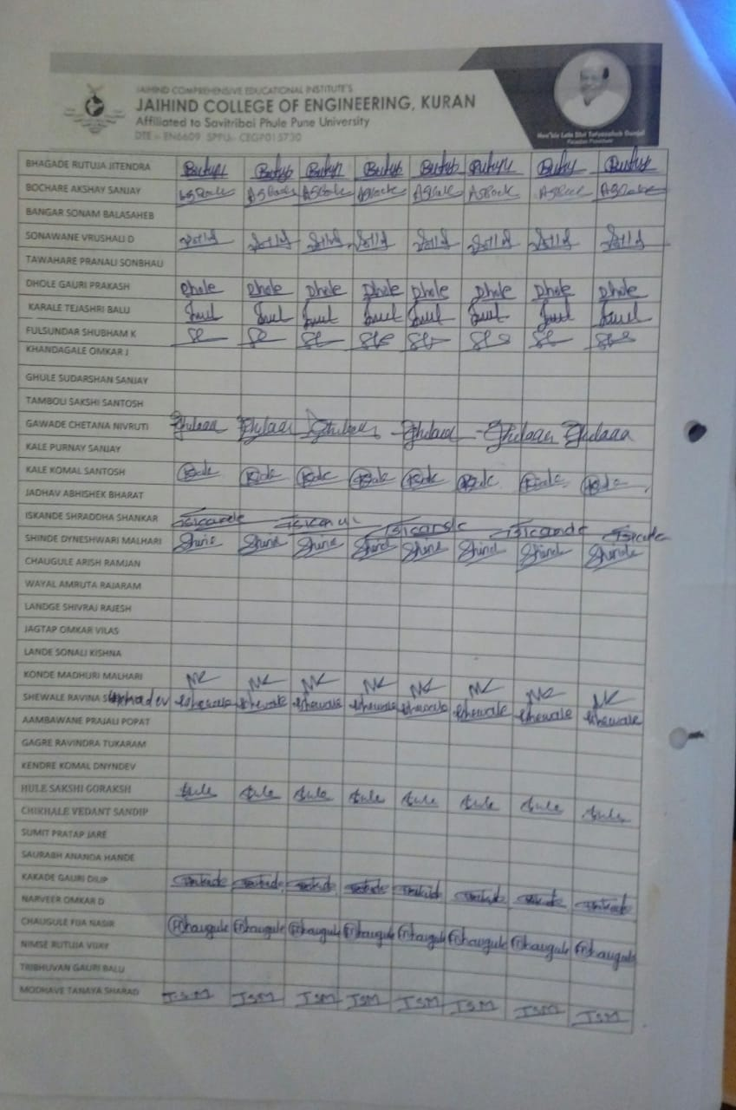

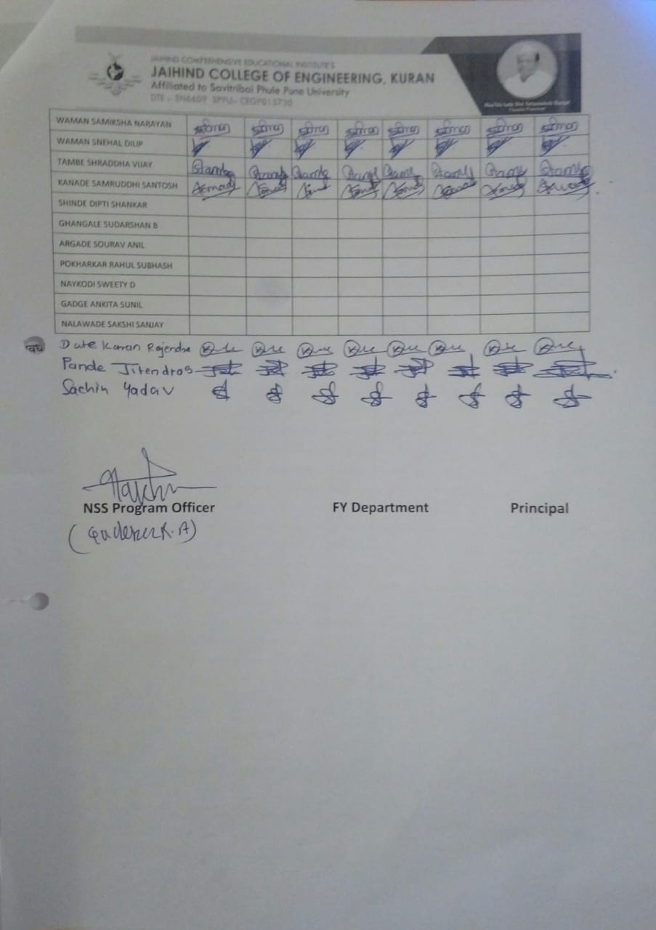

ATTENDENCE